**Question 1.1: Write the Answer to these questions.**

**Note: Give at least one example for each of the questions.**

1.What is the difference between static and dynamic variables in Python.

Solution:

**Static Variables** **-**

* Generally the static variables are those which should be declare the type of that variable before define it.
* As python is a dynamically typed language we cannot use the method of declaration the type of the variable. But in python oops we have a concept of the static variable.
* In pythons oops concept the static variables are the variables of the class which should be define in the class but outside of any instance method or constructors.
* These static variables of class share among all the instance of class.
* Static variables retain their values even the instance of class are modified or new instance is created.
* Practical eg.:
* 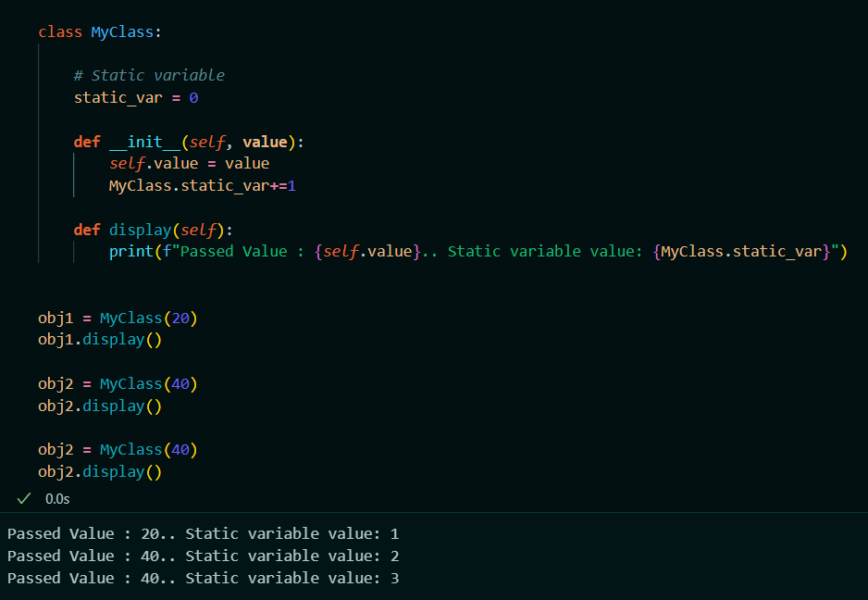

**Dynamic Variables –**

* As python is dynamically typed language we know that , In python we doesn’t need any declaration method to declare the type of the variable.
* Whereas the type of the variable is depends upon the value we assign to it.
* In python oops concepts the dynamic variable are those which are defined in the instance method of the class or in constructor.
* The dynamic variable is also called as the instance variable of the class, which will be specific to each instance of the class.
* They are defined within methods (typically within the __init__ method) and are unique to each instance.
* The values of the dynamic variable can be vary between different instance of the class.
* Practical eg.:

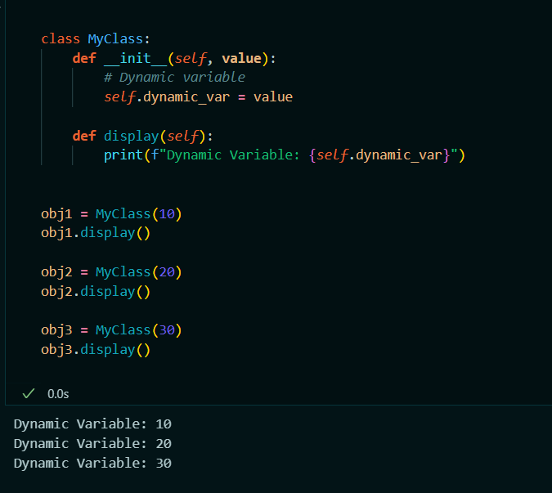

2. Explain the purpose of "pop","popitem","clear()" in a dictionary with suitable examples.

Solution:

* In Python, dictionaries are collections of key-value pairs. The methods pop, popitem, and clear are used to manipulate these dictionaries.
* **pop Method**:

The pop method removes a specified key from the dictionary and returns its corresponding value. If the key is not found, it raises a KeyError unless a default value is provided.

Syntax - dict.pop(key, default)

Practicle eg:

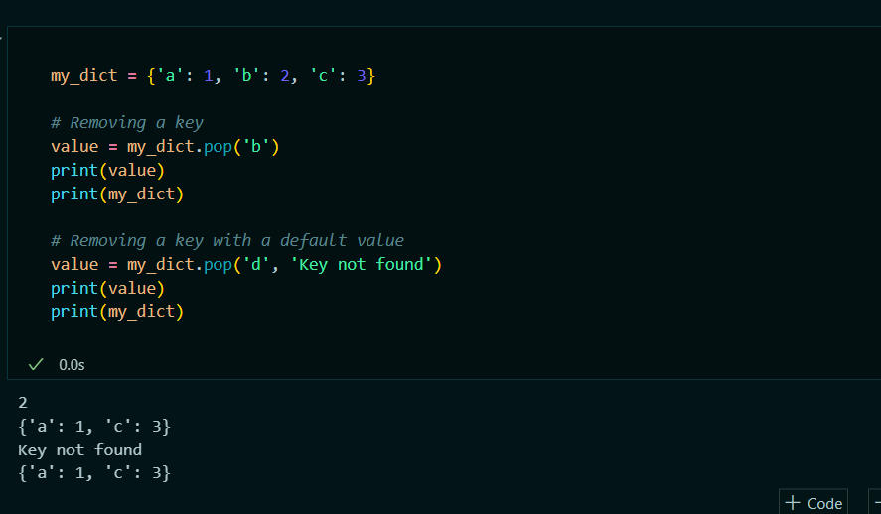

* **popitem Method:**

-The popitem method removes and returns the last key-value pair from the dictionary. If the dictionary is empty, it raises a KeyError.

-This method is useful for efficiently removing items from the dictionary during iteration.

- Syntax: dict.popitem()

- Practicle eg:

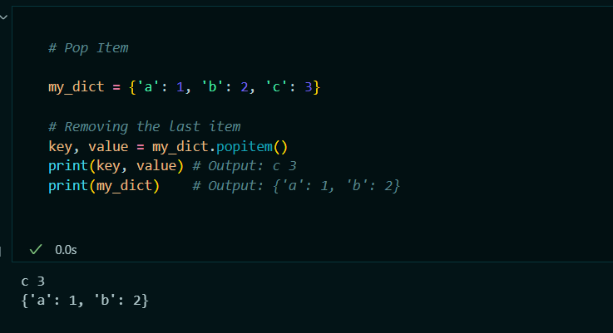

* **clear() Method:**
* The clear method removes all items from the dictionary, effectively emptying it.
* Syntax: dict.clear()
* Practicle eg:

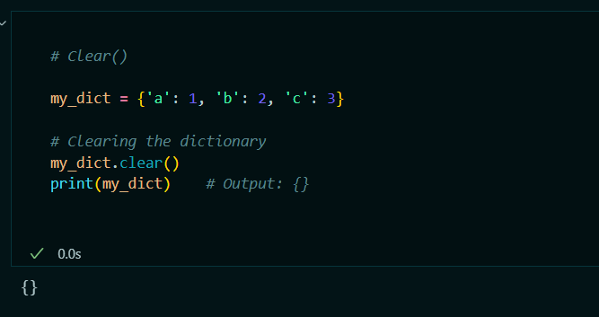

3. What do you mean by FrozenSet? Explain it with suitable examples.

* Solution: A frozenset in Python is an immutable version of a set.
* Unlike a regular set, which can be modified after its creation by adding or removing elements, a frozenset cannot be changed once it is created.
* This makes frozenset usable as a key in dictionaries or as elements of other sets.
* A frozenset can be created using the frozenset function.
* Supports set operations like union, intersection, difference, and symmetric difference

Practicle eg:

* 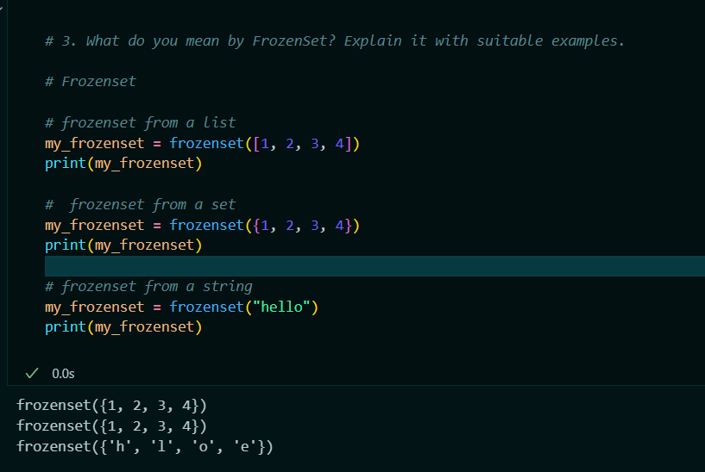

4. Differentiate between mutable and immutable data types in Python and give examples of mutable and immutable data types.

Solution:

* In Python, data types can be categorized as either mutable or immutable based on whether their values can be changed after they are created.

**Mutable Datatypes:**

* Mutable data types are those whose values can be changed in place after they are created. This means you can modify, add, or remove elements without creating a new object.
* Can be changed after creation.
* Ex. List, Set, Dictonary, ByteArray.

**Immutable Datatypes:**

* Immutable data types are those whose values cannot be changed after they are created. Any modification to an immutable object results in the creation of a new object.
* Cannot be changed after creation.
* Ex. String, Tuple, Frozenset.

5.What is __init__?Explain with an example.

Solution:

* In Python, __init__ is a special method called a constructor.
* It is automatically called , when a new instance of a class is created. The purpose of the__init__ method is to initialize the object's attributes and set up any necessary initial state.
* Practicle eg:

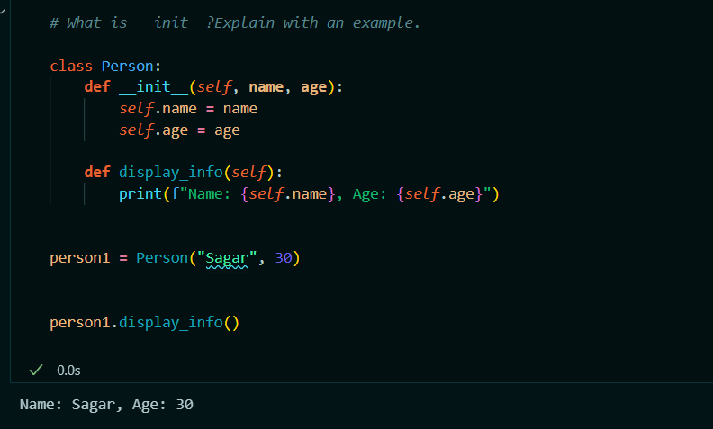

6. What is docstring in Python? Explain with an example.

Solution:

* A docstring in Python is a string literal that appears right after the definition of a function, method, class, or module.
* It is used to document the object and describe what it does.
* Docstrings are not just comments; they are stored as an attribute of the function, method, class, or module they document, making them accessible programmatically.
* They can be accessed using the __doc__ attribute of the object or via the help() function.
* They provide a convenient way of associating documentation with Python code.
* Docstrings are defined using triple quotes """ or '''.
* Practicle eg:

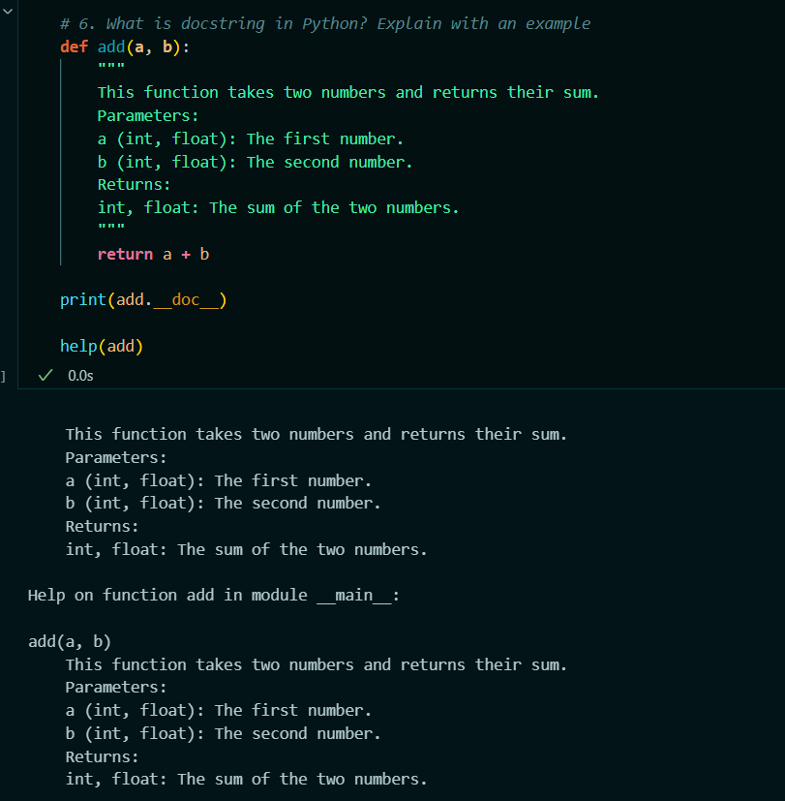

7. What are unit tests in Python?

Solution:

* Unit tests in Python are a type of software testing where individual units or components of a software are tested in isolation from the rest of the application.
* The primary goal of unit tests is to validate that each unit of the software performs as expected.
* A unit can be a function, method, class, or module.
* Tests a specific piece of code without dependencies on external systems.
* Can be run automatically, often as part of a continuous integration (CI)pipeline.
* Should produce the same results every time they are run.
* Typically run very quickly to allow for frequent execution during development.
* They catch bugs early in the development process.
* Ensure that changes to code do not break existing functionality.
* Provide confidence that the code works as intended.
* Python has built-in unittest framework (also known as PyUnit) is the standard way to write and run unit tests.
* It provides tools for creating and running tests, as well as for reporting results.

8. What is break, continue and pass in Python?

Solution:

* In Python, break, continue, and pass are control flow statements used to manage the execution of loops and conditionals.
* **Break Statement:**

The break statement is used to exit a loop prematurely, regardless of the loop's condition. It is commonly used when a certain condition is met within the loop.

Practical eg.:

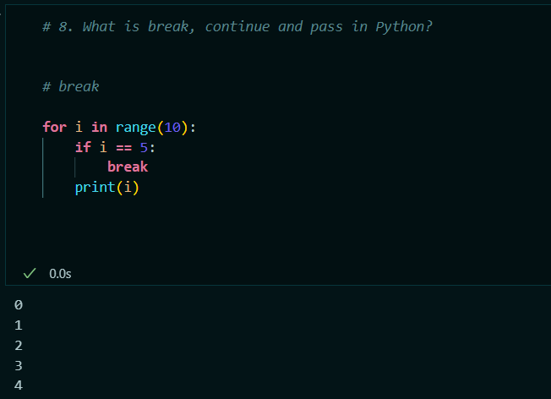

* **Continue Statement:**

The continue statement is used to skip the rest of the code inside the loop for the current iteration and move to the next iteration of the loop.

Practicle eg:

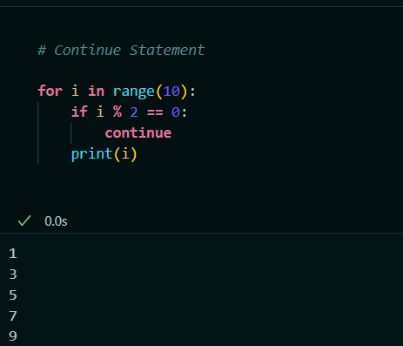

* **Pass Statement:**

The pass statement is a null operation; it does nothing when executed. It is used as a placeholder for future code. It allows you to write syntactically correct code where a statement is required syntactically but you have nothing to write there yet.

Practicle eg:

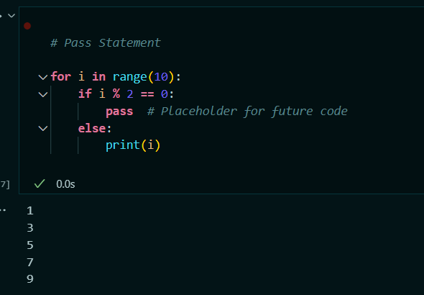

9. What is the use of self in Python?

Solution:

* In Python, self is a conventional name used for the first parameter of instance methods in a class.
* Which refers to the instance of the class on which the method is being called.
* Using self, you can access attributes and methods of the class in Python.
* It refers to the instance of the class itself.
* You can access and modify instance attributes.
* You can call other methods within the same class.
* Without self, Python would have no way of knowing whether an attribute belongs to the instance or is a local variable.
* Using self is a convention that ensures consistency and readability in class definitions.
* Practical Eg:

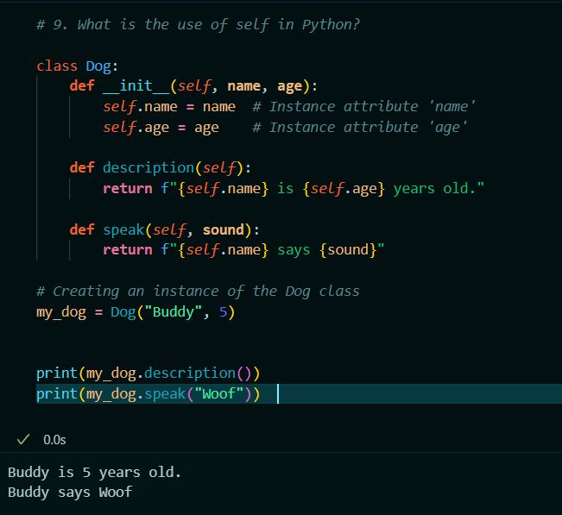

10. What are global, protected and private attributes in Python?

Solution:

* In Python, attributes of a class can have different levels of visibility, determining how they can be accessed and modified.
* The three common types are global, protected, and private attributes.
* **Global** :

In Python, "global attributes" typically refer to attributes defined at the module level, outside any class. These are accessible throughout the module in which they are defined.

Practical eg:

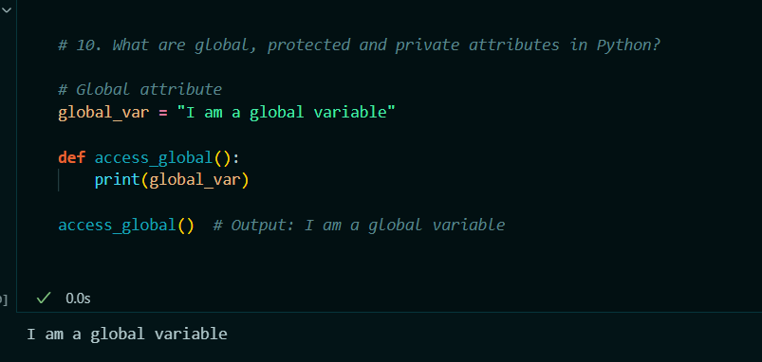

* **Protected:**

Protected attributes are intended to be accessible only within their own class and subclasses. By convention, these attributes are prefixed with a single underscore _. However, this is only a convention and does not enforce strict access control; the attributes are still accessible from outside the class but are indicated as non-public.

Practical eg:

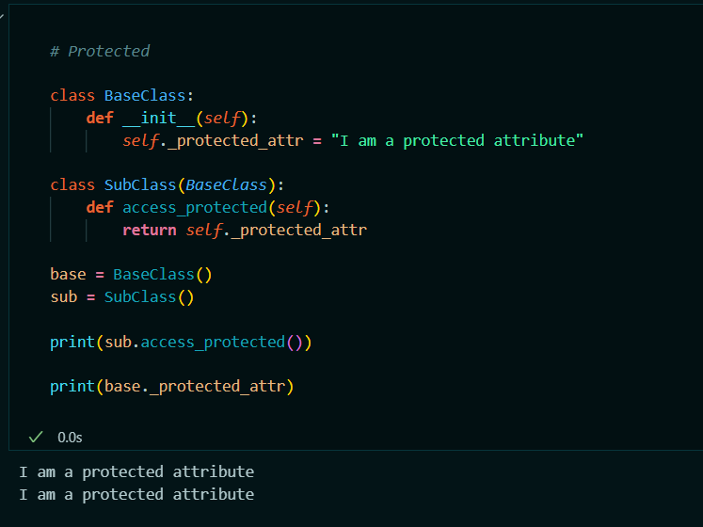

* **Private:**

Private attributes are intended to be inaccessible from outside their class. They are prefixed with a double underscore __. This name mangling makes it harder to access these attributes from outside the class, but it is still possible through special name mangling syntax.

Practical eg:

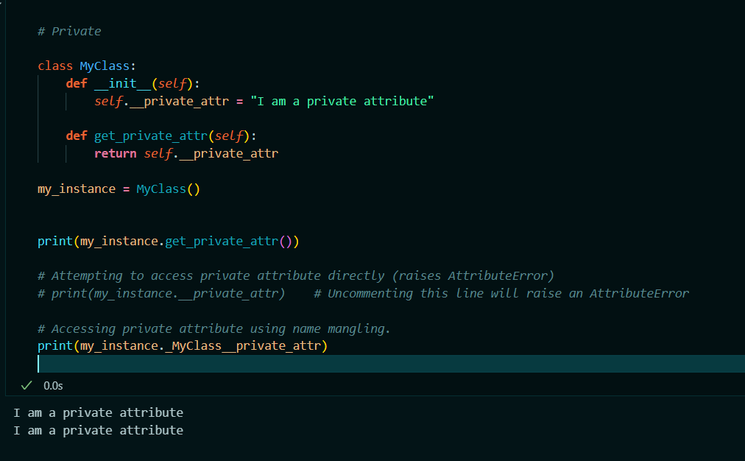

**11.** What are modules and packages in Python?

Solution:

* In Python, modules and packages are used to organize and structure code, making it more manageable, reusable, and maintainable.
* Modules: A module in Python is a single file containing Python code. Modules can define functions, classes, and variables, and they can also include runnable code. By organizing code into modules, you can reuse it across multiple programs and avoid redundancy.
* Practical eg: module creation and import it in ipynb file

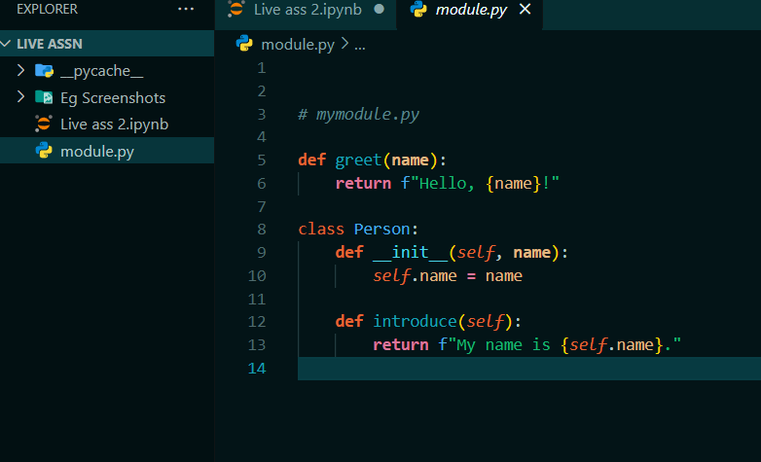

**Module importing**

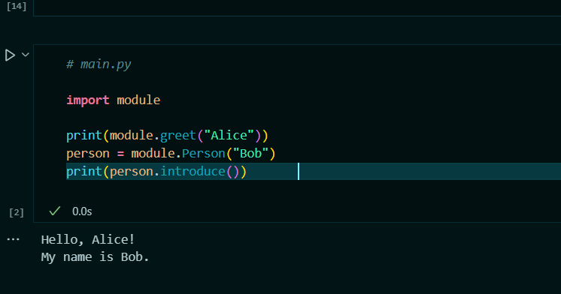

* **Packages:**

A package is a collection of modules organized in directories that provide a hierarchical structure. Packages allow you to organize modules into subdirectories, making it easier to manage large codebases.

Create a directory structure :

**mypackage/**

**__init__.py**

**module1.py**

**module2.py**

* Define functions , variables in these above modules.
* After that we can import those function from the modules of packages.

Ie. # main.py

from mypackage import module1, module2

print(module1.func1())

print(module2.func2())

12. What are lists and tuples? What is the key difference between the two?

Solution:

* Lists and tuples are two of the most commonly used data structures in Python. They are both used to store collections of items, but they have some key differences.
* **List:**

A list is a mutable, ordered collection of items. It can contain elements of different data types, and you can change, add, or remove items after the list is created.

- List is mutable (can be changed).

- Defined using square brackets [].

- More built-in methods available (e.g., append(), remove()).

- Slower than tuples due to mutability.

- Suitable for collections of items that can change.

Creating list : my_list = [1, 2, 3, "apple", [5, 6, 7]]

Eg.

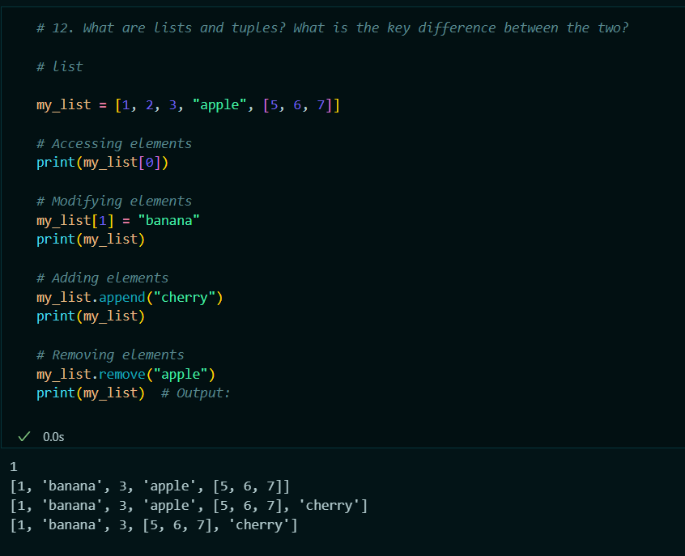

* **Tuple:**

A tuple is an immutable, ordered collection of items. Like lists, tuples can contain elements of different data types, but once a tuple is created, its elements cannot be changed, added, or removed.

-Tuple is Immutable (cannot be changed).

- Defined using parentheses ().

- Fewer built-in methods.

- Faster than lists due to immutability.

- Suitable for fixed collections of items that should not change

Creating Tuple: my_tuple = (1, 2, 3, "apple", (5, 6, 7))

Eg:

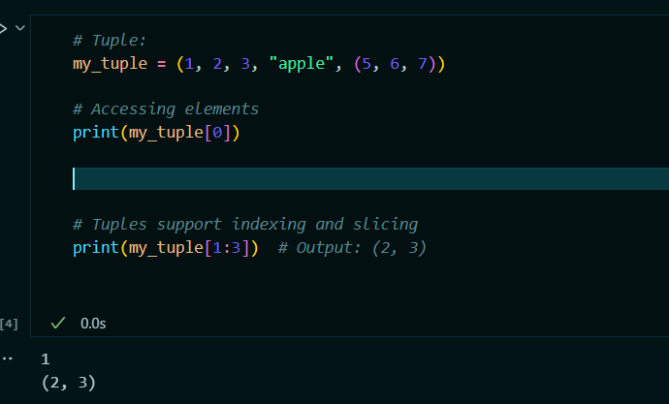

13. What is an Interpreted language & dynamically typed language?Write 5 differences between them

Solution:

* **Interpreted Language:**

An interpreted language is a type of programming language for which most of its implementations execute instructions directly and freely, without previously compiling a program into machine-language instructions. In an interpreted language, an interpreter runs through the program line by line and executes each command.

* Focus on how the code is executed (line by line via an interpreter).
* **Execution**: Code is executed line by line.
* **Flexibility**: Easier to debug and test during development.
* **Portability**: Typically more portable across different platforms since the interpreter handles platform-specific details.
* **Development Speed**: Faster to write and test since there's no need for a compilation step.
* **Performance**: Generally slower than compiled languages because the code is interpreted at runtime.
* **Examples**: Python, JavaScript, Ruby, PHP.
* **Dynamically typed language**:

A dynamically typed language is a language in which types are checked at runtime as opposed to compile-time. This means that you do not need to declare the type of a variable when you write the code. Instead, the type is associated with the value the variable holds at any given time.

* Focus on when type checking occurs (at runtime).
* **Type Checking**: Types are checked during runtime.
* **Variable Declaration**: No need to explicitly declare the data type of a variable.
* **Flexibility**: More flexible and easier to write generic code.
* **Error Detection**: Type-related errors are caught during execution.
* **Performance**: Can be slower due to the overhead of type checking during execution.
* **Examples**: Python, JavaScript, Ruby, PHP.

14. What are Dict and List comprehensions?

Solution:

* In Python, comprehensions provide a concise way to create dictionaries and lists. They offer a readable and efficient way to generate and transform collections.
* **List Comprehension:**

List comprehensions provide a compact way to create lists. They consist of brackets containing an expression followed by a for clause, and optionally more for or if clauses.

Syntax: [expression for item in iterable if condition]

* Practical eg:

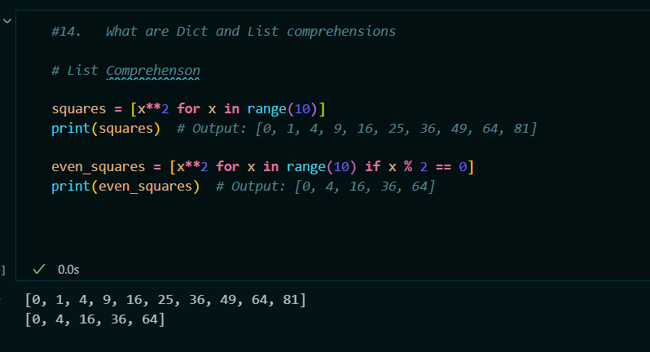

* **Dict Comprehension:**

Dictionary comprehensions provide a syntactically elegant way to create dictionaries. They follow a similar structure to list comprehensions but use curly braces {}.

* Syntax: {key_expression: value_expression for item in iterable if condition}
* Eg:

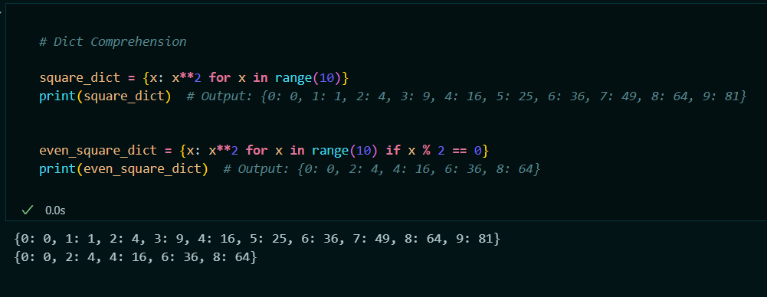

15. What are decorators in Python? Explain it with an example.Write down its use cases.

Solution:

* Decorators in Python are a powerful feature that allows you to modify or extend the behavior of functions or methods without changing their actual code.
* They are a type of higher-order function that takes another function as an argument and returns a new function that enhances or alters the original one.
* Decorators are commonly used for logging function calls and results.
* Decorators can check if a user has the necessary permissions before allowing access to a function.
* Decorators can be used to cache the results of expensive function calls to improve performance.
* Decorators can measure the execution time of a function.

Python.

* Syntax: A decorator is defined using the @decorator_name syntax above a function definition. It is essentially a function that wraps another function.
* Eg:

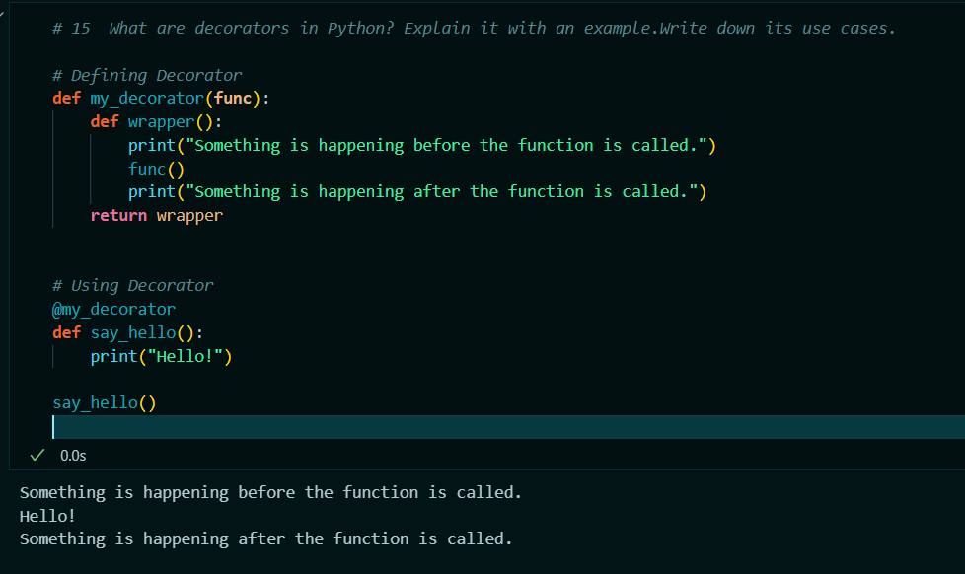

16. How is memory managed in Python?

Solution:

* Memory management in Python is a complex topic, as it involves several layers and mechanisms to handle allocation, garbage collection, and overall memory efficiency.
* **Memory Allocation:**

Object Management:

Dynamic Typing: Python's dynamic typing means that memory is allocated for objects as needed, and the type of object determines how memory is used.

Memory Pooling: Python uses an internal memory management system to allocate and deallocate memory efficiently.

Built-in Data Structures:

Python’s memory allocator handles small objects (like integers, strings, and lists) using a system called "pymalloc." For larger objects, Python uses the underlying system allocator.

* **Garbage Collector:**

Reference Counting:

Reference Counting: Python keeps track of the number of references to each object using a reference count. When an object’s reference count drops to zero, it is immediately deallocated.

* **Memory Management Details:**
* pymalloc: Python uses a specialized memory allocator for small objects, known as pymalloc, which improves performance by reducing the overhead of frequent memory allocations and deallocations.
* Custom Allocators: Python has custom allocators for different types of objects. For example, lists and dictionaries have their own allocation strategies that optimize performance for their specific use cases.

17. What is lambda in Python? Why is it used?

Solution:

* In Python, lambda is a keyword used to create small, anonymous functions at runtime.
* Unlike regular functions defined using the def keyword, lambda functions are typically used for short-lived operations and are often used in places where a function is needed temporarily.
* Lambda functions are often used for short, simple operations where defining a full function using def would be overkill.
* Lambda functions are useful when you need to pass a small function as an argument to another function, such as in higher-order functions like map(), filter(), and sorted().
* Lambda functions are a key component of functional programming in Python. They are used in conjunction with functions like map(), filter(), and reduce() to perform operations on collections.
* Syntax: lambda arguments: expression
* Practical eg:

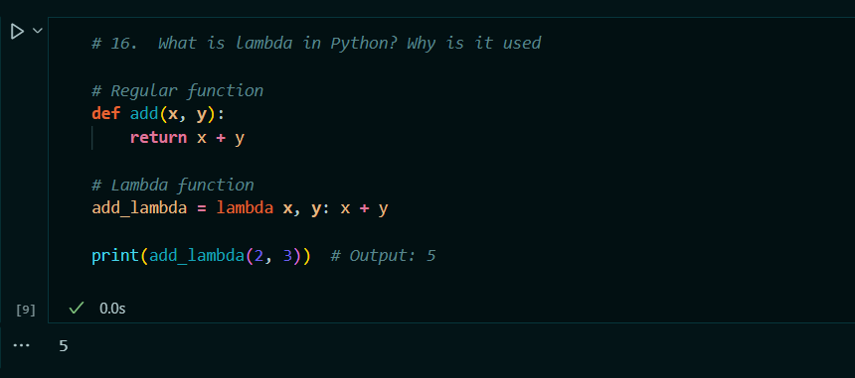

18. Explain split() and join() functions in Python.

Solution:

* In Python, split() and join() are string methods that are commonly used for manipulating and working with strings. They serve opposite purposes and are often used together to process and format strings.
* Split():

The split() method divides a string into a list of substrings based on a specified delimiter. By default, it splits the string at whitespace characters.

* Useful for breaking a string into components based on delimiters, such as parsing CSV data or processing input.
* Syntax: str.split([separator[, maxsplit]])
* Eg

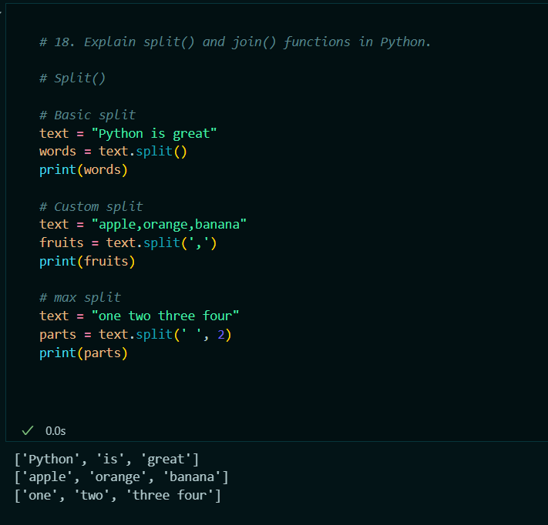

* **Join() Method:**

The join() method concatenates a list of strings into a single string, with a specified delimiter inserted between each element.

* Useful for combining elements of a list or tuple into a single string with a specified separator.
* Syntax: delimiter.join(iterable)
* Eg:

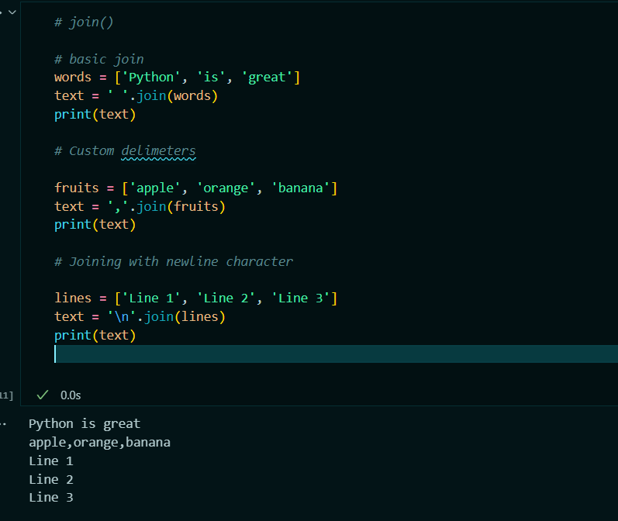

19. What are iterators , iterable & generators in Python?

Solution:

* In Python, iterators, iterables, and generators are fundamental concepts that are used for working with sequences of data.
* **Iterables:**

An iterable is any Python object that can return an iterator. It is an object capable of returning its members one at a time, allowing it to be looped over in a for loop or used in other contexts that require iteration.

* Implement __iter__() Method: An iterable implements the __iter__() method, which returns an iterator.
* **Eg** Lists, tuples, dictionaries, sets, and strings are examples of iterables.
* **Iterators:**

An iterator is an object that represents a stream of data. It provides methods to iterate through the elements in a collection. An iterator must implement two methods: __iter__() and __next__() (or next() in Python 2)

* implement __iter__() Method: Returns the iterator object itself.
* Returns the next item in the sequence. Raises StopIteration when there are no more items.
* Eg:
* 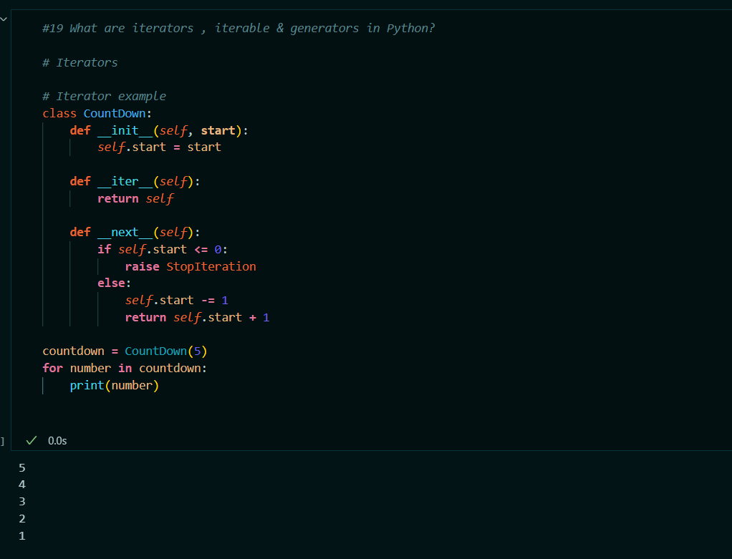
* **Generators:**

Generators are a special type of iterator created using functions with the yield keyword. They provide a convenient way to implement iterators without needing to define a class with __iter__() and __next__() methods.

* Functions that use yield instead of return to produce values.
* Generators automatically maintain their state between iterations.
* Eg:

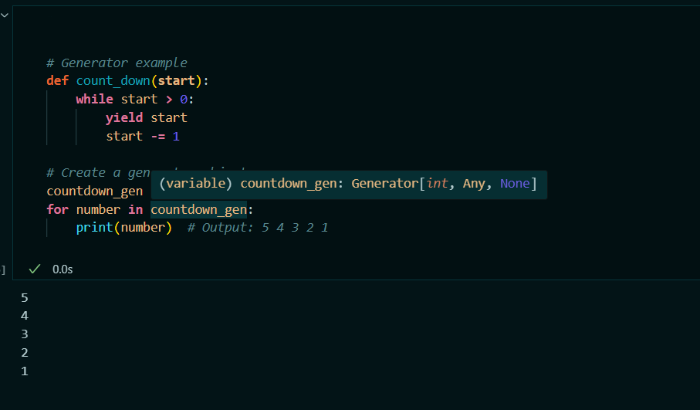

20. What is the difference between xrange and range in Python?

Solution:

* In Python, range and xrange are used to generate sequences of numbers, but they differ in terms of how they handle memory and performance.
* **Range:**

range returns a list of numbers.

Eg Python 2 example

numbers = range(1, 5)

print(numbers) # Output: [1, 2, 3, 4]

* In Python 3, range has been optimized and now behaves like xrange from Python 2.

Eg # Python 3 example

numbers = range(1, 5)

print(list(numbers)) # Output: [1, 2, 3, 4]

* **XRange:**
* xrange returns an xrange object that generates numbers on demand (lazy evaluation).
* Unlike range in Python 2, xrange does not create a list in memory but generates numbers as needed, making it more memory-efficient for large ranges.
* Eg # Python 2 example

numbers = xrange(1, 5)

print(list(numbers)) # Output: [1, 2, 3, 4]

21. Pillars of Oops.

Solution:

* In Python The main pillars of OOP are four fundamental concepts that guide the design and organization of code.
* **Encapsuation:**

Encapsulation is the concept of wrapping data (attributes) and methods (functions) into a single unit called a class. It hides the internal state of an object and only exposes a controlled interface to the outside world.

* Protects the internal state of an object from unintended or unauthorized access.
* Use access specifiers (e.g., public, protected, private) to control the visibility of class members.
* Eg. :

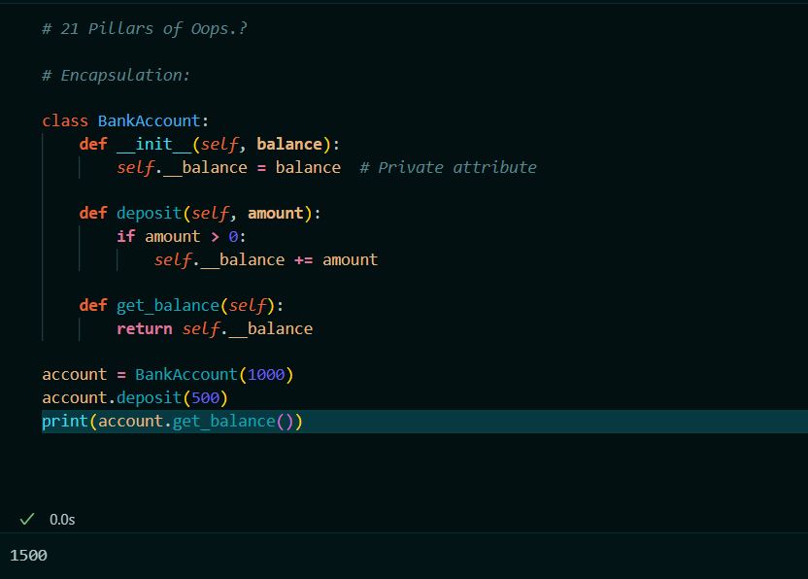

* **Abstraction:**

Abstraction is the concept of simplifying complex systems by modeling classes based on essential characteristics and ignoring irrelevant details. It focuses on what an object does rather than how it does it.

* Define abstract classes with abstract methods that must be implemented by subclasses.
* Use abstract classes to provide a common interface for different implementations.
* Eg :

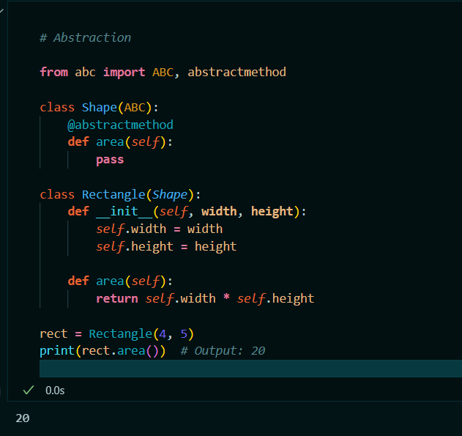

* **Inheritance:**

Inheritance is the mechanism by which one class (the child or subclass) can inherit attributes and methods from another class (the parent or superclass). It allows for code reuse and the creation of a hierarchical relationship between classes.

* A subclass inherits from a single superclass.
* A subclass can inherit from multiple superclasses (Python supports this).
* A subclass can override methods of its superclass to provide specific behavior.
* Eg.:

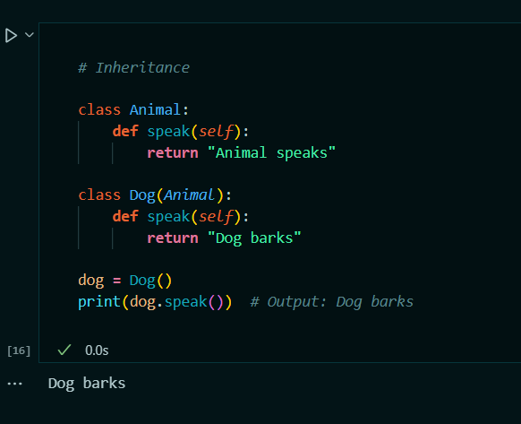

* **Polymorphism:**

Polymorphism is the concept that allows objects of different classes to be treated as objects of a common superclass. It provides a way to perform a single action in different forms.

* Multiple methods with the same name but different parameters (not natively supported in Python, but can be simulated).
* Subclasses provide specific implementations of methods defined in the superclass.
* In Python, polymorphism is often achieved through duck typing, where the type or class of an object is determined by its behavior (methods and properties) rather than its explicit class.
* Eg:
* 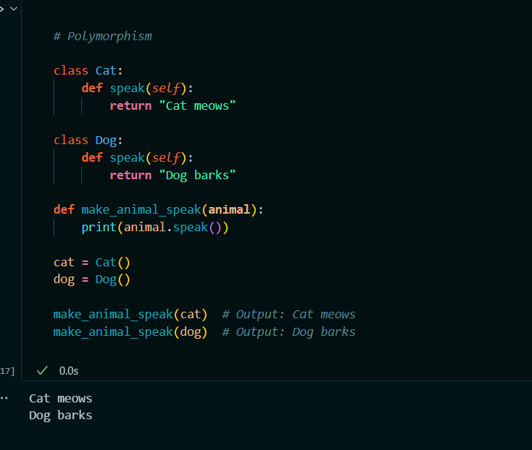

22.How will you check if a class is a child of another class?

Solution:

* **1. Using ‘issubclass()’ Function:**

The issubclass() function checks if a class is a subclass of another class. It returns True if the first class is a subclass of the second class (or the second class itself).

The most direct way to check if one class is a subclass of another.

Syntax: issubclass(subclass, superclass)

* **2. Using ‘__bases__’ Attribute:**

The __bases__ attribute of a class provides a tuple of base classes (i.e., parent classes). You can check if a class is a subclass of another by examining its __bases__ attribute.

Inspect the base classes directly, useful for introspection.

Eg:

class Parent:

pass

class Child(Parent):

pass

print(Parent in Child.__bases__) # Output: True

print(Child in Parent.__bases__) # Output: False

* **3. Using ‘isinstance()’ Function:**

While isinstance() is typically used to check if an instance is of a specific class or a subclass, you can use it to check the relationship between classes by creating an instance of the child class.

Useful for checking if an instance belongs to a class or its subclasses, indirectly verifying class relationships.

* Eg:

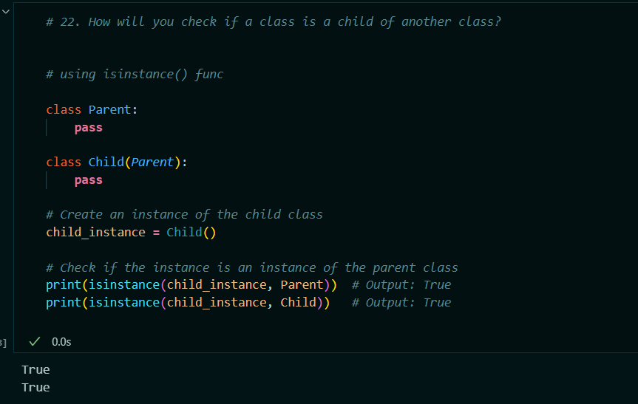

23. How does inheritance work in python? Explain all types of inheritance with an example?

Solution:

* Inheritance is a fundamental concept in object-oriented programming (OOP) that allows one class (the subclass or derived class) to inherit attributes and methods from another class (the superclass or base class). This mechanism promotes code reuse and creates a natural hierarchy between classes.
* In Python, inheritance is achieved by defining a new class that derives from an existing class. The new class inherits all attributes and methods from the existing class and can also define additional attributes and methods or override existing ones.
* Syntax:

class Superclass:

# Superclass attributes and methods

class Subclass(Superclass):

# Subclass attributes and methods

* Types of inheritance:
* **Single Inheritance:**
* Single inheritance occurs when a class (child class) inherits from only one base class (parent class).
* Eg :

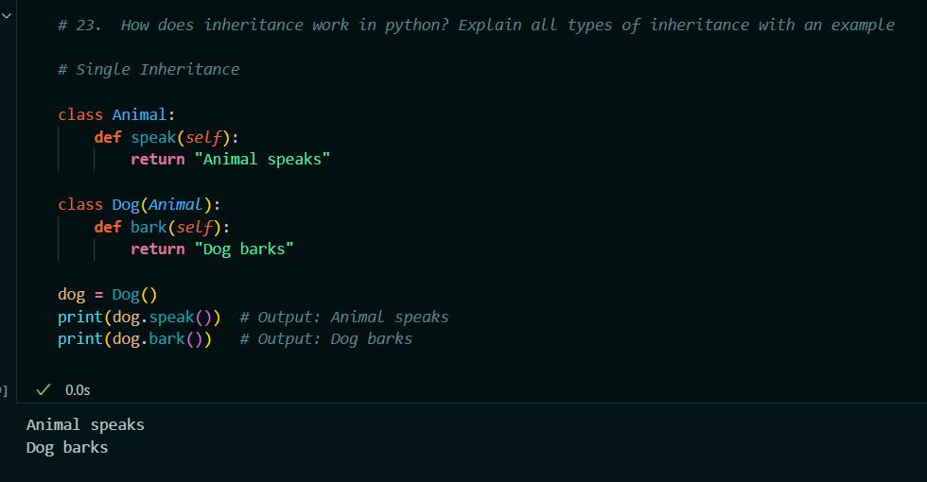

* **Multiple Inheritance:**
* Multiple inheritance occurs when a class (child class) inherits from more than one base class. This allows a class to combine features from multiple classes.
* Eg:

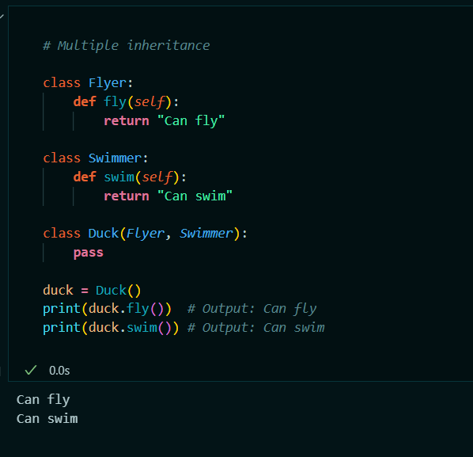

* **Multilevel Inheritance:**
* Multilevel inheritance involves a chain of inheritance where a class inherits from another class, which in turn inherits from another class, and so on.
* Eg :

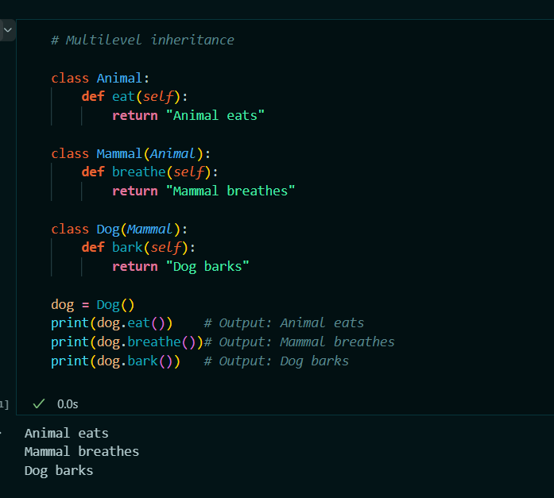

* **Hierarchical Inheritance:**
* Hierarchical inheritance occurs when multiple classes inherit from a single base class. Each subclass has its own implementation but shares common functionality from the base class.
* Eg :

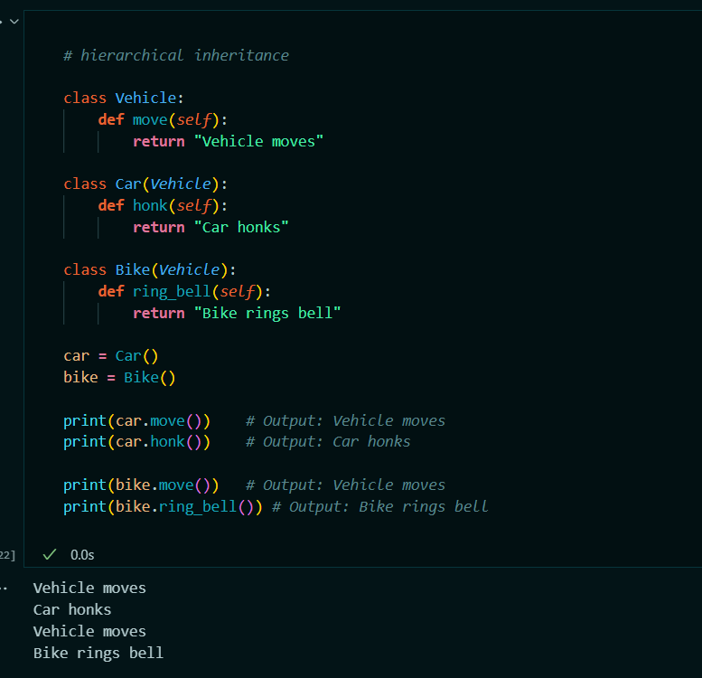

* **Hybrid Inheritance:**
* Hybrid inheritance is a combination of two or more types of inheritance. It may involve multiple and hierarchical inheritance, leading to more complex class relationships.
* Eg:

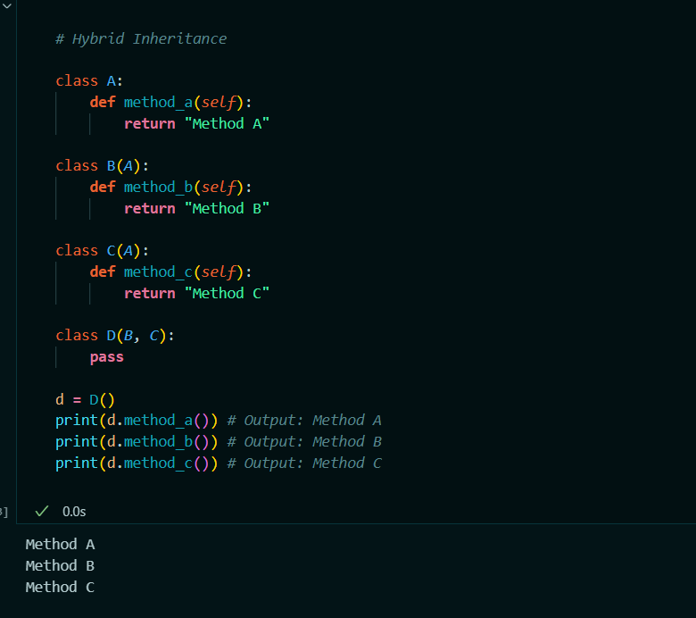

**24.** What is encapsulation? Explain it with an example.

**Solution:**

* Encapsulation is a fundamental concept in OOP that involves bundling the data and the methods) that operate on the data into a single unit called a class.
* It also refers to restricting direct access to some of an object's components, which is achieved through access modifiers.
* This allows for the internal state of an object to be hidden from the outside world and only accessible through a controlled interface.
* Encapsulation helps in hiding the internal state of an object from the outside world. This is achieved using private or protected attributes.
* Public methods (getters and setters) are provided to access and modify the private attributes, thus controlling how the data is accessed and changed.
* Encapsulation makes the class a modular unit, which means that changes to the internal implementation can be made without affecting the external code that uses the class.
* Eg:

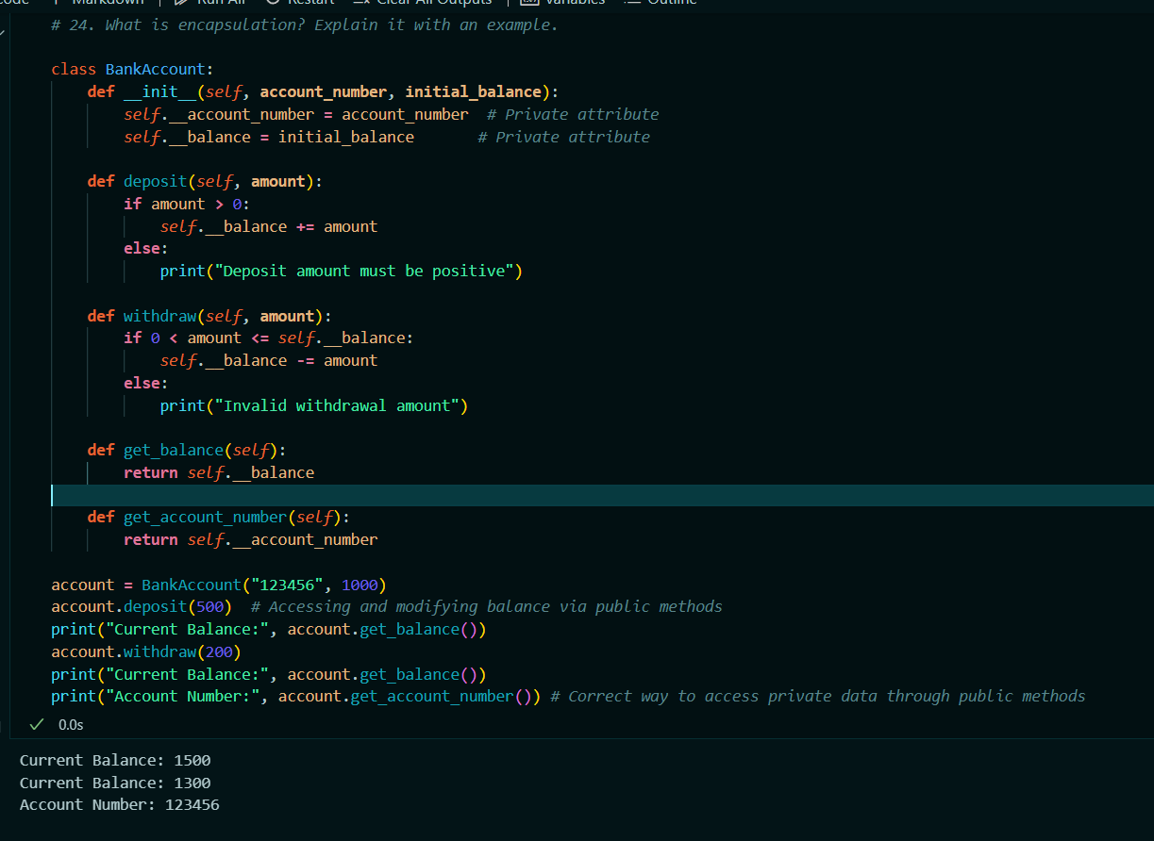

**25.** What is polymorphism?  Explain it with an example

Solution:

* Polymorphism is a key concept in object-oriented programming (OOP) that allows objects of different classes to be treated as objects of a common superclass.
* It provides a way to perform a single action in different forms.
* Polymorphism enables methods to do different things based on the object it is acting upon, even though the method name remains the same.
* Key Aspects of polymorphism:
* **Method Overriding:** Subclasses can provide specific implementations of methods that are already defined in their superclass. This allows the subclass to alter or extend the behavior of the inherited method.
* **Method Overloading:** Although not natively supported in Python, method overloading refers to defining multiple methods with the same name but different parameters. Python does not support method overloading directly but achieves similar behavior through default arguments or variable-length argument lists.
* **Duck Typing:** Python uses a concept called "duck typing," where the type or class of an object is determined by its behavior (methods and properties) rather than its explicit class. If an object behaves like a certain type, it is treated as that type.
* **Eg:**

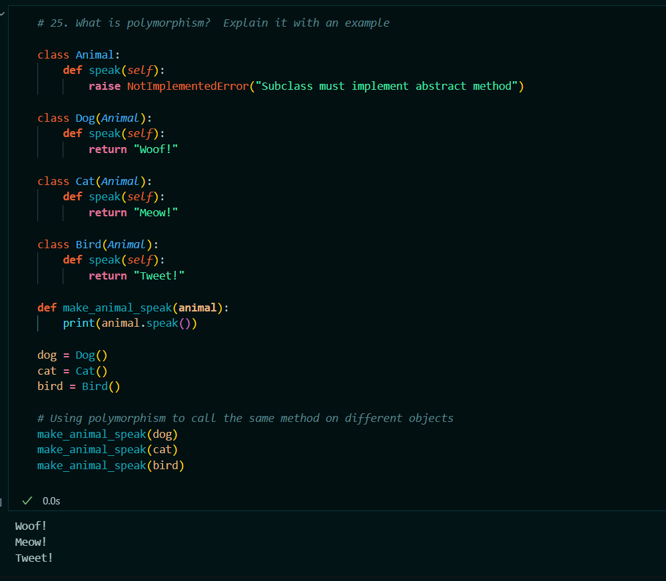

**Question 1. 2. Which of the following identifier names are invalid and why?**

a) Serial_no.

b) 1st_Room

c) Hundred$

d) Total_Marks

e) total-Marks

f) Total Marks

g) True

h) _Percentag

Solution:

* According to python’s rules of indentifires following identifires names are invalid:
* **b) 1st_Room :** This identifier name is invalid Because, it begins with digit and identifier cannot start with digit.
* **e) total-Marks :** Its is also invalid identifier because, Contains a space, which is not allowed in identifier names.
* **f) Total Marks :** ThisContains a space, which is not allowed in identifier names. So , it is also an invalid indentifire.
* **g) True :** This is invalid in python. Because it is reserved keyword in python.

**Question 1.3. name = ["Mohan", "dash", "karam", "chandra","gandhi","Bapu"] do the following operations in this list;**

1. add an element "freedom_fighter" in this list at the 0th index.

Solution:

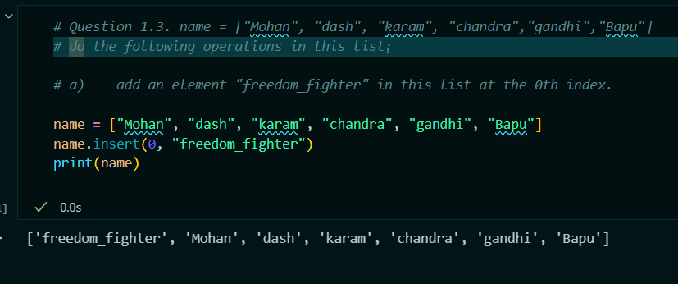

1. find the output of the following ,and explain how?

**name = [“freedomFighter”,"Bapuji","MOhan" "dash", "karam", "chandra","gandhi"] length1=len((name[-len(name)+1:-1:2]))**

**length2=len((name[-len(name)+1:-1]))**

**print(length1+length2)**

Solution:

* **Calculate length1 :**

- length1=len((name[-len(name)+1:-1:2]))

- len(name)+1 is -6+1 which is -5 and -1 is the second index.

- 2 is the step.

- i.e: **name[-5:-1:2]**

- This means we are slicing the list starting from the second element (index -5) up to the second-to-last element (index -1) with a step of 2.

- So it will be:

**name** = ["freedomFighter", "Bapuji", "MOhandash", "karam", "chandra", "gandhi"]

**sliced_list** = ["Bapuji", "karam"]

So length of this list = 2.

i.e: **length1 = 2**

* **Calculate length2:**
* length2 = len(name[-len(name)+1:-1])
* -len(name)+1 is -6+1 which is -5 and -1 is the second index.
* name[-5:-1]
* This means we are slicing the list starting from the second element (index -5) up to the second-to-last element (index -1).
* So it will be:

**name** = ["freedomFighter", "Bapuji", "MOhandash", "karam", "chandra", "gandhi"]

**sliced_list** = ["Bapuji", "MOhandash", "karam", "chandra"]

So the length of this list is 4

i.e: **length2 = 4**

* **Calculating Final Output:**

print(length1 + length2) -----> 6

Lets verify with practical eg:

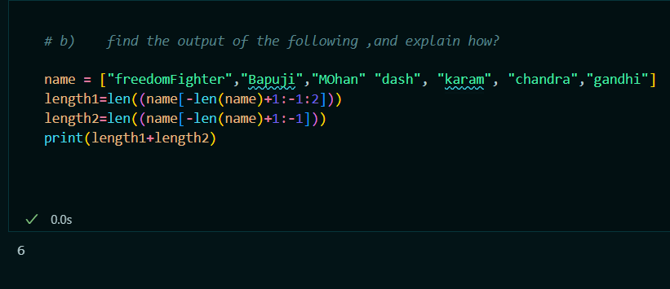

1. Add two more elements in the name ["NetaJi","Bose"] at the end of the list.

Solution:

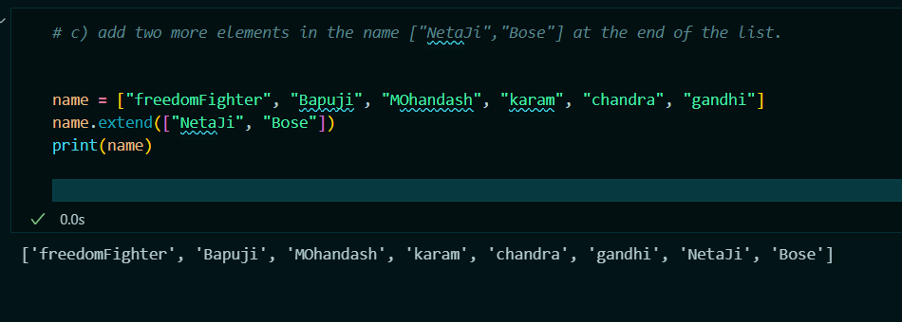

1. what will be the value of temp:

name = ["Bapuji", "dash", "karam", "chandra","gandi","Mohan"]

temp=name[-1]

name[-1]=name[0]

name[0]=temp

print(name)

Solution:

* Assign temp=name[-1] i.e. temp = “**Mohan**”
* Assign name[-1]=name[0] , Here name[0] = “Bapuji” . So i.e name[-1] = “Bapuji”

So our list will be name = ["Bapuji", "dash", "karam", "chandra", "gandi", "**Bapuji**"]

* Now Assign name[0]=temp i.e. As temp = “Mohan”. So name[0] = “Mohan”

So updated list will be name = ["**Mohan**", "dash", "karam", "chandra", "gandi", "Bapuji"]

* Here we have just replace the “**Mohan**” with “Bapuji” and “**Bapuji**” with “Mohan”
* And the value of temp = “**Mohan**”
* Lets Verify:

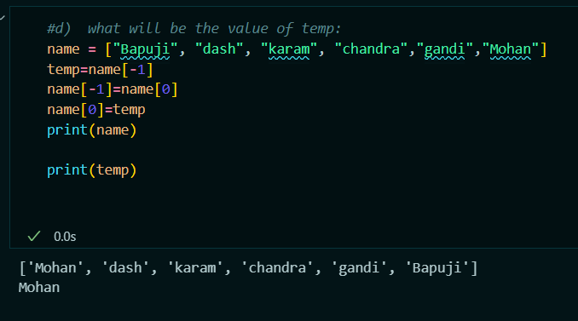

**Question 1.4.Find the output of the following.**

animal = ['Human','cat','mat','cat','rat','Human', 'Lion']

print(animal.count('Human'))

print(animal.index('rat'))

print(len(animal))

Solution:

Here the output will be : 2

4

7

Lets verify:

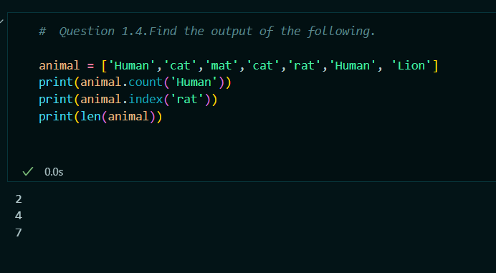

**Question 1.5. tuple1=(10,20,"Apple",3.4,'a',["master","ji"],("sita","geeta",22),[{"roll_no":1}, {"name":"Navneet"}])**

a)print(len(tuple1))

b)print(tuple1[-1][-1]["name"])

c)fetch the value of roll_no from this tuple.

d)print(tuple1[-3][1])

e)fetch the element "22" from this tuple.

Solution:

**a)print(len(tuple1))**

-> 8

**b)print(tuple1[-1][-1]["name"])**

-> Navneet

**c)fetch the value of roll_no from this tuple.**

-> tuple1[-1][0][" roll_no "]

**d)print(tuple1[-3][1])**

-> ji

**e)fetch the element "22" from this tuple.**

-> tuple1[-2][-1]

**Q 20. What do you mean by Measure of Central Tendency and Measures of Dispersion .How it can be calculated.**

**Solution:**

* **Measures of Central Tendency** and **Measures of Dispersion** are fundamental concepts in statistics used to describe and summarize data.
* **Measures of Central Tendency:**
* Measures of central tendency are statistical metrics that describe the center or typical value of a dataset. The most common ways to measure the central tendency are mean, median, mode.
* ***Mean***: Mean is used to get a arithmetic average value of the dataset.
* It doesn’t work on categorical data.
* It is denoted by Mu (μ).
* Sum of all values divided by number of values.

Formulae : Mean = Summation(xi)/n

* ***Median***: Median helps us to get the middle value of dataset. The dataset should be numerical.
* The dataset should be in order, So that we can get the middle value.
* If the data is not already sorted we have to sort it, then we can get median value.
* It is easy to get the middle value dataset. Which dataset counts (quantity of data) is odd.

Eg: dataset = 2,5,7,8,10. Median = 7

* But in even count dataset, we have to calculate the mean or avg of 2 most middle data element.

Eg : dataset = 3,5,6,8,9,11. Median = mean(6,8) or avg(6,8)

= (6+8)/2

= 14/2

Median = 7

* ***Mode***:The most frequently occurring value in a dataset.
* The value that appears most frequently. A dataset can have one mode, more than one mode, or no mode at all.
* **Measures of Dispersion:**
* Measure of dispersion describe the spread or variability of the dataset.
* The most common ways to measure the dispersion of data are:
* Range, Variance, Standard Deviation, Interquartile range (IQR).
* ***Range***: Range helps us to get the difference between maximum and minimum values.
* Formulae : Range = Maximum value - Minimum value
* ***Variance:***
* The average of the squared differences from the mean.
* Variance is also denoted by sigma square(σ^2)
* Formulae : σ^2= (Summation(xi - μ))^2/n

where xi ​ are the data values, μ is the mean, and n is the number of values.

* ***Standard Deviation:***
* The square root of the variance.
* Standard Deviation is denoted by sigma(σ).
* Formulae: σ = squareRoot(σ^2)​***.***
* ***Interquartile Range (IQR)***:
* The difference between the first quartile (*Q*1) and the third quartile (*Q*3).
* It is denoted by IQR.
* To calculate the IQR first we have to arrage the data into ascending order.
* Here *Q*1 = The median of the first half of the data

*Q*2 = The median of the second half of the data.

* Formulae: IQR = *Q*3 – *Q*1
* Practical Calculation:

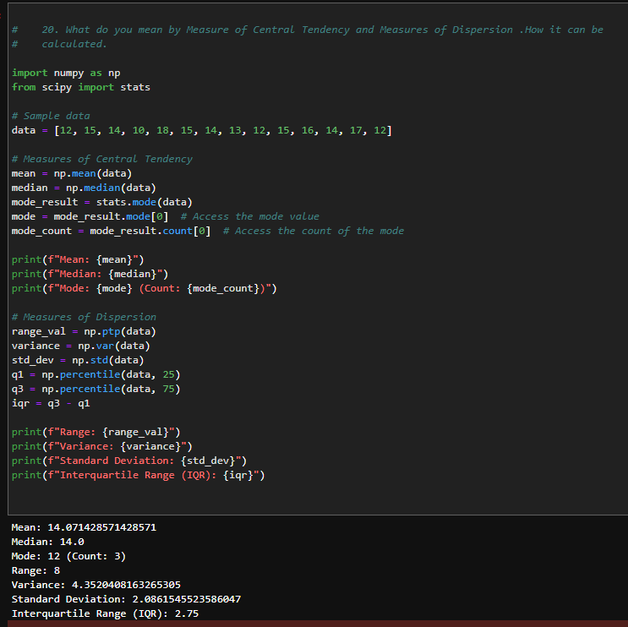

**Q21. What do you mean by skewness.Explain its types.Use graph to show.**

* **Skewness** is a measure of the asymmetry or lopsidedness of a probability distribution or dataset around its mean.
* It indicates whether the data are skewed to the right (positively skewed) or to the left (negatively skewed) of the mean.
* The skewness can be visible in histogram.
* There are three types of the skewness:

1. Positive Skewness.
2. Negative Skewness.
3. Zero Skewness.

* **Positive Skewness:**
* In Positive Skewness the distribution has long tail on right side**.**
* Most of the data values are concentrated on the left side of the distribution.
* The mean is typically greater than the median.
* Example: Income distribution in many countries (a few very high incomes skew the mean to the right).
* **Negative Skewness:**
* The distribution has a long tail on the left side.
* Most of the data values are concentrated on the right side of the distribution.
* he mean is typically less than the median.
* Example: age at retirement
* **Zero Skewness:**
* The distribution is symmetrical.
* he mean and median are approximately equal.
* Example: A normal distribution.
* Practical eg:

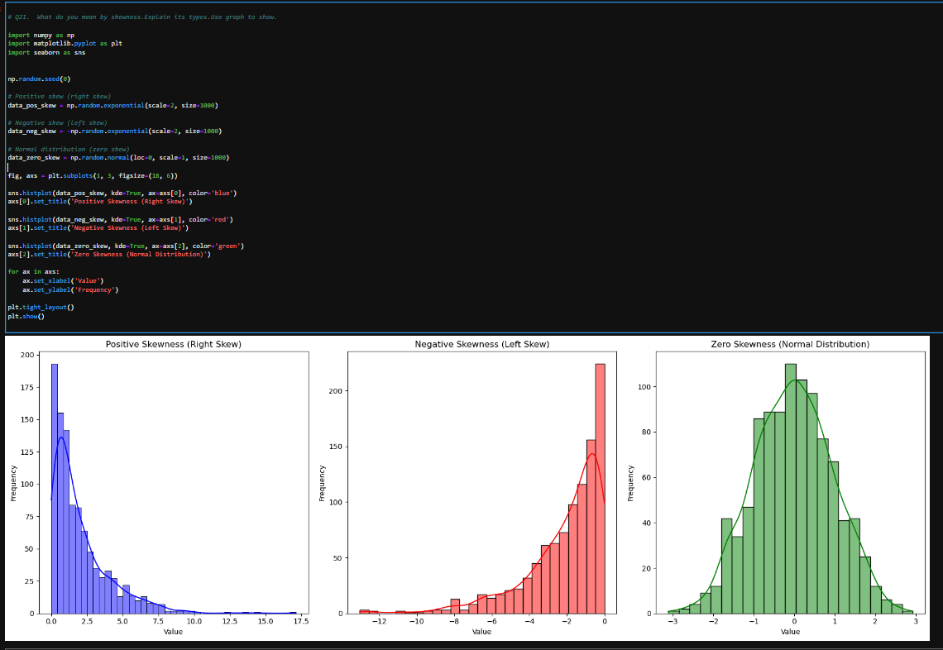

**Q22. Explain PROBABILITY MASS FUNCTION (PMF) and PROBABILITY DENSITY FUNCTION (PDF). and what is the difference between them?**

**Solution:**

* **Probability Mass Function (PMF)** and **Probability Density Function (PDF)** are fundamental concepts in probability theory and statistics.
* Used to describe the distribution of random variables.
* They are used for different types of random variables: discrete and continuous, respectively.
* **Probability Mass Function (PMF):**
* The **Probability Mass Function (PMF)** is used for discrete random variables.
* It gives the probability that a discrete random variable is exactly equal to a specific value.
* For a discrete random variable X with possible values *x1,x2,x3*,…**,** the PMF is defined as:

*P(X = xi) = p(xi)*

* where p(xi) is the probability that the random variable X takes the value xi​.
* *Properties :* Non-negativity (*p(xi)>= 0* for all *xi*) and Normalization (The sum of the probabilities of all possible values equals 1)
* *Usecases:*
* Used for discrete random variables.
* Directly gives the probability of the random variable taking a specific value.
* The values of the PMF are probabilities and hence lie between 0 and 1.
* Probabilities are summed over discrete values.
* **Probability Density Function (PDF):**
* The **Probability Density Function (PDF)** is used for continuous random variables.
* It describes the likelihood of a continuous random variable falling within a particular range of values.
* For a continuous random variable *X* with a PDF *f(x)* the probability that *X* falls within the interval [*a,b*] is given by the integral of *f(x)* over that interval:

*P(a≤X≤b)* = *ab​f(x)dx*

* *Properties:* Non-negativity: *f(x)≥0* for all *x*. and Normalization (The total area under the PDF curve equals 1)
* *Usecases:*
* Used for continuous random variables.
* Provides the density of probability, not the probability directly. To find the probability of a range, integrate the PDF over that range.
* The values of the PDF can be greater than 1 but the integral over the entire range must equal 1.
* Probabilities are obtained by integrating the density function over intervals.
* **Practical eg:**

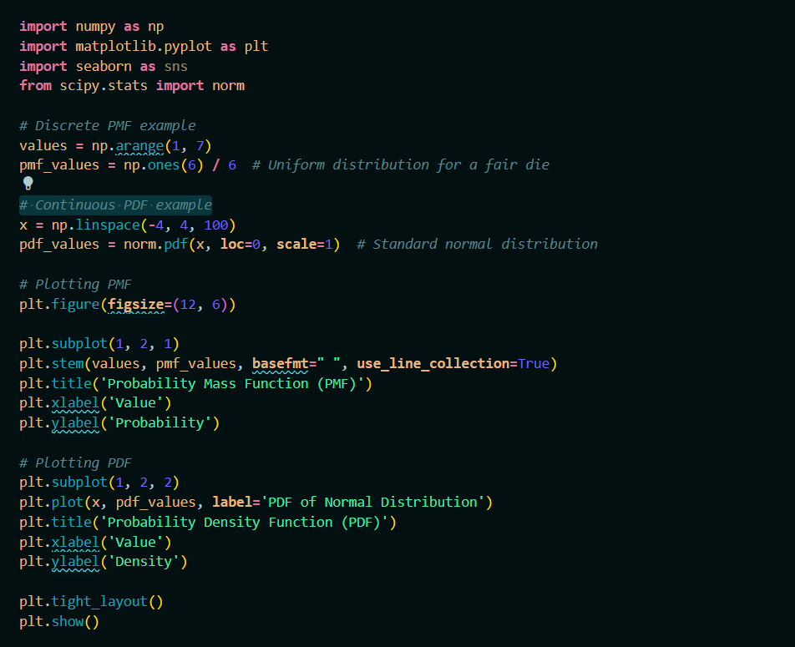

Output:

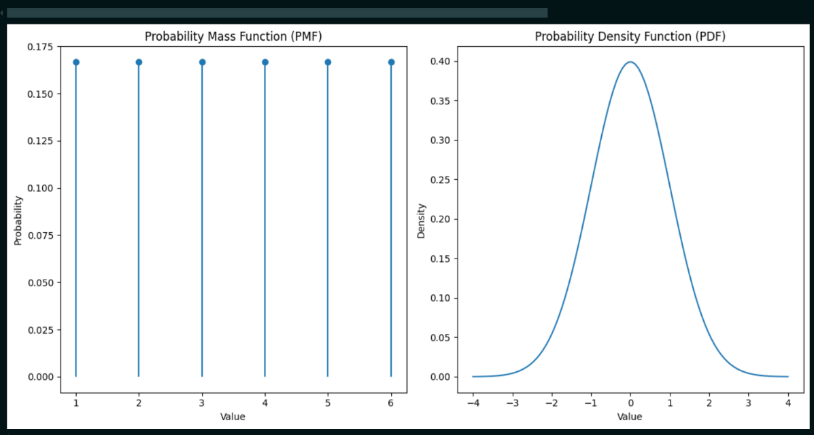

**Q23. What is correlation. Explain its type in details. what are the  methods of determining correlation.**

**Solution:**

* **Correlation** is a statistical measure that describes the strength and direction of a relationship between two or more variables.
* It helps to understand how changes in one variable are associated with changes in another.
* **Types of Correlation**:
* *Positive Correlation*:

When two variables move in the same direction. As one variable increases, the other variable also increases, and vice versa.

* Ex : Height and weight; generally, as height increases, weight tends to increase as well.
* Coefficient of correlation ranges from 0 to +1
* *Negative Correlation:*
* When two variables move in opposite directions. As one variable increases, the other variable decreases, and vice versa.
* Ex: Temperature and heating bills; as temperature increases, heating bills tend to decrease.
* Coefficient of correlation ranges from 0 to -1.
* *No Correlation:*
* When there is no discernible relationship between the two variables.
* Ex: Shoe size and intelligence; generally, there is no meaningful relationship between these variables.
* Coefficient of correlation close to 0.
* There are different types of methods to determine the correlation:
* **Pearson Correlation Coefficient**:
* Measures the linear relationship between two continuous variables.
* Formulae*: r = (summation(Xi- Xˉ)(Yi-Yˉ)) / Squareroot(summation(Xi- Xˉ)^2)*(summation (Yi-Yˉ)^2)*
* where *r* is the correlation coefficient, *Xi* and *Yi*​ are the variables, and *Xˉ* and *Yˉ* are their means.
* **Range**: -1 to +1.
* Interpretation:

*r>0r > 0r>0*: Positive correlation

*r<0r < 0r<0*: Negative correlation

*r=0r = 0r=0:* No correlation

* Practical Eg:

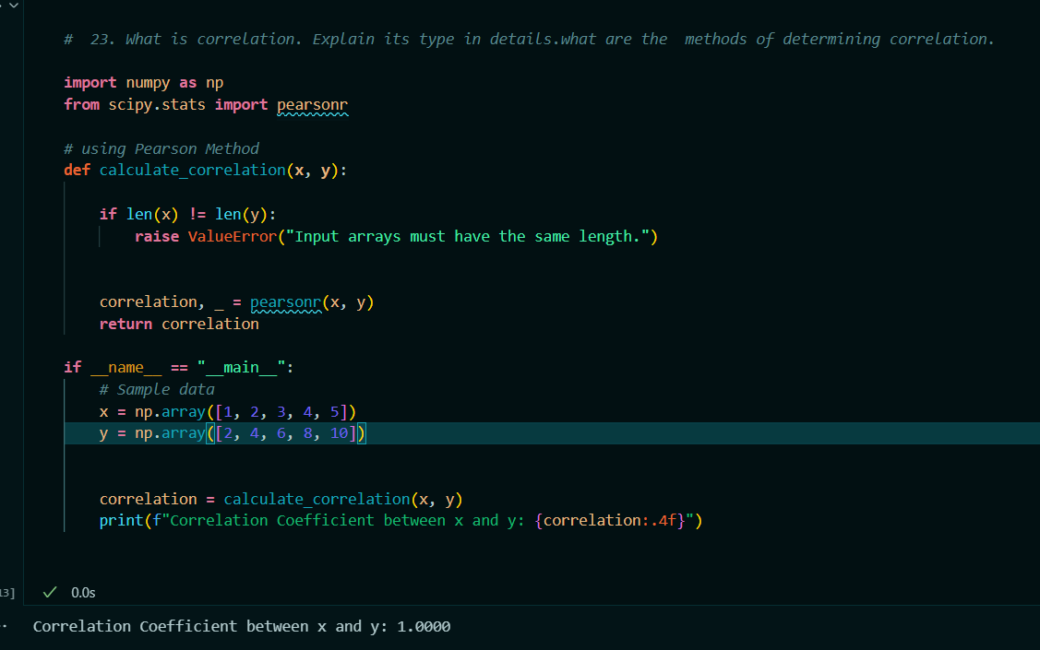

**Q 24. Calculate coefficient of correlation between the marks obtained by 10 students in Accountancy and statistics:**

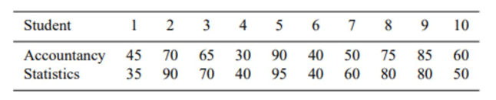

Use Karl Pearson’s Coefficient of Correlation Method to find it.

Solution:

* The Formulae for Pearson Correlation Coefficient r is:

*r* = *n*(summation(*xy*) - (summation(*x*))(summation(*y*)) /

sqr_root([*n(*summation(x^2-(summation(x))^2 ))] *

[*n(*summation(y^2-(summation(y))^2 ))])

* Practical eg:

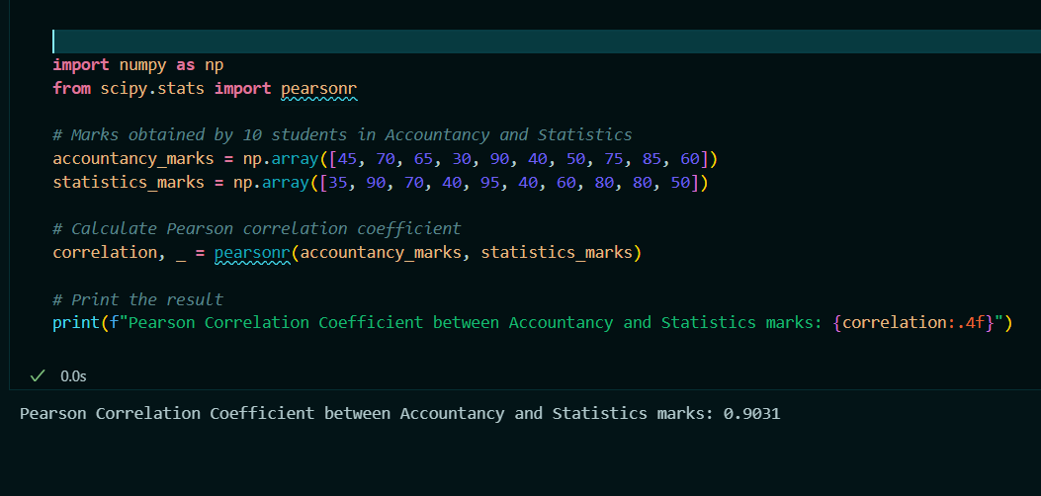

**Q 25. Discuss the 4  differences between correlation and regression.**

**Solution:**

* Correlation and regression are both statistical methods used to examine relationships between variables, but they have different purposes, assumptions, and interpretations.
* *Correlation:*
* purpose
* The purpose of correlation is to measure the strength and direction of the linear relationship between two variables.
* And it provides a single value (correlation coefficient) that quantifies the degree of association between the variables.
* Correlation is always symmetric, The correlation between *X* and *Y*  is same as the between the *Y* and *X.*
* Interpretation:

Coefficient Value: The correlation coefficient (r) ranges from -1 to +1.

r=+1r = +1r=+1: Perfect positive linear relationship.

r=−1r = -1r=−1: Perfect negative linear relationship.

r=0r = 0r=0: No linear relationship.

* Strength and Direction: Only indicates the strength and direction of the linear relationship but does not imply causation.
* Use-cases:
* It should be use when the goal is to determine and quantify the strength and direction of a linear relationship between two variables without making predictions.
* And it requires paired data for two variables.
* Calculation:
* Calculated using the correlation coefficient formula, such as Pearson's correlation.

*r* = *n*(summation(*xy*) - (summation(*x*))(summation(*y*)) /

sqr_root([*n(*summation(x^2-(summation(x))^2 ))] *

[*n(*summation(y^2-(summation(y))^2 ))])

* *Regression:*
* Purpose:
* The purpose of regression is to model the relationship between a dependent variable (response) and one or more independent variables (predictors).
* And it provides an equation that describes how the dependent variable changes as the independent variables change.
* Regression is Asymmetric.
* Interpretation:

Regression Coefficients: The coefficients in the regression equation (slope and intercept) provide specific information about the relationship.

Slope: Indicates the change in the dependent variable for a one-unit change in the independent variable.

Intercept: The value of the dependent variable when the independent variable is zero.

* Prediction and Causation: Can be used for prediction and, under certain conditions, can imply causation.
* Use_case:
* It should be use when the goal is to model the relationship between variables, make predictions, and understand the impact of one variable on another.
* And it requires one dependent variable and one or more independent variables.
* Calculation:
* Uses the simple linear regression equation.

*Y=*β*0​+*β*1​X+ϵ*

where *Y* is the dependent variable, *X* is the independent variable, β*0* is the intercept, β*1*​ is the slope, and *ϵ* is the error term.

finding the best-fit line (regression line) that minimizes the sum of squared residuals (differences between observed and predicted values)

**Q26. Find the most likely price at Delhi corresponding to the price of Rs. 70 at Agra from the following data: Coefficient of correlation between the prices of the two places +0.8.**

**Solution:**

* Given:

Coefficient of correlation (*r*) = +0.8

Price at Agra ( *X*) = 70

* We require mean and standard deviation of the prices at both places. Let's assume the following:

Mean price at Agra ( *Xˉ*) = 60

Mean price at Delhi ( *Yˉ*) = 65

Standard deviation of prices at Agra ( *σX* ​) = 10

Standard deviation of prices at Delhi ( *σY*)= 12

* Using the linear regression equation of *Y* on *X*:

*Y*=β0 + β1*X*

Where

β1​ (slope) is given by: β1=r(σY/σX)​​

β0​ (intercept) is given by: β0=Yˉ−β1Xˉ

* Let's calculate the slope (β1​):

β1=0.8(12/10)=0.96

calculate the intercept (β0​):

β0​=65−(0.96×60) =65−57.6 =7.4

* Now use the Regression equation to find the most likely price at delhi (*Y*) when the price at agra (*X*) is rs. 70.

Y=7.4+0.96×70

Y=7.4+67.2

Y =74.6

* Therefore, the most likely price at Delhi corresponding to the price of Rs. 70 at Agra is Rs. 74.6.

**Q27. In a partially destroyed laboratory record of an analysis of correlation data, the following results only are legible: Variance of x = 9, Regression equations are: (i) 8x−10y = −66; (ii) 40x − 18y = 214. What are (a) the mean values of x and y, (b) the coefficient of correlation between x and y, (c) the σ of y.**

**Solution:**

* **Given Data:**

Variance of x = 9

Regression Equations:

* + 1. 8x - 10y = -66
    2. 40x - 18y = 214
* *a) Mean Values of x and y:*

Solving the regression equations simultaneously:

1. 8x - 10y = -66
2. 20x - 9y = 107 (Dividing the second equation by 2)

* Multiply the first equation by 2.5:

20x - 25y = -165

* Subtract:

16y = 272 y = 17

* Substitute y = 17 into 8x - 10y = -66:

8x - 170 = -66

8x = 104

x = 13

* Mean values:

xˉ=13

yˉ=17

* *(b) Coefficient of Correlation (r):*

Regression coefficients:

b base(yx) =0.8 (from y = 0.8x + 6.6)

b base (xy) =0.45 (from x = 0.45y + 5.35)

* Calculate r:

r^2=b base(yx) * b base(xy)

r^2= 0.8×0.45

r^2=0.36

r=sqrt(0.36)

r=0.6

* *(c) Standard Deviation of y (σ base(y) ​):*

Given variance of x:

*σ*^x 2 = 9

*σ*x=3

* Using b base(yx) = r (*σ base(*y)/*σ base(*x)) ​​:

0.8=0.6(*σ base(*y)/3)

*σ base(*y) ​= 0.8×3/0.6

*σ base(*y) = 4

- **Summary:**

(a) Mean values: xˉ=13, yˉ=17

(b) Coefficient of correlation: r=0.6

(c) Standard deviation of y: *σ* base(y) =4

**Q28. What is  Normal Distribution? What are the four Assumptions of Normal Distribution? Explain in detail.**

**Solution:**

* The normal distribution, also known as the Gaussian distribution, is a continuous probability distribution characterized by its bell-shaped curve.
* This distribution is symmetric around its mean, indicating that data near the mean are more frequent in occurrence than data far from the mean.
* The normal distribution is defined by two parameters: the mean (μ) and the standard deviation (σ).
* The normal distribution is perfectly symmetric about the mean.
* The highest point of the curve is at the mean, and the curve decreases as you move away from the mean.
* For a normal distribution, mean, median, mode, these three measures of central tendency are equal.
* As tails of the normal distribution curve approach, but never touch, the horizontal axis.

So it is Asymptotic.

* Approximately 68% of the data falls within one standard deviation of the mean, 95% within two standard deviations, and 99.7% within three standard deviations.
* There are 4 Assumption for Normal Distribution:
* 1. Independence:

**Assumption**: The observations are independent of each other.

**Explanation**: Each data point is collected independently, ensuring that the occurrence of one event does not affect the occurrence of another. For example, in a survey, responses from one participant should not influence the responses from another participant.

**Importance**: Ensures that the sample accurately reflects the population and that results are not biased by interdependencies.

**Violation Consequences**: If violated, statistical tests may yield inaccurate results, leading to erroneous conclusions. For example, if survey responses are influenced by a common factor, such as participants discussing answers, the data collected would not be truly independent.

* **2**. Normality:

**Assumption**: The data follows a normal distribution.

**Explanation**: The distribution of the data points should resemble the bell-shaped curve of the normal distribution. This can be checked using graphical methods such as Q-Q plots or statistical tests such as the Shapiro-Wilk test.

**Importance**: Many statistical tests rely on the assumption of normality to provide valid results.

**Violation Consequences**: If data significantly deviates from normality, it can impact the validity of inferential statistics. For instance, hypothesis tests like t-tests and ANOVAs assume normal distribution; significant deviation may lead to incorrect p-values.

* 3. Homoscedasticity:

**Assumption**: The variance among the observations is constant.

**Explanation**: The spread or dispersion of the data points should be consistent across all levels of the independent variable. This means that the standard deviation remains the same across the data range. In a scatter plot of residuals versus predicted values, the points should be evenly distributed without a clear pattern.

**Importance**: Ensures consistent variability across all levels of the independent variable, which is crucial for accurate predictions and conclusions.

**Violation Consequences**: When violated, it can lead to inefficient estimates and biased standard errors. For instance, in regression analysis, unequal variance can cause the regression coefficients to be less reliable, affecting the model’s predictive power.

* 4. Linearity:

**Assumption**: There is a linear relationship between the dependent and independent variables.

**Explanation**: The relationship between the variables should be linear, meaning that a change in the independent variable results in a proportional change in the dependent variable. This can be visualized through scatter plots, where the points should form a straight line.

**Importance**: Simplifies the relationship between variables, making it easier to understand and predict outcomes.

**Violation Consequences**: Non-linear relationships can result in poor model fit and inaccurate predictions. For example, using a linear model for data that follows a quadratic relationship would lead to significant prediction errors.

* When these assumptions are met, the normal distribution provides a powerful tool for statistical inference, allowing researchers to make predictions and generalize findings to a larger population.

**Q29. Write all the characteristics or Properties of the Normal Distribution Curve.**

**Solution:**

* **Symmetricity:**

The normal distribution curve is perfectly symmetric around the mean. This implies that the left side of the curve is a mirror image of the right side.

* **Bell-Shaped Curve:**

The curve of a normal distribution is bell-shaped and smooth. It rises in the middle and tapers off symmetrically on both sides.

* **Mean, Median, and Mode**:

For a normal distribution, the mean, median, and mode are all equal and located at the centre of the distribution.

* **Asymptotic**:

The tails of the normal distribution curve approach, but never touch, the horizontal axis. This means that the probability of the random variable taking an infinitely large positive or negative value is zero.

* **Area Under the Curve:**

The total area under the normal distribution curve is equal to 1. This represents the total probability of all outcomes.

* **Standard Normal Distribution**:

When the mean (μ) is 0 and the standard deviation (σ) is 1, the distribution is called the standard normal distribution. It is often denoted as N(0,1).

* **Linear Transformation**:

Any linear transformation of a normally distributed variable results in another normally distributed variable. If X is normally distributed, then *Y=aX+b* is also normally distributed.

* **No Skewness and Kurtosis**:

A normal distribution has a skewness of 0, indicating no skew, and a kurtosis of 3, which is considered mesokurtic, indicating that it has the same peak and tails as a standard normal distribution.

**Q30. Which of the following options are  correct about Normal Distribution Curve.**

(a) Within a range 0.6745 of σ on both sides the middle 50% of the observations occur i,e. mean ±0.6745σ covers 50% area 25% on each side.

(b) Mean ±1 S.D. (i,e.µ ± 1σ) covers 68.268% area, 34.134 % area lies on either side of the mean.

(c) Mean ±2 S.D. (i,e. µ ± 2σ) covers 95.45% area, 47.725% area lies on either side of the mean.

(d) Mean ±3 S.D. (i,e. µ ±3σ) covers 99.73% area, 49.856% area lies on the either side of the mean. (e) Only 0.27% area is outside the range µ ±3σ.

Solution:

1. Within a range 0.6745 of σ on both sides the middle 50% of the observations occur i.e., mean ±0.6745σ covers 50% area 25% on each side.

* This statement is **correct**. The value of 0.6745σ on either side of the mean approximately covers the central 50% of the data, leaving 25% on each side.

1. Mean ±1 S.D. (i,e.µ ± 1σ) covers 68.268% area, 34.134 % area lies on either side of the mean.

* This statement is **correct**. The interval µ ± 1σ indeed covers approximately 68.268% of the data, with 34.134% on each side of the mean.

1. Mean ±2 S.D. (i,e. µ ± 2σ) covers 95.45% area, 47.725% area lies on either side of the mean.

* This statement is **correct**. The interval µ ± 2σ covers approximately 95.45% of the data, with 47.725% on each side of the mean.

1. Mean ±3 S.D. (i,e. µ ±3σ) covers 99.73% area, 49.856% area lies on the either side of the mean.

* This statement is **incorrect**. The correct value should be 49.865% on either side of the mean, but the interval µ ± 3σ does cover approximately 99.73% of the data.

1. Only 0.27% area is outside the range µ ±3σ.

* This statement is **correct**. Since the interval µ ± 3σ covers 99.73% of the data, the remaining 0.27% lies outside this range.
* So, the correct options are **(a), (b), (c), and (e)**.

**Q31. The mean of a distribution is 60 with a standard deviation of 10. Assuming that the distribution is normal, what percentage of items be (i) between 60 and 72, (ii) between 50 and 60, (iii) beyond 72 and (iv) between 70 and 80?**

**Solution:**

* Given:

Mean (μ\μ) = 60

Standard deviation (σ\sigmaσ) = 10

The Z-score is calculated using the formula:

Z-score = X- µ / σ

* **Percentage of item between 60 and 72**:

For X=60:

Z=60−60/10 = 0 The cumulative probability for Z=0 is 0.5 (or 50%).

For X=70:

Z=62−60/10 = 1.2 Using a Z-table or calculator, the cumulative probability for Z=1.2 is approximately 0.8849 (or 88.49%).

The percentage of items between 60 and 72 is:

0.8849 - 0.5 = 0.3849

0.3849×100 = 38.49%

* **Percentage of items between 50 and 60:**

For X=50:

Z=500−60/10 = -1.0 The cumulative probability for Z=−1.0 is approximately 0.1587 (or 15.87%).

For X = 60:

The cumulative probability for Z=0 is 0.5 (or 50%).

The percentage of items between 50 and 60 is:

0.5−0.1587=0.3413

0.3413×100=34.13%

* **Percentage of items beyond 72:**

For X=72:

The cumulative probability for Z=1.2 is approximately 0.8849 (or 88.49%).

The percentage of items beyond 72 is:

1−0.8849=0.1151

0.1151×100=11.51%

* **Percentage of items between 70 and 80:**

For X=70:

Z = (70−60)/10​=1.0 The cumulative probability for Z=1.0 is approximately 0.8413 (or 84.13%).

For X=80:

Z = (80−60)/10​=2.0 The cumulative probability for Z=2.0 is approximately 0.9772 (or 97.72%).

* The percentage of items between 70 and 80 is:

0.9772 − 0.8413 = 0.1359

0.1359 × 100 = 13.59%

**Q32. 15000 students sat for an examination. The mean marks was 49 and the distribution of marks had a standard deviation of 6. Assuming that the marks were normally distributed what proportion of students scored (a) more than 55 marks, (b) more than 70 marks.**

**Solution:**

* Here we will use the properties of the normal distribution. Specifically, we will use the z-score formula to find the proportion of students who scored more than a certain number of marks.

z = (X - µ) /σ

Here X is score, µ is mean of distribution and σ is standard deviation of distribution.

After having z-score we can use the standard normal distribution table or cumulative

Distribution function (CDF) to find the corresponding proportion.

* Proportion of students scoring more than 55 marks:

Calculate the z-score for 55 marks

z = (55-49)/6 =6/6 = 1

Calculate the z-score of 70 marks:

z = (70-49)/6 =21/6 = 3.5

* A z-score tells us how many standard deviations a particular value is from the mean.
* A z-score of 1 means the value is 1 standard deviation above the mean, and a z-score of 3.5 means the value is 3.5 standard deviations above the mean
* For z- score of 1

the standard normal distribution area of left of z-score 1 is approximately 0.8413.

so the area of the right 1-0.8413 = 0.1587 or 15.87%.

* For z- score of 3.5

Similarly here the standard normal distribution area of left of z-score 3.5 in standard normal distribution is very close to 1.

Therefore, the area to the right is 1−0.9998=0.0002 or 0.023%.

* So, the proportions of students who scored more than the given marks are:
* (a) More than 55 marks: approximately 15.87%
* (b) More than 70 marks: approximately 0.023%

**Q33. If the height of 500 students are normally distributed with mean 65 inch and standard deviation 5 inch. How many students have height : a) greater than 70 inch. b) between 60 and 70 inch.**

**Solution:**

* **Given:**

Mean height (μ): 65 inches

Standard deviation (σ): 5 inches

Total number of students: 500

* Number of students with height greater than 70 inches:

z – score for 70 inches:

z = (X - µ) /σ

z = (70-65)/5 = 1

proportion of students with a height greater than 70 inches:

z-score of 1 corresponds to the 84th percentile,

it means 84% of the students are below this height.

So, the proportion of students with height greater than 70 inches:

1−0.84=0.161 - 0.84 = 0.161−0.84=0.16 or 16%.

**Let’s calculate the number of students:**

0.16×500=80

So, approximately 80 students have a height greater than 70 inches.

* Number of students with height between 60 and 70 inches:

Calculate the z-scores for 60 and 70 inches:

For 60:

z = (70-65)/5 = 1

For 70:

z = (70-65)/5 = 1

* proportion of students with heights between these z-scores

The z-score of -1 corresponds to the 16th percentile, and the z-score of 1 corresponds to the 84th percentile.

So the proportion of students with height between 60 and 70 inches is 0.84−0.16=0.68 or 68%.

* **Calculate the number of students:**

0.68×500=340

* (a) Approximately 80 students have a height greater than 70 inches.
* (b) Approximately 340 students have a height between 60 and 70 inches.

**Q34. What is the statistical hypothesis? Explain the errors in hypothesis testing.b)Explain the  Sample. What are Large Samples & Small Samples?**

**Solution:**

* A **statistical hypothesis** is an assumption or claim about a population parameter (e.g., mean, variance) that can be tested using statistical methods.
* Hypothesis testing involves two competing hypotheses:
* **Null Hypothesis (**H0​**)**: The statement that there is no effect or no difference, and it serves as the default or baseline assumption. For example,H0​: The mean height of students is 65 inches.
* **Alternative Hypothesis (**H1​ **or** Ha​**)**: The statement that there is an effect or a difference. It is what the researcher aims to support. For example, Ha​: The mean height of students is not 65 inches.
* **Errors in Hypothesis Testing:**
* Type 1 Error (α error):

Occurs when the null hypothesis (H0​) is true, but we incorrectly reject it.

The probability of committing a Type 1 error is denoted by α, which is the significance level of the test (commonly set at 0.05).

Example: Concluding that the mean height is not 65 inches when it actually is.

* Type 2 Error (β error):

Occurs when the null hypothesis (H0H_0H0​) is false, but we fail to reject it.

The probability of committing a Type II error is denoted by β\betaβ.

Example: Concluding that the mean height is 65 inches when it is actually different.

* **Sample:**
* A **sample** is a subset of individuals or observations selected from a larger population. The sample is used to make inferences about the population. Sampling is essential because it is often impractical or impossible to study the entire population.
* There are 2 samples:
* *Large Sample*:

Typically, a sample size greater than 30 is considered large.

Large samples tend to provide more reliable and accurate estimates of the population parameters.

The Central Limit Theory applies, meaning the sampling distribution of the sample mean is approximately normal regardless of the population distribution.

* *Small Sample:*

A sample size of 30 or fewer is considered small.

Small samples may not accurately represent the population, and estimates derived from them are subject to greater variability.

When dealing with small samples, the t-distribution is often used instead of the normal distribution to account for the increased uncertainty.

**Q 35.A random sample of size 25 from a population gives the sample standard derivation to be 9.0. Test the hypothesis that the population standard derivation is 10.5. Hint(Use chi-square distribution).**

**Solution:**

* To test the hypothesis that the population standard deviation is 10.5 using a sample standard deviation of 9.0, we can use the chi-square distribution.
* The chi-square test for standard deviation is used to determine whether there is enough evidence to reject the null hypothesis that the population standard deviation is equal to a specified value.
* Null Hypothesis (H0​): σ=10.5
* Alternative Hypothesis (H1​): σ!=10.5
* Test Statistics

The test statistic for testing a hypothesis about the population standard deviation is:

X^2=(n−1)s^2/ ​ σ^2 with base 0

* n is the sample size,
* s is the sample standard deviation,
* σ with base 0 ​ is the population standard deviation under the null hypothesis.

Given:

Sample size (n) = 25

Sample standard deviation (s) = 9.0

Population standard deviation under H0 (σ0) = 10.5

* Calculate the chi-square statistic:

X^2 = (25-1) 9.0^2/ 10.5^2

= 24.81/110.25

= 1944/110.25

= 17.63

* Determine the degree of freedom(df):

df = n-1 =25-1 =24

* So we need to find the critical values for the chi-square distribution with 24 degrees of freedom at the desired significance level (α\alphaα).
* Let's assume a significance level of 0.05 (5%), which is common in hypothesis testing.
* Since it is a two-tailed test, we will look at the critical values that correspond to the lower 2.5% and the upper 2.5% of the chi-square distribution.
* Using chi-square distribution tables, our critical values:

X^2 with base 0.025,24 (lower critical value) **≈** 13.848

X^2 with base 0.975,24 (upper critical value) **≈** 36.415

* If the calculated chi-square statistic falls outside the range of the critical values (i.e., less than 13.848 or greater than 36.415), we reject the null hypothesis.
* Conclusion:

Since the calculated chi-square statistic (17.63) is within the range of the critical values (13.848 to 36.415), we do not reject the null hypothesis.

Therefore, there is not enough evidence to reject the hypothesis that the population standard deviation is 10.5 at the 5% significance level.

**Q37.100 students of a PW IOI obtained the following grades in Data Science paper : Grade :[A, B, C, D, E] Total Frequency :[15, 17, 30, 22, 16, 100] Using the  χ 2 test , examine the hypothesis that the distribution of grades is uniform.**

**Solution:**

* Null Hypothesis (H0​): The grades are uniformly distributed.
* Alternative Hypothesis (H1): The grades are not uniformly distributed.
* Data:

Grades: A, B, C, D, E

Observed frequencies: [15, 17, 30, 22, 16]

Total number of students: 100

* Expected frequencies = Total no of students/ No. of grades

= 100/5 =20

* Chi-square test stats:

X^2 = summation((Oi-Ei)^2/Ei)

Here Oi = observed frequency for category i

Ei = expected frequency for category i

* Let's calculate the chi-square test statistic for each grade:

Grade A: ((15-20)^2)/20 = 25/20 = 1.25

Grade B: ((17-20)^2)/20 = 9/20 = 0.45

Grade C: ((30-20)^2)/20 = 100/20 = 5.00

Grade D: ((22-20)^2)/20 = 4/20 = 0.20

Grade E: ((16-20)^2)/20 = 16/20 = 0.80

Summing these values

X^2=1.25+0.45+5.00+0.20+0.80=7.70

* Degree of freedom for chi-square test:

df =no. of categories – 1 =5-1 =4

* Critical value:

X^2 with base (0.05,4) **≈**9.488

* If X^2 statistic is greater than the critical value, we reject the null hypothesis.
* If the calculated X^2 statistic is less than or equal to the critical value, we do not reject the null hypothesis.
* So, the distribution of grades is uniform at the 5% significance level.
* The calculated X^2 statistic is 7.70, which is less than the critical value of 9.488. Therefore, we do not reject the null hypothesis.

**Q38. Anova test:**

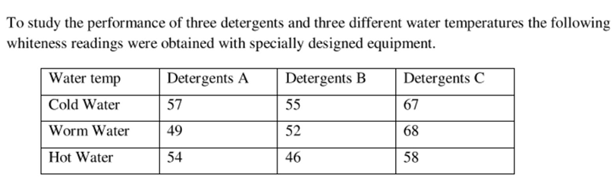

**Solution:**

* **Hypothesis:**
* For Detergents:

Null Hypothesis (*Ho*): There is no significant difference in whiteness among the three detergents.

Alternate Hypothesis (*Ha*): There is a significant difference in whiteness among the three detergents.

* For Temperature:

Null Hypothesis (*Ho*): There is no significant difference in whiteness among the three water temperatures.

Alternate Hypothesis (*Ha*): There is a significant difference in whiteness among the three water temperatures.

* For Interaction:
* Null Hypothesis (*Ho*): There is no interaction effect between detergents and water temperatures on whiteness.
* Alternate Hypothesis (*Ha*): There is an interaction effect between detergents and water temperatures on whiteness.
* **Calculate the 2 way Anova:**
* Calculate the grand Mean:

Grand Mean = summation( All Observation) / Total no. of Observations

= (57+55+67+49+52+68+54+46+58​)/9 =506/9 **​≈**56.22

* Calculate row and column mean:

Row Mean:

Cold water: (57+55+67)/3 =179/3 **≈**59.67

Warm water: (49+52+68)/3 =169/3 ​**≈**56.33

Hot water: (54+46+58)/3 ​=158/3 ​**≈**52.67

Column Mean:

Detergent A: (57+49+54)​/3 =160/3 ​**≈**53.33

Detergent B: (55+52+46)/3 ​= 153/3 **​≈**51.00

Detergent C: (67+68+58)/3​ =193/3 **​≈**64.33

* Calculate sum of squares:
* Total Sum of Square (SST):

SST = summation (Xij – Grand Mean)^2 =(57-56.22)^2 + (55-56.22)^2……

(58-56.22)^2 **​≈** 439.56

* Sum of squares for rows (SSR):

SSR = 3 summation (Row mean – Grand mean)^2

= 3[(59.67 – 56.22)^2 + (56.33-56.22)^2 + (52.67-56.22)^2]

**≈** 73.56

* Sum of squares for columns (SSC):

SSC = 3 summation (Column mean – Grand mean)^2

= 3[(53.33 – 56.22)^2 + (51.00-56.22)^2 + (64.33-56.22)^2]

**≈** 304.22

* Sum of squares of errors (SSE):

SSE=SST−SSR−SSC = 439.56−73.56−304.22 **≈** 61.78

* Calculate the Degree of Freedom:
* Degree of freedom of Total df(total): 9-1 =8
* Degree of freedom of rows df(rows): 3-1 =2
* Degree of freedom of columns df(columns): 3-1 =2
* Degree of freedom of error df(error):

df(rows) * df(columns) =2*2 =4

* Calculate Mean Squares:
* Mean Square for Rows (MSR):

MSR= ​SSR​/ df(rows) =273.56/2​ **≈** 36.78

* Mean Square for Columns (MSC):

MSC= ​SSC​/ df(columns) =304.22/2 **​≈**152.11

* Mean Square for Error (MSE):

MSE= ​SSE/ df(error) ​=61.78​/4 **≈**15.44

* Calculate F- values:
* F-value for Rows:

F(rows) ​=MSR/MSE ​=36.78/15.44 **​≈**2.38

* F-value for Columns:

F(columns) ​=MSC/MSE ​=152.11/15.44 **​≈**9.85

* Critical F-values (at α=0.05):
* Critical F-value for Rows:

F(0.05,2,4) =6.94

* Critical F-value for Columns:

F(0.05,2,4)=6.94

* Here our interpretation:
* **Water Temperature:**

F-value (2.38) < critical value (6.94) - No significant effect.

* **Detergents:**

F-value (9.85) > critical value (6.94) - Significant effect.

* So According to result there is no significant impact of water temperature on whiteness.

But there is significant impact of detergents on whiteness.

**Q39. How would you create a basic Flask route that displays "Hello, World!" on the homepage?**

**Solution:**

* To execute this route firstly we need to install flask package.
* Then create a app.py file to write the route code.
* Create a index route and return a “Hello World!” statement.
* Run the code. You will get a localhost link as an output.
* And open the link in browser.

**Note: I have also submitted a Practical implementation of this route.. Check it from Flask_Practicals folder (Q-39 Hello_world_route)**

* The route:

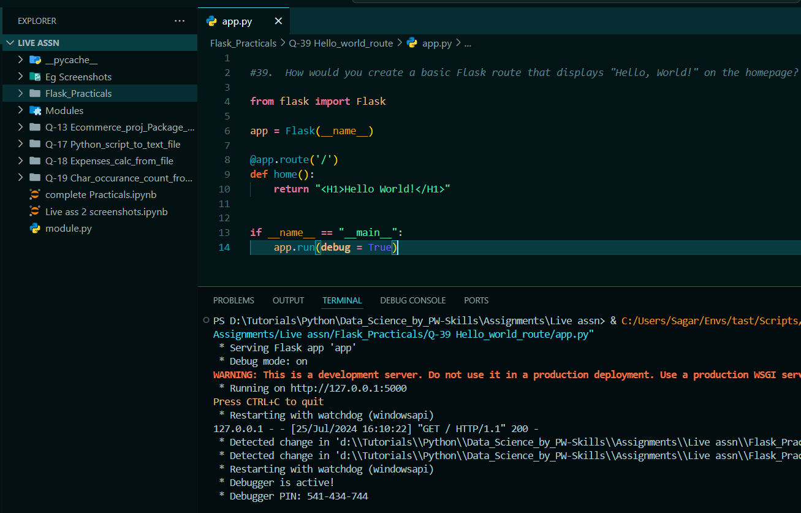

Browser Screen:



**Q40. Explain how to set up a Flask application to handle form submissions using POST requests.**

**Solution:**

* Install the flask package.
* Create a directory structure as:

First create a project folder. Then create a python file named as “app.py” and a folder named as “templates”. Inside templates folder create the html file named as “form.html”.

my_flask_app/

│

├── templates/

│ └── form.html

└── app.py

* Now in app.py create the 2 routes , 1 is of index and second is of form submission route.
* In index render the form.html template. So as soon as we open a browser the form will be display.
* Create a submit route, and use methods = [‘POST’] to submit the form.

Store a data (name, email) in variable and return a submitted message. Which will be display after clicking on submit button.

* In html template create a form using <form> tag
* In starting from of tag use action and method attribute. Due to why it will call that submit route and use method = ‘post’.
* Use a <label> tag form labelling and <input> tag for taking input from user.
* For submit button use a <input> tag and use type attribute as button.

Note: **Note: I have also submitted a Practical implementation of this route.. Check it from Flask_Practicals folder (Q-40 Form_submission_using_post)**

* **App.py**

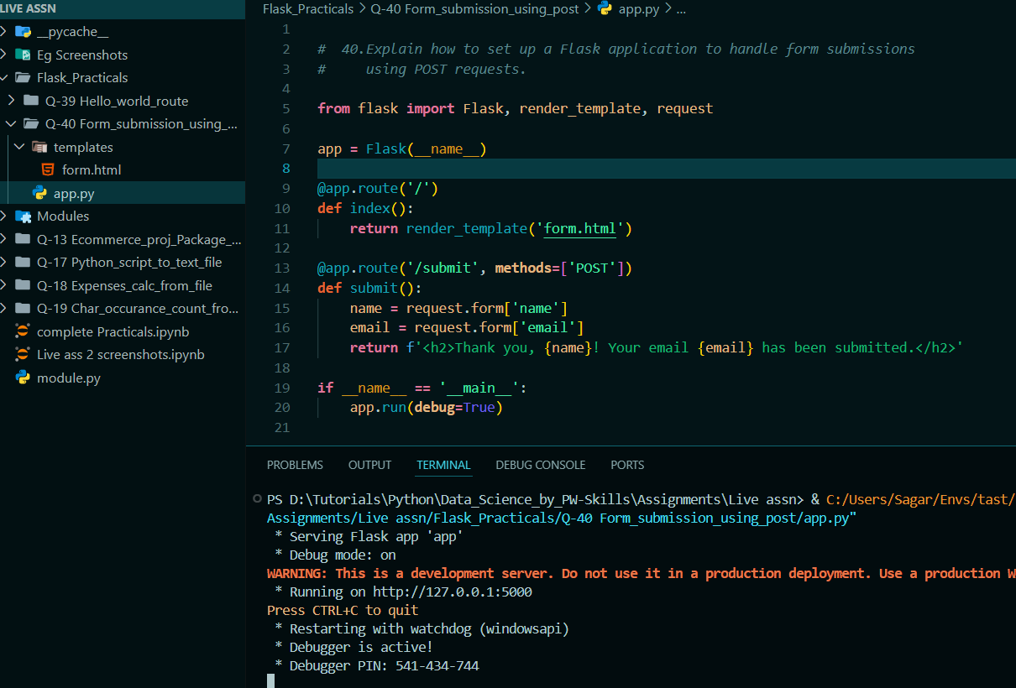

* **HTML form file:**

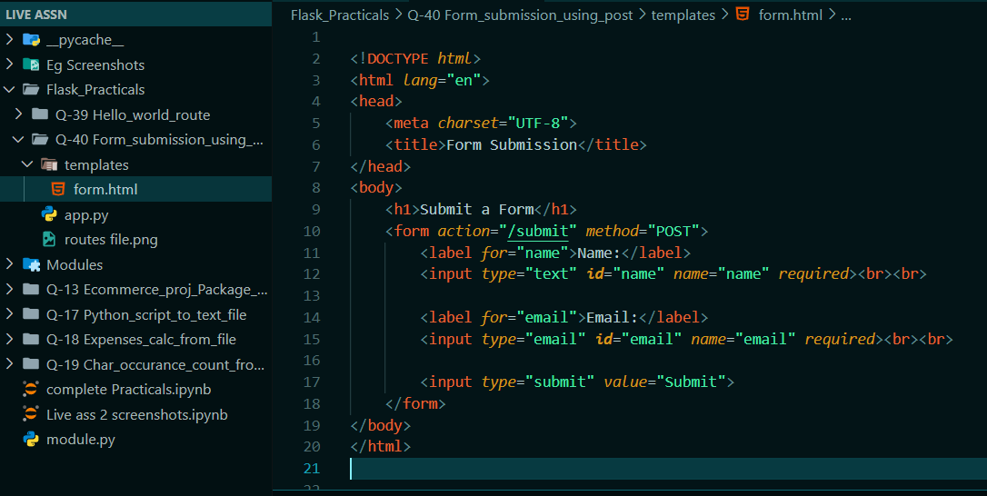

* **Browser screen (output):**

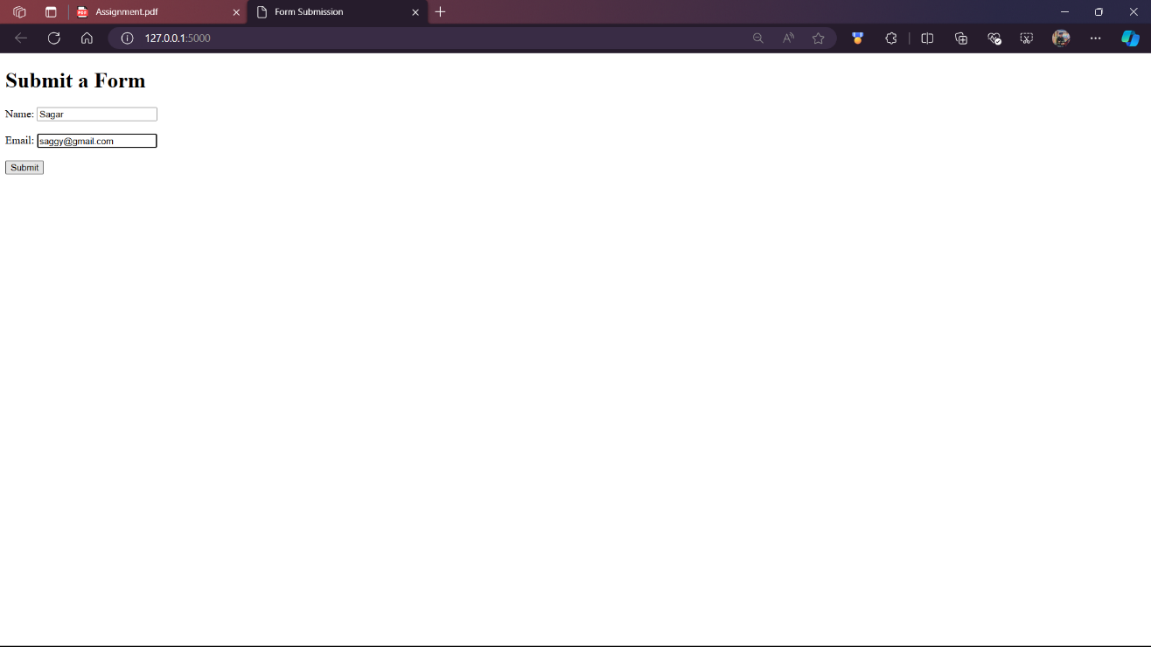

* **Message screen:**

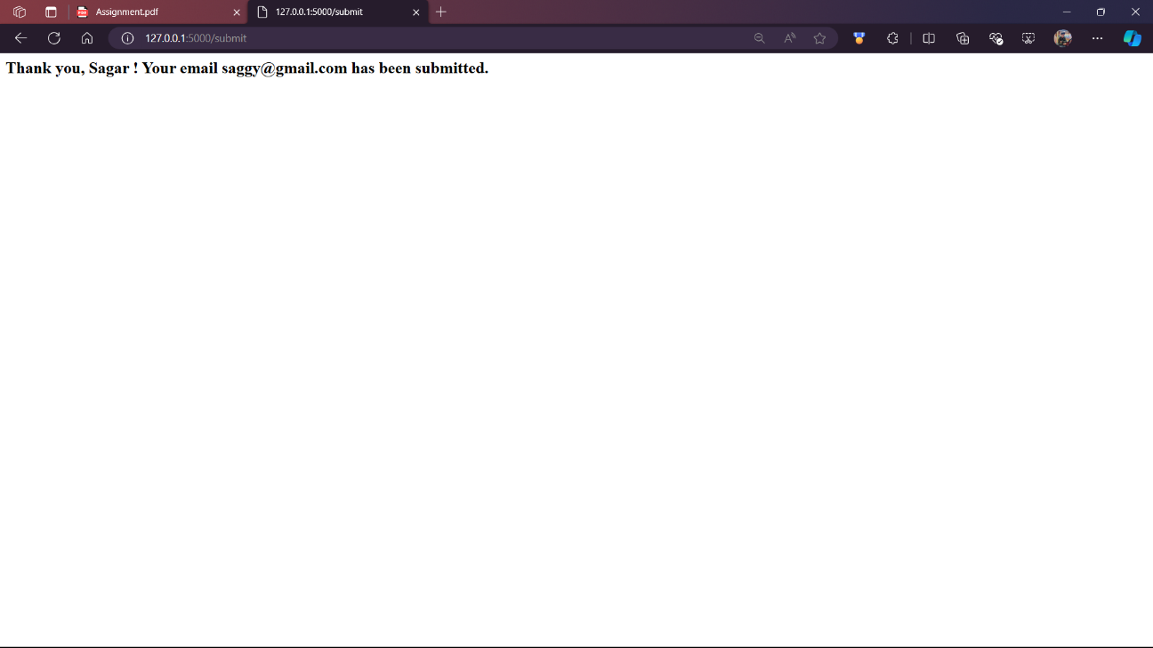

**Q41.Write a Flask route that accepts a parameter in the URL and displays it on the page.**

**Solution:**

* **Note: I have submitted a Practical implementation of this route.. Check it from Flask_Practicals folder (Q-41 URL_parameter_display)**

**Q42. How can you implement user authentication in a Flask application?**

**Solution:**

* **The practical implementation of authentication is submitted in the flask practical’s folder. (Q-42 User_Authentication)**
* Explanation:
* For execution of this project we need the flask, Flask-Login, and Werkzeug,

And for authentication it requires ‘user’ Class and ‘usermixin’.

**Flask**: A web framework for building web applications.

**Flask-Login**: An extension that provides session management and user authentication.

**Werkzeug**: A library for password hashing.

* **User Model:**

**User Class:** Inherits from UserMixin and includes methods for password hashing and checking.

**UserMixin:** Provides necessary methods like is_authenticated used by Flask-Login.

* **LoginManager:** Manages user sessions and handles login and logout functionality. It is initialized and configured with the Flask app.

**‘user_loader’ Callback**: Loads the user object by user ID.

* **Routes:**
* **‘/’ (Index Route)**: Displays buttons for login and registration.
* **‘/register’ :** Handles user registration by creating new user objects and storing them.
* **‘/login’ :** Authenticates users by checking provided credentials and managing user sessions.
* **‘/home’:**  A protected route that only logged-in users can access.
* **‘/logout’:** Logs the user out and redirects them to the login page.
* **Templates:**

index.html: Provides links to login and register pages.

login.html: Contains the login form.

register.html: Contains the registration form.

home.html: Displays a welcome message to logged-in users.

**Working:**

* **Registration:** Firstly users register with a username and password, which are stored after hashing.
* **Login:** Then users log in with their credentials. If the credentials are correct, they are authenticated and their session is managed.
* **Access Control:** The home route is protected and requires the user to be logged in. Users can only access it if authenticated.
* **Logout**: Ends the user session and redirects them to the login page.

**Q43. Describe the process of connecting a Flask app to a SQLite database using SQLAlchemy.**

**Solution:**

* SQLAlchemy is an Object-Relational Mapping (ORM) tool that helps manage database operations with Python classes and objects.
* Firstly installFlask and SQLAlchemy using pip command.
* Create a basic Flask application and configure it to use SQLAlchemy.
* **Set Up the Project Structure like below:**

my_flask_app/

├── app.py

├── models.py

└── config.py

* **Install Required Packages:**

Use pip to install Flask and SQLAlchemy

* **Configure the Flask Application:**

Create a config.py file to store configuration settings, including the database URI.

**(See the Practical implementation to see this file)**

* **Set Up Flask and SQLAlchemy:**

Create the main application file app.py to set up Flask and SQLAlchemy.

**(See the Practical implementation to see this file)**

* **Define the Database Models:**

Create a models.py file to define your database models.

* **Set Up Flask CLI Commands:**

Create a manage.py file to define custom CLI commands for database management.

* **Run Flask CLI Commands:**
  + Navigate to project Directory:

cd path/dir

* + For Windows (PowerShell):

$env:FLASK_APP = "manage.py"

* + **Create the Database and Tables**:

flask create_db

* + **Add a New User**:

flask add_user <username> <email> <password>

* + **Drop the Database and Tables**:

flask drop_db

* By following these steps, you can successfully connect a Flask application to an SQLite database using SQLAlchemy, manage the database, and perform CRUD operations.

**Note:** ***See the practical implementation of this project in folder Flask_Practicals navigate to Q-43._Flask_SQLAlchemy.***

**Q44.How would you create a RESTful API endpoint in Flask that returns JSON data?**

**Solution:**

* Creating a RESTful API endpoint in Flask that returns JSON data involves the following steps:
* 1. Set Up the Project Structure:

**my_flask_api/**

**├── app.py**

**├── config.py**

**├── models.py**

**└── requirements.txt**

* 2. Install Required Packages:

Create a requirements.txt file with the following contents:

Flask

Flask-SQLAlchemy

Install the required packages using:

pip install -r requirements.txt

* 3. Configure Flask:

Config.py:

See the config.py file in Practical implementation.

App.py:

See the app.py file in Practical implementation.

Models.py:

See the models.py file in Practical implementation.

* 4.Create the API Endpoints:

In app.py, we've already defined a simple API endpoint /api/users that returns a list of users in JSON format.

* 5. Create the Database:

Navigate the project directory and run the following commands in your terminal:

* + $env:FLASK_APP = "app.py"
  + flask shell
  + >>> from app import db
  + >>> db.create_all()
  + >>> exit()
  + flask shell
  + >>> from app import db
  + >>> from models import User
  + >>> user1 = User(username='testuser1', email='test1@example.com', password='password')
  + >>> user2 = User(username='testuser2', email='test2@example.com', password='password')
  + >>> db.session.add(user1)
  + >>> db.session.add(user2)
  + >>> db.session.commit()
  + >>> exit()
* Run the Falsk application using command:
  + flask run

* Open the Browser and use this url:

“http://127.0.0.1:5000/api/users”

* **Note:** ***See the practical implementation of this project in folder Flask_Practicals navigate to Q-44._Flask_RestAPI.***

**Q45. Explain how to use Flask-WTF to create and validate forms in a Flask application.**

**Solution:**

* First, you need to install Flask-WTF and its dependencies.
* So, you need to install Flask, Flask-WTF, email-validator.
* Setup a Flask application:
* Set up a basic Flask application with the necessary configuration by creating the app.py file and configure it with a secret key for CSRF protection.

( you can refer the practical implementation of project to see the detailed code.)

* Create a form class using Flask-WTF (Flask_form). Define the fields and validation rules for your form.
* Create a separate file for this e.g. forms.py. And add fields and validation rules.
* In your Flask application (app.py), create a route to display the form and handle form submissions. This route should render the form template and handle form validation.
* Create a Jinja2 template to render the form and display validation messages. Save this file in a templates directory (e.g., templates/form.html).
* Finally run the program (e.g. app.py) file . You will get a link to see the form as output.

Add “/form” in URL bar with this link. You will get your desired output.

* **Note:** ***See the practical implementation of this project in folder Flask_Practicals navigate to Q-45._Flasks_validate_forms.***

**Q46.How can you implement file uploads in a Flask application?**

**Solution:**

* Implementing file uploads in a Flask involves configuring the application, creating an HTML form for the file upload, handling the file upload in a route, and saving the uploaded file.
* Set Up Your Flask Application First, set up a basic Flask application with the necessary configurations for handling file uploads.
* Configure it with a secret key, upload folder, and max file size.
* Create routes for the index page and file upload handling.
* Create two HTML templates: one for the index page and one for the upload form.
* Run your Flask application to start the server:
* Before running make sure that the you are in right directory where the app.py file located.
* Because after running the flask application the uploads folder will be created to save the upload files.
* If the terminal is not in right change the pointer to current directory using ‘cd’ command in terminal.
* If all of these requirements are fully satisfied then you can run the application.
* The uploaded files will be saved in the specified upload folder.
* **Note:** ***See the practical implementation of this project in folder Flask_Practicals navigate to Q-46._Flasks_file_uploads.***

**Q47. Describe the steps to create a Flask blueprint and why you might use one.**

**Solution:**

* Set up a Project Directory:

Organize your project directory to separate different components. A recommended structure is:

/Q-47_Flasks_Blueprints

|-- /app

| |-- __init__.py

| |-- /blueprints

| |-- __init__.py

| |-- my_blueprint.py

|-- run.py

* **Create Blueprint File:**

Define your blueprint in a separate file, such as my_blueprint.py within the blueprints directory.

Include the necessary route definitions and any associated functions.

* **Initialize Blueprints**:

Create an __init__.py file within the blueprints directory.

Import and initialize your blueprints in this file.

* **Create Application Factory**:

In the __init__.py file within the app directory, set up an application factory function that initializes the Flask application.

Register your blueprints within this factory function.

* **Setup Application Entry Point**:

Create a run.py file at the root of your project.

This file will import the application factory, create an instance of the application, and run the Flask development server.

* **Define Routes**:

Within your blueprint file, define routes and their corresponding view functions.

* **Register Blueprints**:

In the application factory function, use the register_blueprint method to register each blueprint with the Flask application.

Optionally, specify a URL prefix for the blueprint routes to namespace them appropriately.

* Run your Flask application using the run.py file to start the development server.
* Access your defined routes through the web browser to ensure everything is working correctly.
* Use the prefix in URL before route which we given e.g. my/ and the route name e.g. /hello.
* **Note:** ***See the practical implementation of this project in folder Flask_Practicals navigate to Q-47._Flasks_Blueprints.***
* **Use Blueprints:**
* **Modularity**: Blueprints allow you to break down your application into smaller, self-contained modules. This makes it easier to manage and understand your code, especially as the application grows.
* **Reusability**: You can reuse blueprints across different projects. For example, if you have a user authentication system, you can encapsulate it in a blueprint and reuse it in multiple applications.
* **Organization**:Blueprints help organize routes, templates, and static files logically. This organization makes the codebase cleaner and more maintainable.
* **Team Collaboration**:In a team setting, blueprints allow different developers to work on different parts of the application simultaneously without causing conflicts.
* **Note:** ***See the practical implementation of this project in folder Flask_Practicals navigate to Q-47._Flasks_Blueprints.***

**Q48. How would you deploy a Flask application to a production server using Gunicorn and Nginx?**

**Solution:**

* Hereisstep-by-step guide to deploying a Flask application to a production server using Gunicorn and Nginx.
* **Step 1: Prepare Your Flask Application:**
* **Set Production Settings**:Make sure your Flask app is configured for production. Set DEBUG to False.
* **Create a Requirements File**: Run pip freeze > requirements.txt to list all dependencies in a file.
* **Step 2: Install and Set Up Gunicorn:**
* **Install Gunicorn**: In your project’s virtual environment, install Gunicorn using pip install gunicorn.
* **Run Gunicorn**: Test Gunicorn by running: ‘*gunicorn -w 4 -b 127.0.0.1:8000 your_flask_app:app*’.
* Replace ‘*your_flask_app*’ with the name of your Python file (without .py), and ‘*app*’ with the Flask app instance.
* **Create a Gunicorn Service**:
* Create a service file to manage Gunicorn with Systemd.

**File Path**: *‘/etc/systemd/system/your_flask_app.service’*

Include details like user, group, working directory, and the command to start Gunicorn.

* **Start and Enable Gunicorn Service**:

Run ‘*sudo systemctl daemon-reload’* to reload Systemd.

Start Gunicorn with ‘*sudo systemctl start your_flask_app’*.

Enable it to start on boot with ‘*sudo systemctl enable your_flask_app’*.

* **Step 3: Install and Configure Nginx:**
* **Install Nginx**: On your server, install Nginx with *‘sudo apt update’* and *‘sudo apt install nginx’.*
* **Configure Nginx**: Create an Nginx configuration file for your Flask app

**File Path**: *‘/etc/nginx/sites-available/your_flask_app’*

Set it up to forward requests to Gunicorn and serve static files.

* **Enable Nginx Configuration**: Create a symbolic link to enable the site: *‘sudo ln -s /etc/nginx/sites-available/your_flask_app /etc/nginx/sites-enabled/your_flask_app’.*
* **Reload Nginx**:

Test the Nginx configuration: *‘sudo nginx -t’*.

Reload Nginx to apply changes: ‘*sudo systemctl reload nginx’*.

* **Step 4: Secure Your Application:**
* **Set Up SSL with Let’s Encrypt**:

Install Certbot: *‘ sudo apt install certbot python3-certbot-nginx’.*

Obtain and install an SSL certificate: *‘sudo certbot --nginx -d your_domain’*.

* **Check File Permissions**:

Ensure that the files and directories have appropriate permissions for security.

* So, following these steps you can deploy you project to a production server using Gunicon and Nginix.

**Q49. Make a fully functional web application using flask, Mangodb. Signup,Signin page.And after successfully login .Say hello Geeks message at webpage.**

**Solution:**

* **Note: I have submitted a Practical implementation of this Web Application.. Check it from Flask_Practicals folder (Q-49_Flask_Webapplication)**

**Q50. Machine Learning:**

Q1. What is the difference between Series & Dataframe?

Solution:

* In the context of the Pandas library, which is widely used for data manipulation and analysis in Python, the primary data structures are Series and DataFrame.
* **Series:**
* A Series is a one-dimensional labeled array capable of holding any data type (integers, strings, floating-point numbers, Python objects, etc.).
* It can be thought of as a single column of data with an index.
* Each element in a Series has an associated index, which allows for fast lookups.
* You can create a Series from lists, arrays, or dictionaries.
* Series is often used when you need to work with a single column of data.
* E.g.

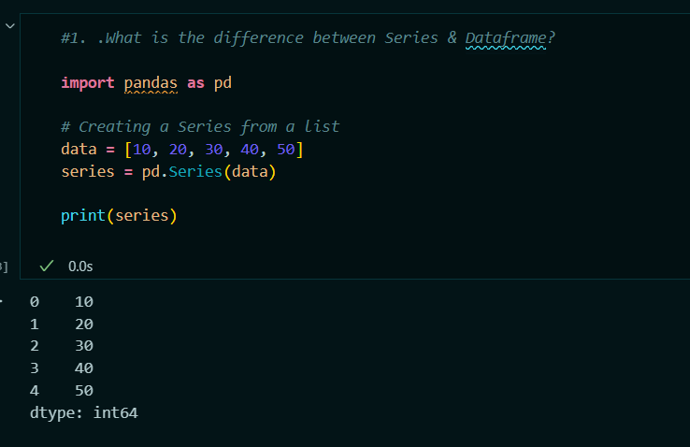

* **DataFrame:**
* A DataFrame is a two-dimensional labeled data structure with columns that can hold different data types.
* It can be thought of as a table or a collection of Series objects.
* DataFrames have both row and column indices, making them more versatile for complex data manipulation.
* You can create a DataFrame from lists of dictionaries, dictionaries of lists, arrays, or other DataFrames.
* DataFrame is used when working with tabular data, where you need to handle multiple columns of data.
* E.g.

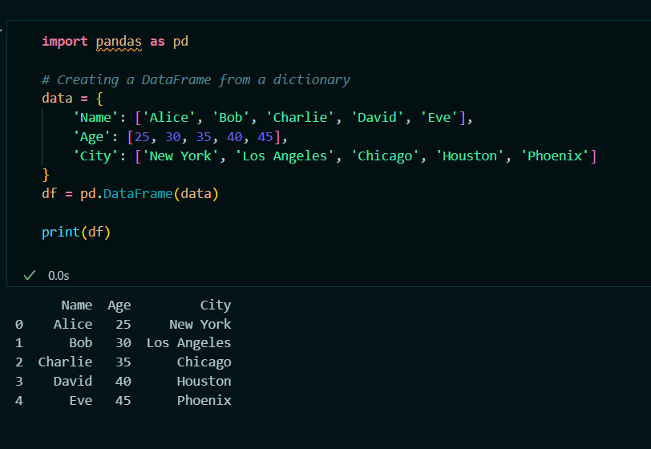

Q2. Create a database name Travel_Planner in mysql ,and  create a table name bookings in that which having attributes (user_id INT,  flight_id INT,hotel_id INT, activity_id INT,booking_date DATE) .fill with some dummy value .Now you have to read the content of this table using pandas as dataframe.Show the output.

Solution:

* Set Up MySQL Database and Table:

I have created a database using SQL Client as shown below:

E.g.:

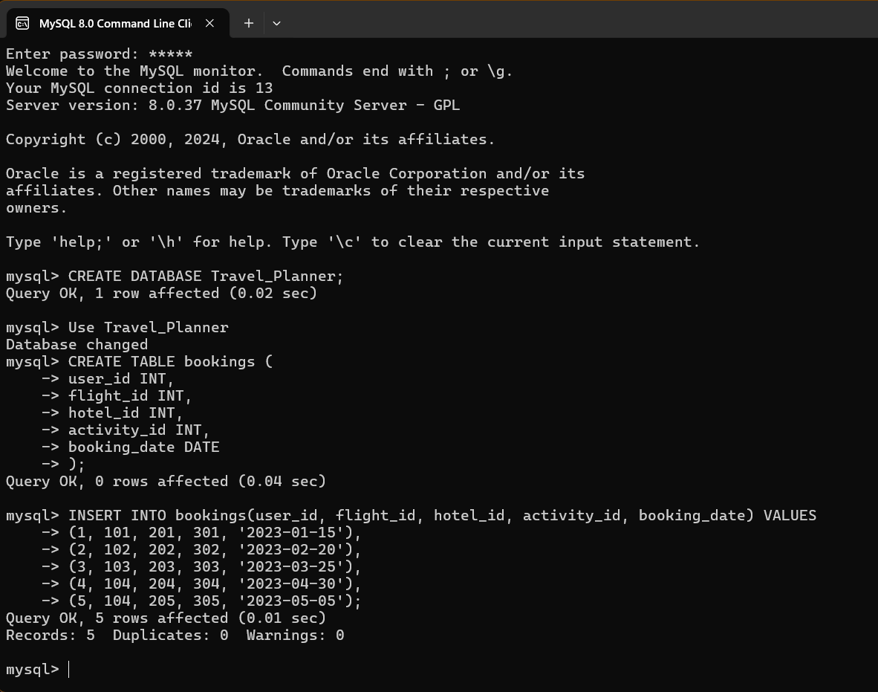

* **Here My SQL workbench or SQL client details:**

Host = localhost

User = root

Password = admin

Database = Travel Planner

* Here we will require ‘mysql-connector-python’ with ‘pymysql’.
* Read the database into Pandas dataframe by using Python Code:

E.g.

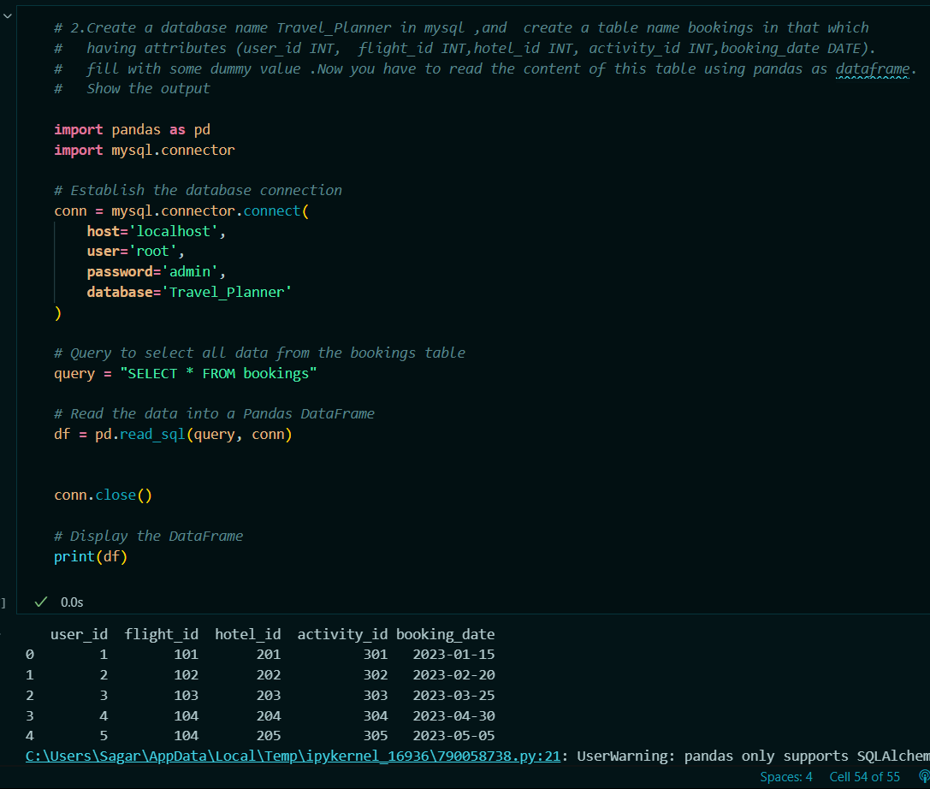

* **Note: I have submitted a Practical implementation of this Web Application.. Check it from Practicals_for_screenshot.ipynb file. In Maching Learning Markdown.**

Q3. Difference between loc and iloc.

Solution:

* ‘Loc’ and ‘iloc’ are methods in Pandas used to access rows and columns in a DataFrame.
* **Loc:**
* ‘Loc’ is used for label-based indexing, which means you select data by using the labels of the rows and columns.
* When specifying a range, ‘Loc’ includes both the start and end labels.
* It can handle labels (strings or numbers) of the DataFrame's index.
* ‘Loc’ can be used with boolean arrays for conditional indexing.
* E.g.:

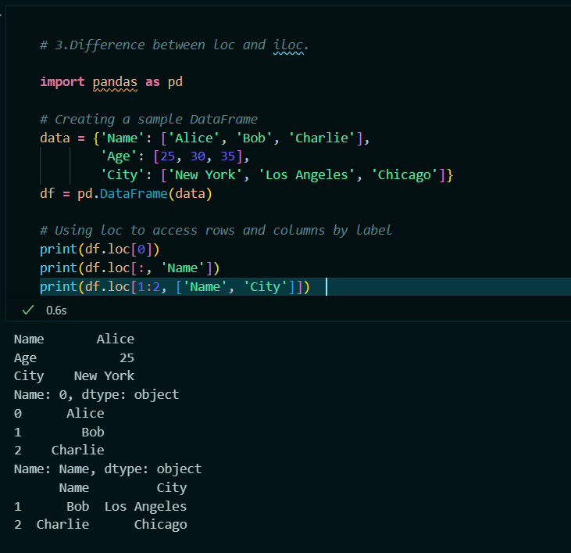

* **Iloc:**
* ‘Iloc’ is used for integer-based indexing, which means you select data by using the integer positions of the rows and columns.
* When specifying a range, ‘Iloc’ excludes the end position.
* It uses the integer locations (zero-based index) of the DataFrame.
* Supports slicing operations where the start is inclusive, and the end is exclusive.
* E.g.

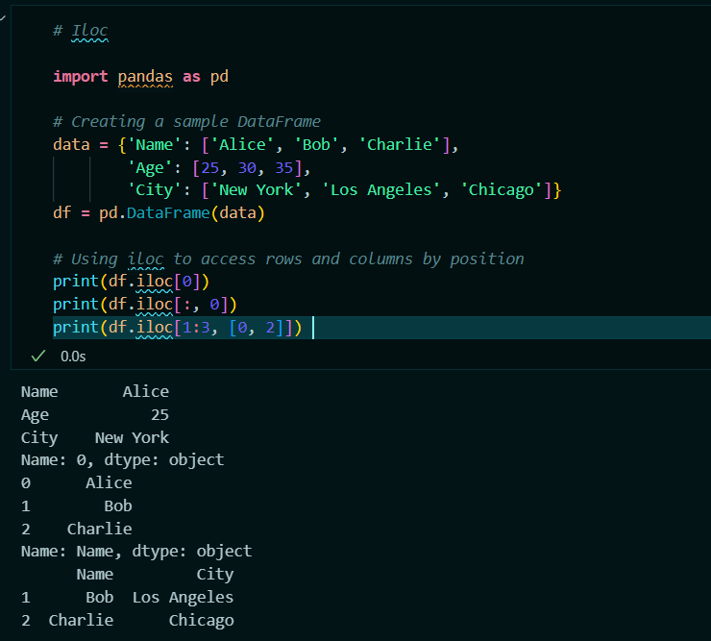

* So ‘Loc’ when you need to select data by label or boolean conditions.

And **Use** ‘Iloc’ when you need to select data by numerical index position.

Q4. What is the difference between supervised and unsupervised learning?

Solution:

* Supervised and unsupervised learning are two main types of machine learning, each serving different purposes and using different approaches
* **Supervised Learning:**
* Supervised learning is a type of machine learning where the model is trained on labeled data. The training dataset includes input-output pairs, where the output is the known label or result.
* The goal is to learn a mapping from inputs to outputs, enabling the model to predict the output for new, unseen inputs.
* There are 2 types of Supervised Learning:

**Classification**: Predicting a discrete label (e.g., spam or not spam, cat or dog).

**Regression**: Predicting a continuous value (e.g., house prices, temperature).

* The model is trained on a dataset that contains both input features and the corresponding labels.
* Once trained, the model can predict the labels for new data.
* The output is known and provided during training (e.g., labels or target values).
* Used in applications where the output is known and can be used to train the model (e.g., classification, regression).
* E.g. Email spam detection., Predicting house prices based on features like size, location, etc. Image recognition.
* E.g.

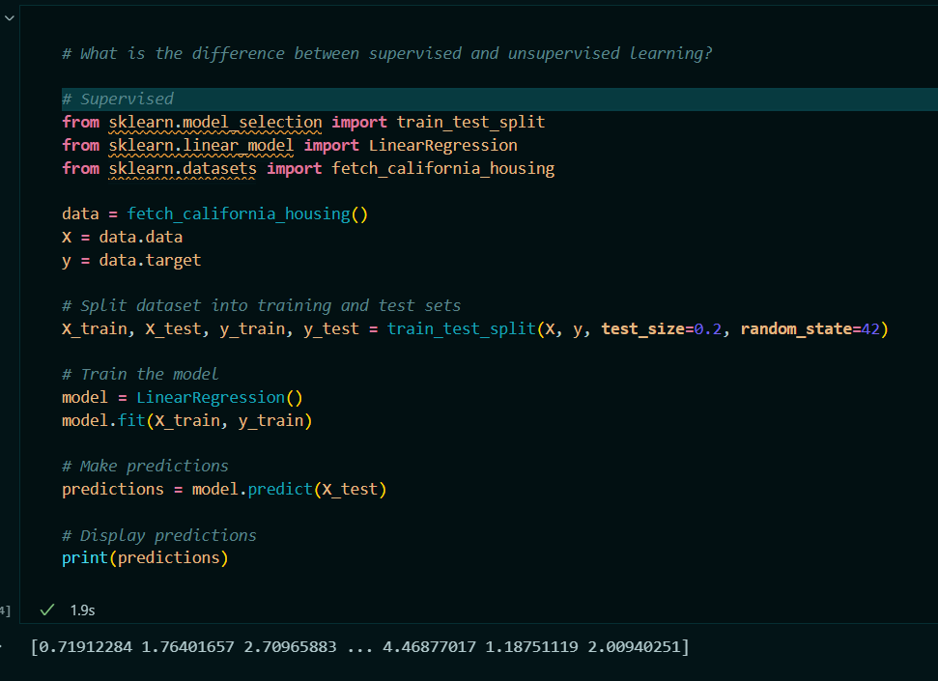

* **Unsupervised Learning:**
* Unsupervised learning is a type of machine learning where the model is trained on unlabeled data.
* The model tries to learn the underlying structure or distribution in the data without any explicit labels.
* The goal is to find hidden patterns or intrinsic structures in the input data.
* It has Three types:
* **Clustering**: Grouping data points into clusters based on similarity (e.g., customer segmentation).
* **Dimensionality Reduction**: Reducing the number of features while preserving important information (e.g., Principal Component Analysis).
* **Anomaly Detection**: Identifying unusual data points that do not fit the general pattern (e.g., fraud detection).
* The model is provided with a dataset without labeled responses.
* he model tries to identify patterns, groupings, or structures in the data.
* The output is not known; the model identifies patterns or groupings.
* Used in applications where the goal is to explore the data and find patterns without predefined labels (e.g., clustering, dimensionality reduction).
* E.g. Market basket analysis e.g., finding products that are frequently bought together.
* Image compression (e.g., reducing the number of pixels while retaining important information).

E.g.

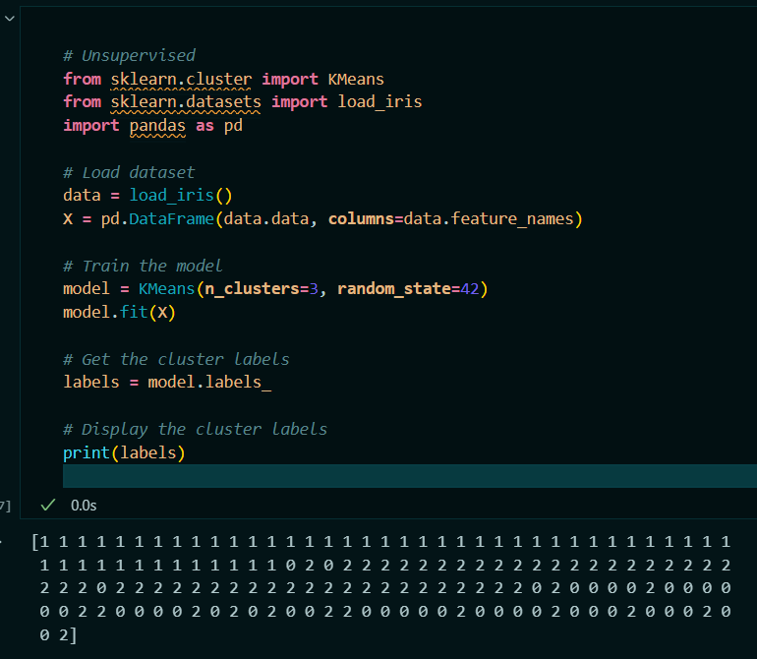

Q5. Explain the bias-variance tradeoff.

**Solution:**

* The bias-variance tradeoff is a fundamental concept in machine learning that describes the tradeoff between two sources of error that affect the performance of predictive models.
* Understanding this tradeoff helps in finding the right balance between underfitting and overfitting a model to achieve optimal performance.
* **Bias:**

Bias refers to the error introduced by approximating a real-world problem, which may be complex, by a simpler model.

**High Bias**: A model with high bias pays very little attention to the training data and oversimplifies the model. This often leads to underfitting, where the model is too simple to capture the underlying patterns in the data.

High bias models are usually too simple, such as a linear regression model used for non-linear data.

* **Variance:**

Variance refers to the error introduced by the model's sensitivity to small fluctuations in the training dataset. It captures the amount by which the model's predictions would change if it were trained on different data.

**High Variance**: A model with high variance pays a lot of attention to the training data, including noise and fluctuations. This often leads to overfitting, where the model is too complex and captures noise in the training data as if it were a true pattern.

High variance models are usually too complex, such as a high-degree polynomial regression model.

* **Tradeoff:**
* **Low Bias, High Variance**: Models that are very flexible and complex, such as decision trees with many branches, tend to have low bias but high variance.

They fit the training data very well but may perform poorly on new, unseen data due to overfitting.

* **High Bias, Low Variance**: Models that are too simple, such as linear regression with few features, tend to have high bias but low variance.

They may not capture the complexity of the training data, leading to underfitting.

* **Optimal Model**: The goal is to find a model that achieves a good balance between bias and variance, resulting in the lowest possible error on new, unseen data.

This involves selecting a model that is sufficiently complex to capture the underlying patterns in the data but not so complex that it overfits the noise in the training data.

* **Visualization:**

Training Error vs. Testing Error:

**Underfitting (High Bias)**: Both training error and testing error are high.

**Overfitting (High Variance)**: Training error is low, but testing error is high.

**Optimal Model**: Training error is low, and testing error is also low.

* Practical example:
* Consider a scenario where you are fitting a polynomial regression model to data:
* **Low Degree Polynomial (Underfitting)**:

High bias because the model is too simple.

Low variance because the model is not sensitive to the specific dataset.

* **High Degree Polynomial (Overfitting)**:

Low bias because the model is flexible enough to fit the training data well.

High variance because the model is too sensitive to the training data, capturing noise as if it were a true pattern.

* **Moderate Degree Polynomial (Optimal)**:

Balanced bias and variance.

The model is complex enough to capture the underlying pattern but not so complex that it overfits the data.

* So, to manage Bias Variance Trade-off use following methods:

**Cross-Validation**: Use techniques like k-fold cross-validation to assess the model's performance on different subsets of the data to ensure it generalizes well.

**Regularization**: Apply regularization techniques (e.g., Lasso, Ridge) to penalize overly complex models and reduce overfitting.

**Ensemble Methods**: Use ensemble methods (e.g., bagging, boosting) to combine multiple models to reduce variance and improve generalization.

**Model Selection**: Carefully select the model and tune its hyperparameters to find the right complexity for the problem at hand.

Q6. What are precision and recall? How are they different from accuracy?

Solution:

* Precision, recall, and accuracy are metrics used to evaluate the performance of classification models, but they measure different aspects of performance.
* **Accuracy:**
* Accuracy is the ratio of correctly predicted instances (both positive and negative) to the total number of instances in the dataset.
* Formula:

Accuracy = No. of Correct predictions / Total No. of Predictions

* Accuracy is a straightforward metric that is useful when the classes are balanced (i.e., there are roughly equal numbers of positive and negative instances). However, it can be misleading in cases where the classes are imbalanced.
* E.g.

If a model correctly predicts 90 out of 100 instances, the accuracy is:

Accuracy = 90/100 = 0.90 or 90%

* **Precision:**
* Precision measures the proportion of positive predictions that are actually correct. It focuses on the quality of positive predictions.
* Formula:

Precision = True Positive / (True positives + False Positives)

* Precision is particularly important when the cost of false positives is high. For example, in medical diagnoses, a high precision means fewer healthy individuals are incorrectly diagnosed as sick.
* E.g.

If a model predicts 30 instances as positive, out of which 20 are actually positive, the precision is:

Precision = 20/30 = 0.67 or 67%

* **Recall:**
* Recall (or Sensitivity) measures the proportion of actual positives that were correctly identified by the model. It focuses on how well the model captures all positive instances.
* Formula:

Recall = True Positive / (True positives + False Negatives)

* Recall is particularly important when the cost of false negatives is high. For example, in spam detection, high recall ensures that most spam emails are identified, even if it means including some non-spam emails.
* E.g.

If there are 50 actual positive instances, and the model correctly identifies 40 of them, the recall is:

Recall = 40/50 = 0.80 or 80%

* **Difference & Relationship:**
* **Accuracy:**

Measures the overall correctness of the model.

Averages the performance across both positive and negative classes.

Can be misleading in imbalanced datasets where one class is dominant.

**Accuracy** gives an overall measure of how often the model is correct.

* **Precision vs. Recall**:

**Precision**: Focuses on the quality of positive predictions. Higher precision means fewer false positives.

**Precision** measures the accuracy of positive predictions, focusing on minimizing false positives.

**Recall**: Focuses on capturing all positive instances. Higher recall means fewer false negatives.

**Recall** measures the ability to capture all positive instances, focusing on minimizing false negatives.

Q7. What is overfitting and how can it be prevented?

Solution:

* **Overfitting** occurs when a machine learning model learns not just the underlying patterns in the training data but also the noise and outliers, leading to a model that performs exceptionally well on training data but poorly on unseen data. This means the model has essentially memorized the training data instead of generalizing from it.
* **Characteristics :**
* **High Training Accuracy**: The model performs very well on the training set.
* **Low Test Accuracy**: The model performs poorly on the validation or test set, indicating that it does not generalize well to new, unseen data.
* **Complex Models**: Overfitting is often seen in models that are excessively complex relative to the amount of training data (e.g., deep neural networks with too many layers or parameters).
* **Overfitting occurs when**:
* **Complex Models**: Models with too many parameters or high complexity relative to the amount of data can fit the training data very well but fail to generalize.
* **Insufficient Data**: Small datasets can lead to models that capture noise instead of patterns.
* **Noisy Data**: Data with a lot of random noise or errors can lead to overfitting as the model tries to fit this noise.
* **Prevention Strategies:**
* **1. Simplify the Model**:

Use less complex models or reduce the number of parameters. For example, in linear regression, use fewer features.

Apply regularization techniques to constrain the model complexity.

* **2. Regularization**:

**L1 Regularization (Lasso)**: Adds a penalty equal to the absolute value of the magnitude of coefficients. This can lead to some coefficients being exactly zero.

**L2 Regularization (Ridge)**: Adds a penalty equal to the square of the magnitude of coefficients, discouraging large coefficients.

**Dropout**: In neural networks, randomly drop neurons during training to prevent reliance on any one neuron.

* **3.** **Cross-Validation**:

Use k-fold cross-validation to assess the model's performance on different subsets of the data. This helps ensure that the model generalizes well across different data splits.

* **4.** **More Training Data**:

Increasing the amount of training data can help the model learn more general patterns and reduce overfitting.

* **5. Early Stopping**:

Monitor the performance of the model on a validation set during training and stop training when performance starts to degrade.

* **6.** **Pruning**:

For decision trees, pruning involves removing branches that have little importance, thus simplifying the model.

* **7.** **Data Augmentation**:

In fields like image processing, augmenting the dataset by creating variations of the training examples can help improve generalization.

* **8. Ensemble Methods**:

Combine multiple models (e.g., bagging, boosting) to reduce the risk of overfitting and improve performance.

* E.g.:

Consider a polynomial regression model applied to a small dataset:

**Underfitting**: Using a linear polynomial (degree 1) when the true relationship is non-linear.

**Good Fit**: Using a polynomial with a degree that balances complexity and fit to the training data.

**Overfitting**: Using a very high-degree polynomial, which fits the training data perfectly but fails to generalize to new data.

* Overfitting is when a model learns the noise in the training data rather than the underlying patterns, resulting in poor generalization to new data.
* To prevent overfitting, you can simplify the model, use regularization, perform cross-validation, gather more data, and use techniques like early stopping and data augmentation.
* Balancing model complexity and training data is key to achieving good generalization performance.

Q8. Explain the concept of cross-validation.

Solution:

* Cross-validation is a technique used in machine learning to evaluate the performance of a model and ensure that it generalizes well to new, unseen data.
* It involves partitioning the dataset into subsets to test the model on different portions of the data and avoid overfitting.
* **Purpose**:
* To assess how well a model generalizes to an independent dataset that was not used during training.
* To ensure that the model's performance is not overly optimistic or pessimistic based on a single train-test split.
* **Basic Idea**:
* The dataset is split into multiple subsets, and the model is trained and validated on different combinations of these subsets. This process helps in estimating the model’s performance on unseen data.
* There are 5 types of cross validation:
* **1**. **k-Fold Cross-Validation**:
* Process:
* Split the dataset into k equally sized folds.
* Train the model k times, each time using k-1 folds for training and the remaining fold for validation.
* Calculate the performance metric (e.g., accuracy, precision, recall) for each fold and average them to get the overall performance.
* Advantages:
* Provides a more reliable estimate of model performance compared to a single train-test split.
* All data points are used for both training and validation.
* **Common Choice**: Typically k is set to 5 or 10.
* **2. Leave-One-Out Cross-Validation (LOOCV)**:
* Process:
* For each data point, use it as the validation set and the remaining data points as the training set.
* Train the model n times (where n is the number of data points) and evaluate performance for each validation set.
* Advantages:
* Provides a very thorough estimate of model performance since each data point is used for validation exactly once.
* Disadvantages:
* Computationally expensive, especially for large datasets.
* **3. Stratified k-Fold Cross-Validation**:
* Process:
* Similar to k-Fold Cross-Validation but ensures that each fold maintains the same proportion of class labels as the original dataset.
* Advantages:
* Useful for imbalanced datasets to ensure each fold is representative of the class distribution.
* **4. Repeated k-Fold Cross-Validation**:
* Process:
* Repeat k-Fold Cross-Validation multiple times with different random splits of the data into folds.
* Advantages:
* Provides a more robust estimate of performance by averaging results from multiple runs.
* **5. Time Series Cross-Validation**:
* Process:
* For time-dependent data, use methods like rolling windows or expanding windows to ensure the temporal order is maintained.
* Advantages:
* Accounts for the temporal nature of time series data, preventing future data from being used to predict past data.
* Steps in k-Fold Cross-Validation:
* **Split Data**: Divide the dataset into k folds.
* **Training and Validation:** For each fold, train the model on k-1 folds and validate it on the remaining fold.
* **Evaluate Performance**: Calculate performance metrics for each fold.
* **Aggregate Results**: Compute the average of the performance metrics across all folds to get the final estimate.
* **E.**g.

Assume you have a dataset of 100 samples and use 5-Fold Cross-Validation:

Split Data: Divide the 100 samples into 5 folds, each with 20 samples.

Training and Validation:

Fold 1: Train on folds 2, 3, 4, and 5; validate on fold 1.

Fold 2: Train on folds 1, 3, 4, and 5; validate on fold 2.

Repeat this process for all folds.

Evaluate Performance: Record the performance metrics (e.g., accuracy) for each fold.

Aggregate Results: Average the performance metrics from all 5 folds.

Q9. What is the difference between a classification and a regression problem.

Solution:

* Classification and regression are two fundamental types of supervised learning problems in machine learning.
* They differ primarily in the nature of the output variable (target) they predict.
* **Classification:**

**Objective**: To predict a categorical label or class for an input based on its features.

**Output**: Discrete values representing class labels.

* **Classification**: Predicts categorical outcomes (e.g., class labels).

Examples:

Binary Classification: Classifying emails as "spam" or "not spam."

Multiclass Classification: Identifying the species of an iris flower (e.g., "setosa," "versicolor," "virginica").

* **Evaluation Metrics:**
  + Accuracy
  + Precision
  + Recall
  + F1 Score
  + Confusion Matrix
* **Algorithms**:
  + Logistic Regression
  + Decision Trees
  + Support Vector Machines (SVM)
  + k-Nearest Neighbors (k-NN)
  + Neural Networks
* **Regression:**

**Objective**: To predict a continuous numerical value based on input features.

**Output**: Continuous values.

* **Regression**: Predicts continuous outcomes (e.g., numerical values).

Examples:

Predicting house prices based on features like size, location, and number of rooms.

Estimating a person's weight based on their height and age.

* Evaluation Metrics:
  + Mean Absolute Error (MAE)
  + Mean Squared Error (MSE)
  + Root Mean Squared Error (RMSE)
  + R-squared
* Algorithms:
  + Linear Regression
  + Polynomial Regression
  + Ridge and Lasso Regression
  + Decision Trees for Regression
  + Neural Networks

Q10. Explain the concept of ensemble learning.

Solution:

* **Ensemble learning** is a machine learning technique where multiple models (often called "base learners" or "models") are combined to improve overall performance compared to individual models.
* The idea is that by combining different models, the ensemble can achieve better accuracy, robustness, and generalization.
* Objective is to improve predictive performance by leveraging the strengths of multiple models and reducing the impact of individual model weaknesses.
* **Types of Ensemble Methods**:
* **1.Bagging (Bootstrap Aggregating)**:

**Process**: Train multiple instances of the same model on different random subsets (with replacement) of the training data. Combine their predictions by averaging (for regression) or majority voting (for classification).

**Goal**: Reduce variance and prevent overfitting.

**Example**: Random Forest, which is an ensemble of decision trees.

* **2.Boosting**:
* **Process**: Train models sequentially, where each model corrects the errors of its predecessor. The predictions from all models are combined, often by weighting them based on their performance.
* **Goal**: Reduce bias and improve accuracy.
* **Example**: AdaBoost, Gradient Boosting Machines (GBM), XGBoost.
* **3.** **Stacking (Stacked Generalization)**:
* **Process**: Train multiple base models and then use their predictions as input features for a meta-model (also called a "blender" or "stacker"). The meta-model learns to combine the base model predictions to make the final prediction.
* **Goal**: Leverage the strengths of different models by combining their outputs in a more sophisticated way.
* **Example**: A stack that includes logistic regression, decision trees, and SVMs with a final meta-model that combines their predictions.
* **Advantages of Ensemble Learning**:
* **Improved Accuracy**: Combining multiple models often results in better performance than any single model.
* **Robustness**: Reduces the risk of overfitting and provides more stable predictions.
* **Versatility**: Can be applied to different types of base models and datasets.
* **Disadvantages of Ensemble Learning**:
* **Complexity**: Ensembles can be more complex to implement and interpret compared to single models.
* **Computational Cost**: Training multiple models can be more resource-intensive and time-consuming.
* Consider a classification problem where individual models like decision trees, logistic regression, and SVM are trained separately. In an ensemble learning approach, these models are combined:
* Bagging Example:
  + Train multiple decision trees on different subsets of the data.
  + Combine their predictions through majority voting to determine the final class.
* Boosting Example:
  + Train decision trees sequentially, each correcting the errors of the previous trees.
  + Combine their predictions, giving more weight to models that perform better.
* Stacking Example:
  + Train a logistic regression model, a decision tree, and an SVM.
  + Use their predictions as input features for a meta-model, which learns the best way to combine these predictions.
* Ensemble learning combines multiple models to improve overall performance by leveraging their strengths and mitigating individual weaknesses.
* Techniques such as bagging, boosting, and stacking offer different ways to create powerful ensembles, enhancing accuracy and robustness in predictive tasks.

Q11. What is gradient descent and how does it work?

Solution:

* **Gradient descent** is an optimization algorithm used to minimize the loss function in machine learning and statistical models. It’s a fundamental method for training models, especially in linear regression, logistic regression, and neural networks.
* **Objective:**To find the parameters (weights) of a model that minimize the value of a loss function, which measures how well the model performs.
* **Loss Function:**A mathematical function that quantifies the error between the model's predictions and the actual outcomes. The goal is to minimize this function.
* **Gradient descent working:**
* **Initialization**:
* Start with initial guesses for the model parameters (weights). These can be set randomly or with a heuristic.
* **Compute the Gradient**:
* Calculate the gradient of the loss function with respect to each parameter. The gradient is a vector that points in the direction of the steepest increase of the loss function.
* **Update Parameters**:

Adjust the parameters in the direction opposite to the gradient. This is done to reduce the loss function. The size of the step is determined by the learning rate.

* **Iterate**: Repeat the process of computing gradients and updating parameters until the loss function converges to a minimum value or until a predefined number of iterations is reached.
* **Convergence**:

The process stops when the change in the loss function or the parameters becomes very small, indicating that the model has found an optimal (or near-optimal) set of parameters.

* **Types of Gradient Descent:**
* **1.Batch Gradient Descent:**
* Uses the entire training dataset to compute the gradient and update the parameters.
* Pros: More stable convergence.
* Cons: Computationally expensive for large datasets.

**2.Stochastic Gradient Descent (SGD):**

* Uses a single data point (or a small random subset) to compute the gradient and update the parameters.
* Pros: Faster and more frequent updates.
* Cons: Convergence can be noisy and may not always reach the exact minimum.
* **3.Mini-Batch Gradient Descent:**
* Uses a small random subset (mini-batch) of the training data to compute the gradient and update the parameters.
* Pros: Balances between the stability of batch gradient descent and the speed of stochastic gradient descent.
* Cons: Requires tuning of mini-batch size.
* **Example:**
* Imagine you have a quadratic loss function L(θ)=(θ−5)^2 ,where θ is the parameter and 5 is the optimal value you want to find.
* **Initialization:** Start with θ=0.
* **Compute Gradient:** The gradient is dL/dθ=2(θ−5)
* Update Parameters:

If the learning rate α is 0.1, then update θ as:

θ:=θ−0.1×2(θ−5)

Repeat this step until θ converges to 5.

* Gradient descent is an optimization algorithm used to minimize the loss function by iteratively adjusting model parameters.
* It calculates the gradient of the loss function with respect to the parameters and updates them in the direction that reduces the loss.

Q12. Describe the difference between batch gradient descent and stochastic gradient descent.

Solution:

* **Batch Gradient Descent** and **Stochastic Gradient Descent (SGD)** are two variations of the gradient descent optimization algorithm, each with its own approach to updating model parameters.
* **Batch Gradient Descent:**
* **Process:**
* Computes the gradient of the loss function using the entire training dataset.
* Updates the model parameters after evaluating the gradient over the whole dataset.
* **Advantages:**
* Stable Convergence: Using the entire dataset for each update provides a more accurate estimate of the gradient, leading to more stable convergence.
* Deterministic Updates: The updates are consistent across iterations since the entire dataset is used for each update.
* **Disadvantages:**
* Computationally Expensive: Requires storing and processing the entire dataset in memory for each gradient calculation, which can be slow and resource-intensive for large datasets.
* Less Frequent Updates: The model parameters are updated less frequently compared to other methods, which can slow down the training process.
* Use Case:
* Suitable for smaller datasets where the entire dataset can be processed efficiently.
* **Stochastic Gradient Descent (SGD):**
* **Process:**
* Computes the gradient of the loss function using a single training example or a small random subset (mini-batch) of the training dataset.
* Updates the model parameters immediately after processing each example or mini-batch.
* **Advantages:**
* Faster Updates: Parameters are updated more frequently, which can lead to faster convergence, especially for large datasets.
* Lower Memory Usage: Does not require the entire dataset to be loaded into memory at once, making it suitable for large datasets.
* **Disadvantages:**
* Noisy Convergence: The gradient estimates can be noisy because they are based on only one example or a small subset of the dataset, which can lead to fluctuations in the convergence path.
* Less Stable: The frequent updates can cause the optimization process to oscillate or converge to a suboptimal solution.
* **Use Case:**
* Preferred for large datasets and online learning scenarios where data arrives in streams or batches.
* **Key Differences:**
* **Data Used for Gradient Calculation**:
* Batch Gradient Descent: Uses the entire dataset.
* SGD: Uses one data point or a small mini-batch.
* **Frequency of Parameter Updates**:
* Batch Gradient Descent: Updates parameters less frequently (after processing the entire dataset).
* SGD: Updates parameters more frequently (after each example or mini-batch).
* **Convergence**:
* Batch Gradient Descent: More stable and deterministic, but can be slower and less suitable for very large datasets.
* SGD: Can converge faster and handle large datasets, but may experience more fluctuations and noise in convergence.
* **Computational Efficiency**:
* Batch Gradient Descent: May require more computational resources and memory.
* SGD: More memory-efficient and can handle large-scale data but may require careful tuning of the learning rate and other hyperparameters.

Q13. What is the curse of dimensionality in machine learning?

Solution:

* The **curse of dimensionality** refers to various issues that arise when working with high-dimensional data in machine learning and data analysis. As the number of features (dimensions) increases, several problems can negatively impact the performance and effectiveness of machine learning models.
* **Issues of the Curse of Dimensionality**
* **1. Data Sparsity**:
* **Problem**: In high-dimensional spaces, data points become sparse because the volume of the space increases exponentially with each added dimension. This sparsity makes it difficult to find meaningful patterns and increases the risk of overfitting.
* **Impact**: Many machine learning algorithms rely on the assumption that data points are close to each other in feature space. When data is sparse, it becomes harder to find neighbors, leading to unreliable models.
* **2**. **Increased Computational Complexity:**
* **Problem**: The computational cost of algorithms often grows with the number of dimensions. High-dimensional data can lead to longer training times and increased resource usage.
* **Impact**: Training and inference become slower and more resource-intensive, making it challenging to work with large datasets.
* **3. Overfitting:**
* **Problem:** With many features, models can become excessively complex and fit noise rather than the underlying data distribution. This results in poor generalization to new, unseen data.
* **Impact:** The model may perform well on the training data but poorly on test data, leading to high variance**.**
* **4. Difficulty in Visualization:**
* **Problem**: As dimensions increase, visualizing the data becomes impractical. Humans can only visualize up to three dimensions, making it difficult to understand and interpret high-dimensional data.
* **Impact**: This hinders exploratory data analysis and the ability to intuitively understand data distributions and relationships.
* **5**. **Distance Metrics Become Less Informative:**
* **Problem**: In high-dimensional spaces, the difference between the distances of points becomes less significant. Most points appear to be roughly equidistant from each other.
* **Impact**: Distance-based algorithms (e.g., k-NN, clustering) become less effective as the distinction between close and distant points diminishes.
* **Strategies to Mitigate the Curse of Dimensionality**
* **1. Dimensionality Reduction:**
* **Techniques**: Use methods like Principal Component Analysis (PCA), t-Distributed Stochastic Neighbor Embedding (t-SNE), or Linear Discriminant Analysis (LDA) to reduce the number of dimensions while retaining essential information.
* **Benefit**: Simplifies the dataset, making it more manageable and improving the performance of algorithms.
* **2**. **Feature Selection:**
* **Techniques**: Select a subset of relevant features based on statistical tests, domain knowledge, or model-based approaches (e.g., L1 regularization).
* **Benefit**: Reduces the number of features and focuses on the most informative ones.
* **3. Regularization:**
* **Techniques**: Apply regularization methods like L1 (Lasso) or L2 (Ridge) to penalize complex models and prevent overfitting.
* **Benefit**: Helps in managing high-dimensional data by constraining the model complexity.
* **4. Increasing Data:**
* **Techniques**: Collect more training data to counteract the sparsity in high-dimensional spaces.
* **Benefit**: Provides more examples for training, helping to better capture the underlying data distribution.
* **5. Feature Engineering**:
* **Techniques**: Create new features or transform existing ones to capture essential patterns and relationships in a more compact form.
* **Benefit**: Enhances the quality of features and reduces the dimensionality without losing significant information.
* The curse of dimensionality refers to the challenges that arise with high-dimensional data, including sparsity, increased computational complexity, overfitting, difficulty in visualization, and ineffective distance metrics.
* Addressing these issues involves techniques like dimensionality reduction, feature selection, regularization, increasing data, and feature engineering to improve model performance and manageability.

Q14. Explain the difference between L1 and L2 regularization.

Solution:

* L1 and L2 regularization are techniques used to prevent overfitting in machine learning models by adding a penalty to the loss function.
* They differ in how they apply this penalty and in their impact on the model parameters.
* **L1 Regularization (Lasso):**
* Adds the absolute value of the magnitude of coefficients as a penalty term to the loss function.
* **Mathematical Formulation:**
* For a linear regression model, the L1 regularized loss function is

J(θ)=Loss(θ)+λ n∑ i=1 ​∣θi​∣

Here, λ is the regularization parameter that controls the strength of the penalty.

* **Effect on Coefficients:**
* Encourages sparsity: L1 regularization can drive some coefficients to exactly zero, effectively performing feature selection.
* Useful when we expect only a few features to be important.
* **Use Cases:**
* When you want to reduce the number of features (feature selection).
* In high-dimensional data where some features are irrelevant.
* **L2 Regularization (Ridge):**
* Adds the squared magnitude of coefficients as a penalty term to the loss function.
* **Mathematical Formulation:**

For a linear regression model, the L2 regularized loss function is:

J(θ)=Loss(θ)+λ n∑i=1 ​θi2​

Here, λ is the regularization parameter that controls the strength of the penalty.

* **Effect on Coefficients**:
* Shrinks coefficients but does not set them to zero: L2 regularization tends to distribute the penalty across all coefficients, reducing their magnitudes but rarely setting any to zero.
* Useful when all features are expected to have some level of importance.
* **Use Cases:**
* **When you expect all features to contribute to the outcome but want to avoid overfitting.**
* **In cases where multicollinearity is a problem (L2 can handle correlated features better than L1).**
* Differences:
* **1. Penalty Type:**
* **L1:** Sum of the absolute values of the coefficients**.**
* **L2:** Sum of the squared values of the coefficients.
* **2. Effect on Model Coefficients**:
* **L1:** Can lead to sparse models with some coefficients exactly zero (feature selection).
* **L2:** Shrinks coefficients but rarely makes them zero, keeping all features in the model.
* **3.** **Use Case Scenarios**:
* **L1**: Preferred when you believe that only a few features are important and want automatic feature selection.
* **L2**: Preferred when you believe that all features contribute to the output and want to avoid overfitting.
* **4**. **Optimization**:
* **L1**: The optimization problem is less straightforward due to the non-differentiable nature of the absolute value function, but can be handled by specific algorithms like coordinate descent.
* **L2**: The optimization problem is easier to solve as it involves differentiable functions, typically solved using gradient descent methods.
* Combined Regularization: Elastic Net:

**Elastic Net** combines both L1 and L2 penalties

J(θ)=Loss(θ)+λ1 n∑​i=1 ​∣θi​∣+λ2 n∑​i=1 ​θi2​

* Useful when there are multiple correlated features and some feature selection is desired along with coefficient shrinkage.
* **L1 Regularization (Lasso)**: Adds an absolute value penalty, encourages sparsity by driving some coefficients to zero.
* **L2 Regularization (Ridge)**: Adds a squared value penalty, shrinks coefficients but does not make them zero, helps with multicollinearity.
* **Elastic Net**: Combines L1 and L2 regularization to leverage the benefits of both methods.

15. What is a confusion matrix and how is it used?

Solution:

* A **confusion matrix** is a table used to evaluate the performance of a classification model by comparing the actual labels with the predicted labels.
* It provides a detailed breakdown of the classification results, which helps in understanding the types of errors the model is making.
* **Structure of a Confusion Matrix**
* **For a binary classification problem, a confusion matrix is a 2x2 table with the following components:**

**Actual pred Positive Pred Negative pred**

**Positive(Actual) True Positive(TP) False Negative(FN)**

**Negative(Actual) False Positive(FP) True Negative(TN)**

**True Positive (TP): The model correctly predicted the positive class.**

**False Positive (FP): The model incorrectly predicted the positive class (Type I error).**

**False Negative (FN): The model incorrectly predicted the negative class (Type II error).**

**True Negative (TN): The model correctly predicted the negative class.**

* Usage of a Confusion Matrix:
* **1. Evaluating Performance Metrics**:

**Accuracy**: Proportion of correct predictions (both TP and TN) among the total number of cases.

Accuracy= TP+TN / TP+FP+FN+TN

**Precision**: Proportion of correctly predicted positive observations to the total predicted positives.

Precision= TP/TP+FP​

**Recall (Sensitivity or True Positive Rate)**: Proportion of correctly predicted positive observations to all actual positives.

Recall= TP/TP+FN​

**F1 Score**: Harmonic mean of precision and recall, providing a single metric that balances both concerns.

F1 Score=2×(( Precision×Recall​) / (Precision+Recall))

**Specificity (True Negative Rate)**: Proportion of correctly predicted negative observations to all actual negatives.

Specificity=TN/TN+FP

* **2. Identifying Model Weaknesses**:
* The confusion matrix helps identify specific types of errors, such as whether the model is more prone to false positives or false negatives, which can be critical for certain applications (e.g., medical diagnosis, fraud detection).
* **3.Multi-class Classification**:
* For multi-class problems, the confusion matrix is extended to an n×n matrix, where n is the number of classes. Each cell (i,j) represents the number of instances of class i that were predicted as class j.
* **Example:**
* Assume we have a binary classification problem to predict whether an email is spam (positive class) or not spam (negative class). After running the model, we get the following confusion matrix:

**Actual pred Positive Pred Negative pred**

**Positive(Actual) 50 10**

**Negative(Actual) 5 100**

* From this confusion matrix, we can calculate the following metrics:

Accuracy:

Accuracy=TP+ TN​/ TP+FP+FN+TN = 50+100​/50+5+10+100 =0.909

Precision:

Precision= TP​/TP+FP = 50/50+5 = 0.909

Recall:

Recall= TP​/TP+FN = 50/50+10 = 0.833

F1 Score:

F1 Score=2×(( Precision ×Recall )/( Precision +Recall)) ​

= 2×(( 0.909×0.833)/(0.909+0.833))

= 0.870

* A confusion matrix is a powerful tool for evaluating the performance of a classification model.
* It provides a comprehensive view of how well the model is performing by breaking down the results into true positives, false positives, false negatives, and true negatives.
* From this, various performance metrics like accuracy, precision, recall, and F1 score can be derived, helping to understand and improve the model's performance.

**Q16.** Define AUC-ROC curve.

Solution:

* The AUC-ROC curve (Area Under the Receiver Operating Characteristic curve) is a performance measurement for classification models at various threshold settings.
* It is widely used in binary classification to evaluate how well a model distinguishes between classes.
* **ROC Curve**:
* **ROC (Receiver Operating Characteristic) Curve**: A graphical plot that illustrates the diagnostic ability of a binary classifier system as its discrimination threshold is varied.
* **True Positive Rate (TPR)**: Also known as Sensitivity or Recall, it is the ratio of correctly predicted positive instances to all actual positive instances.

TPR= TP /TP+FN ​

* **False Positive Rate (FPR)**: The ratio of incorrectly predicted positive instances to all actual negative instances

FPR= FP/FP+TN

* **AUC**:
* **AUC (Area Under the Curve)**: Represents the degree or measure of separability. It tells how much the model is capable of distinguishing between classes.
* **Range of AUC**:
  + AUC=1: Perfect model.
  + 0.5<AUC<1: Better than random guessing; the closer to 1, the better.
  + AUC=0.5: No discriminative power, equivalent to random guessing.
  + AUC<0.5: Worse than random guessing, indicates a poorly performing model.
* Importance:
* **Evaluation**: The AUC-ROC curve helps evaluate the performance of classification models by comparing the true positive rate against the false positive rate.
* **Threshold Selection**: It aids in selecting the optimal threshold for classification decisions.
* **Eg. Of :**calculation and plotting the AUC-ROC curve using Python's scikit-learn library:

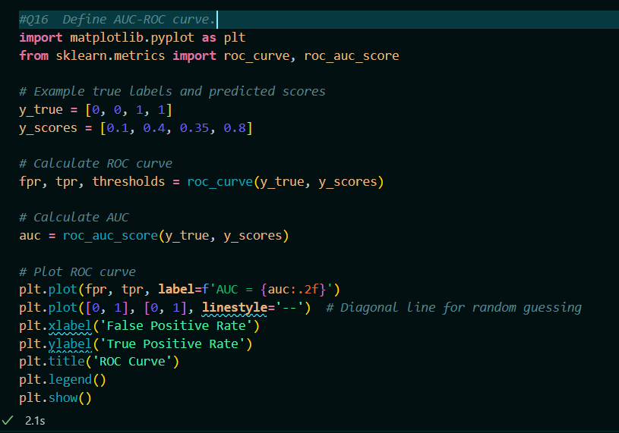

**Output:**

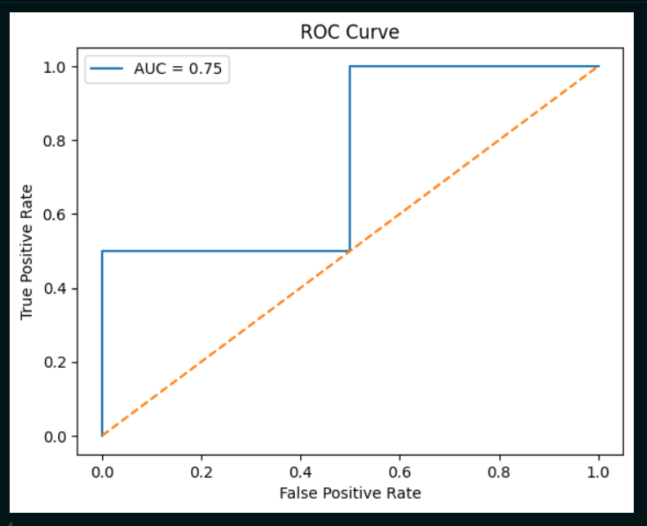

* **In above eg:**
  + ‘y_true’ contains the true binary labels.
  + ‘y_scores’ contains the predicted scores from the classifier.
  + ‘y_scores’ contains the predicted scores from the classifier.
  + ‘roc_auc_score’ computes the AUC value.
  + The plot visualizes the ROC curve with the AUC value indicated in the legend.

Q17.Explain the k-nearest neighbors algorithm.

Solution:

* The k-Nearest Neighbors (k-NN) algorithm is a simple, yet effective, machine learning algorithm used for classification and regression tasks.
* It is based on the principle that data points with similar attributes are likely to have similar classifications or regression values.
* **Instance-Based Learning**: k-NN is an instance-based learning algorithm, meaning it does not explicitly learn a model but rather makes predictions based on the entire dataset.
* **Distance Metric**: The algorithm relies on a distance metric (e.g., Euclidean distance, Manhattan distance) to measure the similarity between data points.
* Working:
* **Classification:**
* **Training Phase**: There is no explicit training phase. The algorithm simply stores all the training data.
* **Prediction Phase:**
* For a given test data point, calculate the distance between this point and all the points in the training dataset.
* Identify the k nearest neighbors to the test point based on the calculated distances.
* Determine the class of the test point by taking a majority vote among the classes of the k nearest neighbors.
* **Regression:**
* **Training Phase**: Similar to classification, the training phase involves storing the training data.
* **Prediction Phase**:
* Calculate the distance between the test point and all training points.
* Identify the k nearest neighbors.
* Predict the value for the test point by averaging the values of the k nearest neighbors.
* **Choosing the Value of k**:
* **Small k (e.g., k=1)**: Can lead to overfitting, as the model becomes sensitive to noise in the training data.
* **Large k**: Can smooth out noise but may lead to underfitting, as it includes too many points, potentially from other classes.
* **Pros:**
* **Simplicity**: Easy to understand and implement.
* **No Training Phase**: No need for a separate training phase.
* **Flexibility**: Can be used for both classification and regression problems.
* **Cons**:
* **Computational Cost**: High during prediction as it involves calculating the distance to all training points.
* **Memory Intensive**: Requires storing the entire training dataset.
* **Sensitivity to Irrelevant Features**: Performance can be affected by irrelevant or redundant features.
* **Curse of Dimensionality**: Performance degrades with increasing dimensionality of the data.
* **Example:**

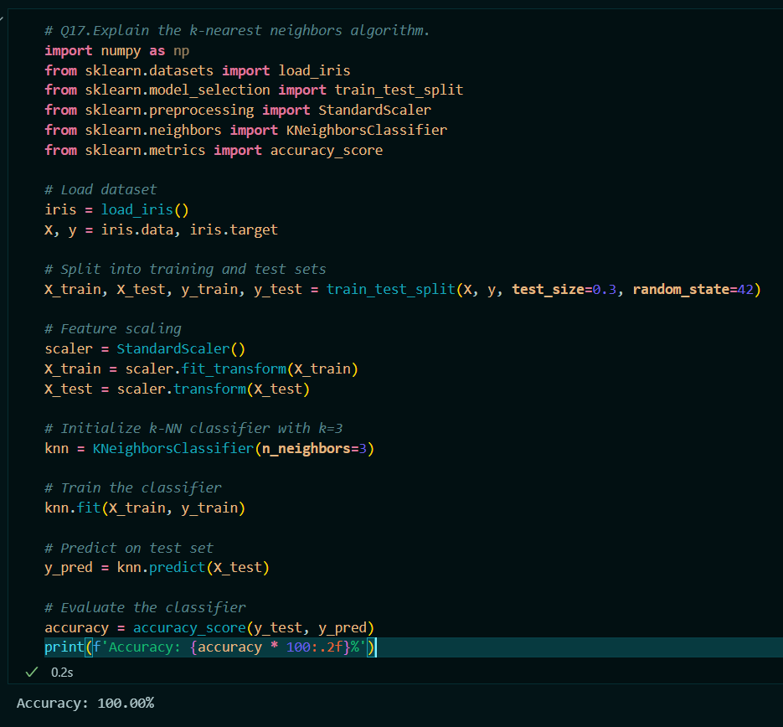

* Here:
* The Iris dataset is loaded and split into training and test sets.
* Feature scaling is applied to standardize the feature values.
* A k-NN classifier is initialized with k=3.
* The classifier is trained on the training data.
* Predictions are made on the test data, and the accuracy of the model is evaluated.

Q18. Explain the basic concept of a Support Vector Machine (SVM).

Solution:

* A Support Vector Machine (SVM) is a powerful supervised machine learning algorithm used for both classification and regression tasks.
* However, it is more commonly used in classification problems. SVMs aim to find the optimal hyperplane that best separates the data points of different classes in a high-dimensional space.
* **Hyperplane**:
* In SVM, a hyperplane is a decision boundary that separates different classes in the feature space. In a 2-dimensional space, this is a line, and in a 3-dimensional space, it is a plane. In higher dimensions, it becomes a hyperplane.
* **Support Vectors**:
* Support vectors are the data points that are closest to the hyperplane. These points are critical in defining the position and orientation of the hyperplane. The hyperplane is maximized based on these points.
* **Margin**:
* The margin is the distance between the hyperplane and the nearest data point from either class. SVM aims to maximize this margin. A larger margin is considered better as it implies a better separation between the classes, leading to better generalization on unseen data.
* Working of SVM:
* **1.Linear SVM**:
* For linearly separable data, SVM finds a hyperplane that linearly separates the data points of different classes with the maximum margin.
* The equation of the hyperplane in an n-dimensional space can be written as:

w⋅x+b=0

where w is the weight vector, x is the feature vector, and b is the bias term.

* **2.Non-Linear SVM:**

For non-linearly separable data, SVM uses a technique called the kernel trick. It maps the original features into a higher-dimensional space where a linear separator (hyperplane) can be found. Common kernel functions include:

**Linear Kernel**: K(xi,xj)=xi⋅xj

**Polynomial Kernel**: K(xi​,xj​)=(xi​⋅xj​+c)^d

**Radial Basis Function (RBF) Kernel**: K(xi,xj)=exp(−γ∥xi−xj∥^2)

**Sigmoid Kernel**: K(xi,xj)=tanh(αxi⋅xj+c)

* Pros:
* **Effective in High Dimensional Spaces:** SVM is effective in high-dimensional spaces and in cases where the number of dimensions exceeds the number of samples.
* **Memory Efficient:** SVM is memory efficient as it uses a subset of training points (support vectors) in the decision function.
* **Versatile:** SVM is versatile due to the use of different kernel functions, making it adaptable to various data distributions.
* Cons:
* **Computational Complexity:** Training an SVM can be computationally intensive, especially with large datasets.
* **Choice of Kernel:** The performance of SVM is heavily dependent on the choice of the kernel and its parameters.
* **Not Suitable for Large Datasets:** SVM is not suitable for very large datasets due to high training times.
* **Eg**

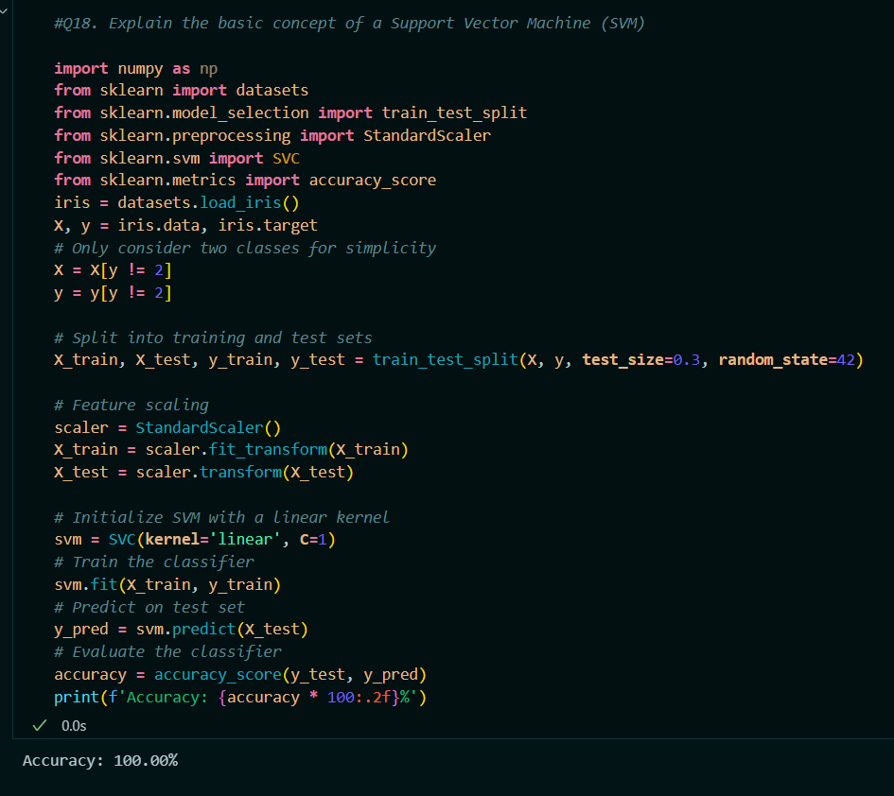

* Here:
* The Iris dataset is loaded, and only two classes are considered for binary classification.
* The data is split into training and test sets, and feature scaling is applied.
* An SVM classifier with a linear kernel is initialized and trained.
* Predictions are made on the test data, and the accuracy of the model is evaluated.

Q19. What are the different types of kernels used in SVM and when would you use each?

Solution:

* Support Vector Machines (SVM) can use various types of kernel functions to handle different kinds of data distributions and make the algorithm more flexible and powerful. Here are the most common types of kernels used in SVM, along with when to use each:
* **1.Linear Kernel:**

Equation: K(xi,xj)=xi⋅xj​

* Usage:
* When the data is linearly separable, i.e., you can separate the classes with a straight line (or hyperplane in higher dimensions).
* When the number of features is very large compared to the number of samples, as the linear kernel is computationally less intensive.
* Examples include text classification tasks with high-dimensional feature spaces (like TF-IDF vectors).
* **2.Polynomial Kernel:**

**Equation:** K(xi,xj)=(αxi⋅xj+c)^d

α: A scalar value (default is usually 1).

c: The bias term, controlling the trade-off between higher-degree and lower-degree terms.

d: The degree of the polynomial.

* **Usage:**
* When the data is not linearly separable but can be separated with a polynomial decision boundary.
* Suitable for cases where interactions between features are important.
* The degree d should be chosen based on the complexity of the data. Higher degrees can capture more complex relationships but might also lead to overfitting.
* **3.Radial Basis Function (RBF) Kernel (Gaussian Kernel):**

Equation: K(xi​,xj​)=exp(−γ∥xi​−xj​∥^2)

γ: Controls the width of the Gaussian function.

A small γ value means a Gaussian with a large variance, while a large γ value means a Gaussian with a small variance.

* **Usage:**
* When the data is not linearly separable and you do not have prior knowledge about the data.
* The RBF kernel can handle complex relationships between features, making it a good default choice for many problems.
* It is widely used because it can map samples into a higher-dimensional space and handle non-linear boundaries.
* **4.Sigmoid Kernel:**

Equation: K(xi​,xj​)=tanh(αxi​⋅xj​+c)

α: A scalar value (controls the slope).

c: The bias term.

* **Usage:**
* When the relationship between the features is similar to that of a neural network with a single hidden layer.
* It is less commonly used compared to the RBF kernel but can be useful in specific scenarios where the data distribution is known to follow a pattern that the sigmoid kernel can capture.
* **Choosing the Right Kernel:**
* **Linear Kernel**: Use when the data is linearly separable or in high-dimensional spaces where the number of features exceeds the number of samples.
* **Polynomial Kernel**: Use when the data can be separated by polynomial decision boundaries and interactions between features are important.
* **RBF Kernel**: Use when the data is not linearly separable and you want a robust and flexible approach. It is often the default choice if you are unsure about the data distribution.
* **Sigmoid Kernel**: Use when the data distribution is known to follow a pattern that a sigmoid kernel can capture, or in specific cases where you want to model the data similar to a neural network.
* **Eg**

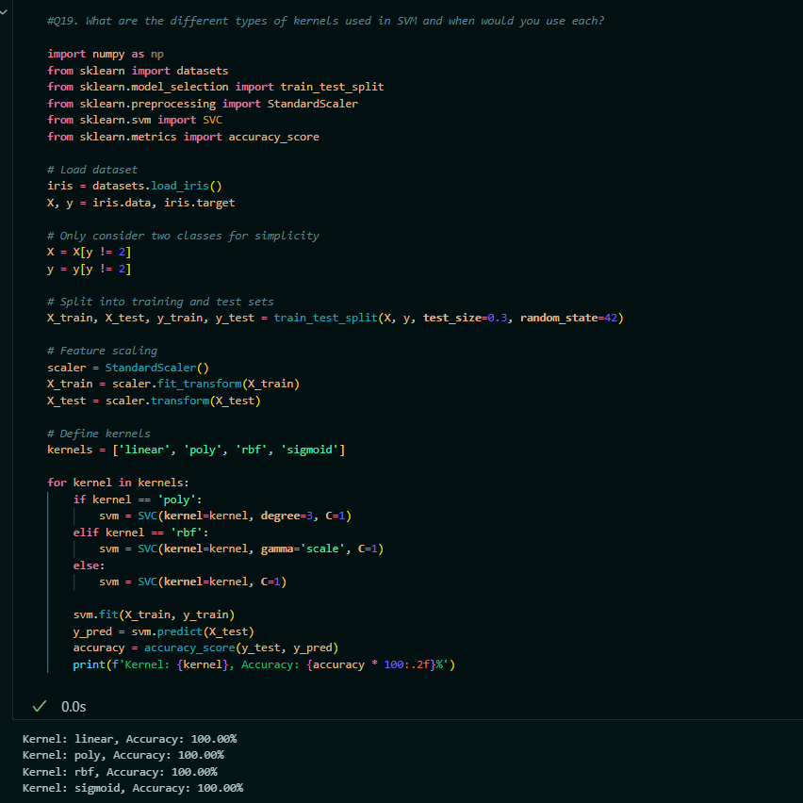

* Here:
* The degree parameter is explicitly set to 3 only for the polynomial kernel.
* The gamma parameter is set to 'scale' for the RBF kernel, which is a common setting that adapts the gamma value based on the number of features.
* The SVM classifier is initialized and trained separately for each kernel type, with the appropriate parameters specified for each kernel.
* Predictions are made on the test data, and the accuracy of each kernel is evaluated and printed.

Q20. What is the hyperplane in SVM and how is it determined?

Solution:

* In Support Vector Machines (SVM), the hyperplane is a decision boundary that separates different classes in the feature space.
* For a given set of training data, the hyperplane is the optimal separating line (or higher-dimensional equivalent) that maximizes the margin between the classes.
* **1.Hyperplane**:
* In an n-dimensional space, a hyperplane is a flat affine subspace of dimension n−1. In 2D, it’s a line; in 3D, it’s a plane; and in higher dimensions, it’s referred to as a hyperplane.
* The equation of the hyperplane can be written as: w⋅x+b=0

where w is the weight vector (normal to the hyperplane), x is the feature vector, and b is the bias term.

* **2. Margin**:
* The margin is the distance between the hyperplane and the nearest data point from either class. SVM aims to maximize this margin.
* Support vectors are the data points that lie closest to the hyperplane and influence its position and orientation.
* Determining the Hyperplane:
* **1.Optimization Problem**:
* SVM finds the hyperplane by solving an optimization problem that maximizes the margin. The optimization problem can be formulated as:

(w,b) min 1/2∥w∥^2

subject to the constraint:

yi​(w⋅xi​+b)≥1∀i

where yi​ is the class label of the iii-th training sample (+1 or −1), and xi​ is the feature vector of the *i*-th training sample.

* **2.Lagrange Multipliers**:
* The optimization problem can be solved using Lagrange multipliers to convert it into a dual problem. The dual problem involves finding the Lagrange multipliers αi that maximize the following objective function:

Maxα ​ (n∑i=1) αi​−(1/2) (n ∑​i=1) (n ∑ ​j=1) αi​αj​yi​yj​K(xi​,xj​)

subject to:

(n ∑ ​i=1)αi​yi​=0 and 0≤αi​≤C

where K(xi,xj) is the kernel function, and C is the regularization parameter.

* **3.Support Vectors**:
* The optimal hyperplane is determined by the support vectors, which are the training samples with non-zero Lagrange multipliers αi ​.
* The weight vector w can be expressed as:

w= (n∑i=1)αiyixi

The bias term b is calculated using any of the support vectors.

* E.g.
* Here in following example:
* The Iris dataset is loaded, and only the first two features are used for visualization.
* The data is converted to a binary classification problem (setosa vs. non-setosa).
* An SVM with a linear kernel is trained.
* The weight vector w\mathbf{w}w and bias term bbb are used to calculate the decision boundary.
* The data points and the decision boundary are plotted, including the margin (shaded area).

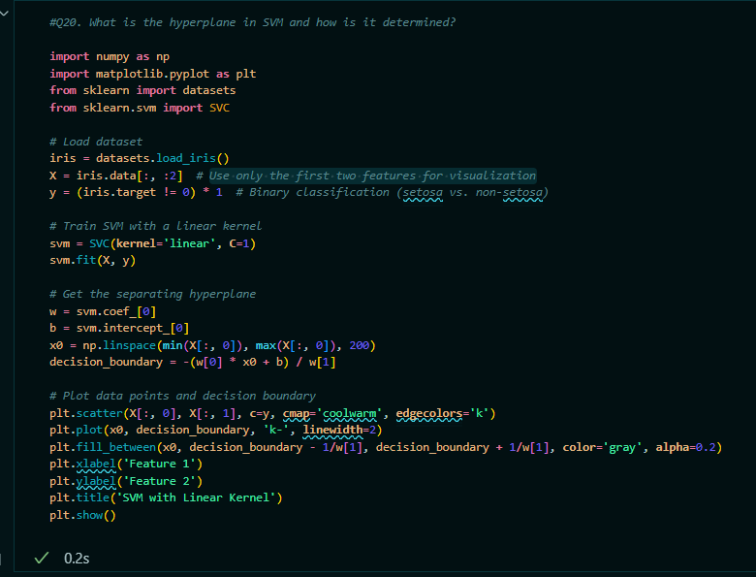

* Output:

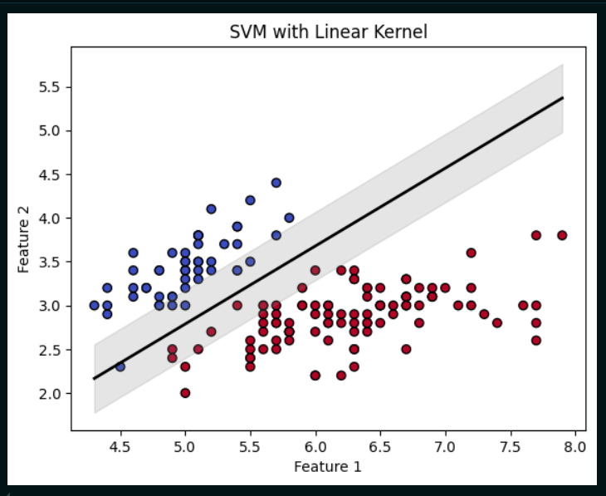

Q21. What are the pros and cons of using a Support Vector Machine (SVM)?

Solution:

* Support Vector Machines (SVM) are powerful and widely used machine learning algorithms, particularly for classification tasks.
* Pros:
* **Effective in High-Dimensional Spaces**:
* SVM performs well in high-dimensional spaces, making it suitable for datasets with many features.
* **Memory Efficient**:
* It uses a subset of training points (support vectors) to define the decision boundary, making it memory efficient.
* **Versatile with Different Kernels**:
* SVM can handle various types of data by using different kernel functions (e.g., linear, polynomial, RBF, sigmoid).
* **Robust to Overfitting**:
* SVM is less prone to overfitting, especially with appropriate regularization parameters.
* **Well-defined Margin**:
* The decision boundary is defined by the support vectors, often leading to a well-defined margin and better generalization.
* Cons:
* **Computational Complexity**:
* Training an SVM can be computationally intensive, especially with large datasets, with complexity usually between O(n^2)and O(n^3).
* **Choice of Kernel**:
* The performance of SVM is highly dependent on the choice of kernel and its parameters, which can be challenging and time-consuming to tune.
* **Not Suitable for Large Datasets**:
* SVM is not well-suited for very large datasets due to its computational complexity.
* **Difficult to Interpret**:
* SVM models can be difficult to interpret, especially when using non-linear kernels.
* **Scaling of Data**:
* SVMs are sensitive to the scaling of the data, requiring appropriate scaling before application.
* **Binary Classification**:
* SVMs are inherently binary classifiers and need to be extended for multi-class classification, which can be less efficient and more complex.

Q22. Explain the difference between a hard margin and a soft margin SVM.

Solution:

* **Hard Margin SVM:**
* A hard margin SVM seeks to find a hyperplane that perfectly separates the classes in the training data without any misclassification.
* It assumes that the data is linearly separable.
* The goal is to maximize the margin between the two classes while ensuring that all data points are correctly classified.
* In mathematical terms, it aims to maximize the distance between the hyperplane and the nearest data points, known as support vectors, with the constraint that all training samples are correctly classified.
* Constraints: The margin is maximized while ensuring that no data points lie within the margin or on the wrong side of the hyperplane.
* Limitation: t is not suitable for data that is not perfectly separable, as it requires a strict separation without any misclassifications, which can be impractical for real-world data that may contain noise or overlap.
* **Soft Margin SVM:**
* A soft margin SVM introduces slack variables to allow for some misclassification or overlap between classes.
* It is designed to handle situations where the data is not linearly separable.
* The goal is to find a hyperplane that maximizes the margin while allowing for some errors.
* This is achieved by minimizing a cost function that includes both the margin width and a penalty for misclassified points.
* The trade-off between maximizing the margin and minimizing classification errors is controlled by a regularization parameter C.
* Constraints: The margin is maximized while allowing some training points to be within the margin or misclassified, with the amount of allowed misclassification controlled by the parameter C.
* **Advantage**: It is more flexible and practical for real-world datasets where perfect separation is not possible. It can handle noisy data and overlapping classes by allowing some points to be incorrectly classified while still finding a good separating hyperplane.

Q23**.** Describe the process of constructing a decision tree.

Solution:

* Constructing a decision tree involves several steps, including data preparation, choosing the best split at each node, and pruning the tree to prevent overfitting.
* 1. **Data Preparation:**
* **Collect Data**: Gather the dataset that will be used to train the decision tree.
* **Pre-process Data**: Handle missing values, encode categorical variables, and normalize or standardize features if needed.
* 2. **Choosing the Best Split**
* At each node in the decision tree, you need to decide how to split the data. This involves choosing a feature and a threshold (for numerical features) or categories (for categorical features) that best separates the data.
* The goal is to create the most homogeneous groups possible.
* Metrics for Splitting:
* **Gini Index**:
* Measures the impurity of a node. The Gini index is calculated as:

Gini = 1− (C ∑ i=1) ​(pi​)2

* where pi​ is the proportion of instances belonging to class i, and C is the number of classes.
* **Entropy and Information Gain**:
* Entropy measures the disorder or impurity of a node. It is calculated as:

Entropy= − (C ∑ i=1) pi​ log base(2)​(pi​)

where pi​ is the proportion of instances belonging to class i.

* Information Gain is the reduction in entropy after splitting the data. It is calculated as:

Information Gain=Entropy base(parent) ​− (n ∑ j=1) ​∣Dj​∣​/∣D∣Entropy base(j)​

Where Dj​ is the subset of data for the j-th split, and ∣Dj​∣ and ∣D∣ are their sizes.

* **Variance Reduction** (for regression):
* Measures how much the variance of the target variable decreases after the split. It is calculated as:

Variance Reduction=Variance base(parent) −(∣D1∣/∣D∣Variance1+∣D2∣/∣D∣Variance2)

* **3.Constructing the Tree:**
* **Create a Root Node**: Start with the entire dataset as the root node.
* **Split Data**: Use the chosen metric to find the best feature and threshold to split the data into subsets.
* **Recursively Split**: For each subset, repeat the process of choosing the best split and creating child nodes until:

**Stopping Criteria**: A stopping criterion is met, such as

A maximum depth of the tree is reached.

The node contains fewer than a minimum number of samples.

The node is pure (all instances belong to a single class).

**Pruning**: Optionally, prune the tree to remove nodes that provide little predictive power, which helps to prevent overfitting.

* **4.Pruning the Tree:**
* Pruning involves removing branches that have little importance and can reduce the complexity of the model.
* **Pre-Pruning (Early Stopping)**:
* Stop splitting nodes if further splits do not improve the model significantly or if the tree reaches a predefined depth.
* **Post-Pruning (Cost Complexity Pruning)**:
* After the tree is fully grown, remove branches that have little impact on the model’s performance by evaluating their effect on a validation set or using statistical criteria.
* Here in following E.g.
* The Iris dataset is loaded and split into training and test sets.
* A decision tree classifier is trained using the entropy criterion and a maximum depth of 3.
* Predictions are made on the test set, and the accuracy is evaluated.
* The decision tree is visualized using plot_tree.

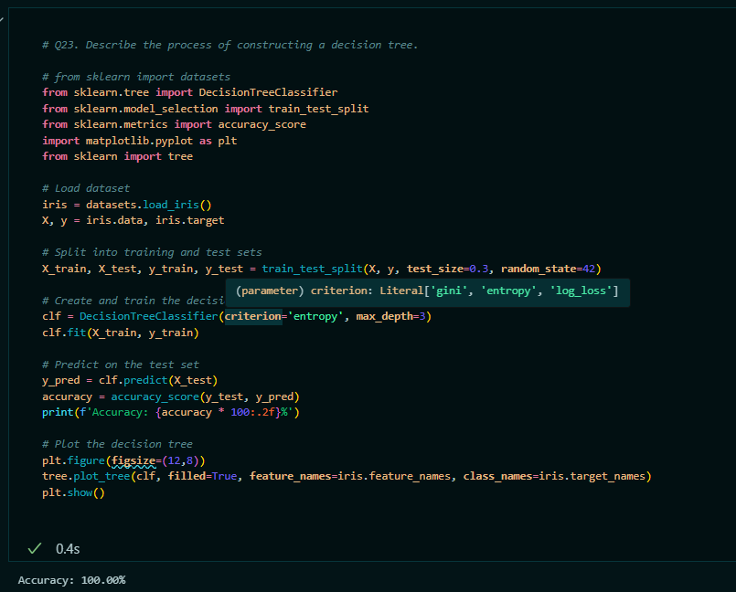

Output:

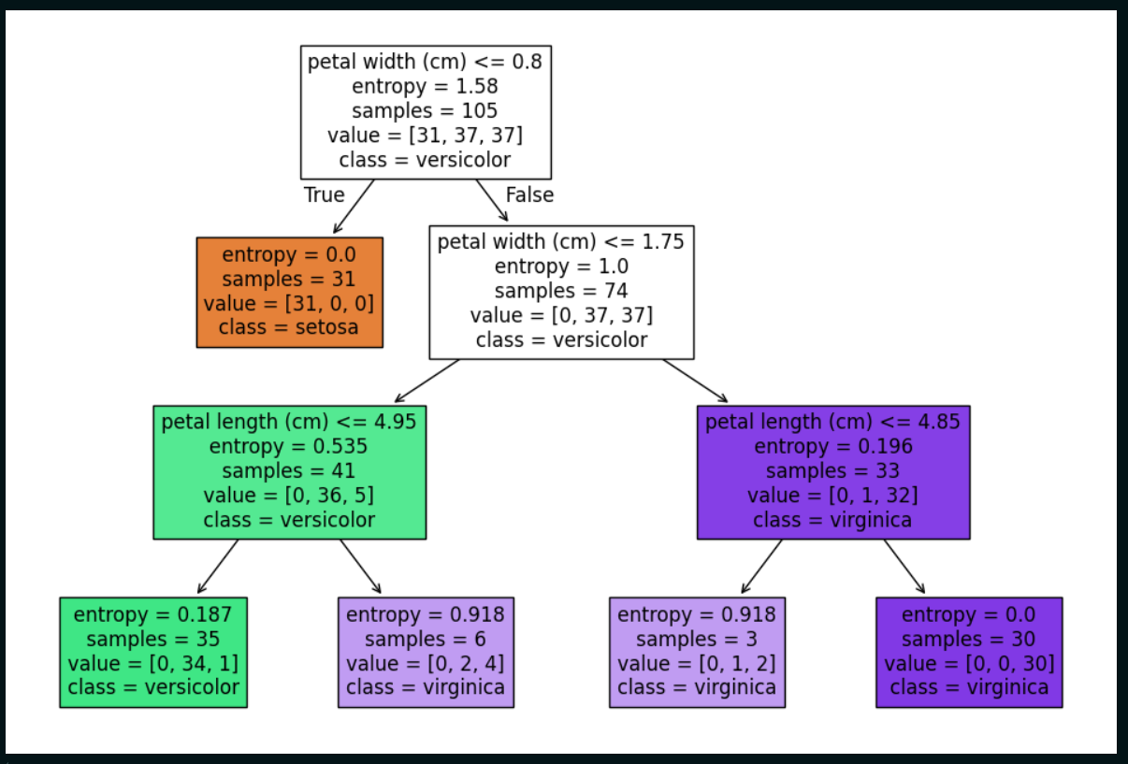

Q24. Describe the working principle of a decision tree.

Solution:

* **Initialization:**
* Start with the entire dataset at the root node.
* **Choosing the Best Split:**
* Evaluate features to determine the best way to split the data.
* Common criteria include Gini index, entropy, and variance reduction.
* **Recursive Splitting:**
* Split the data at each node based on the chosen feature and threshold.
* Continue splitting each subset until a stopping criterion is met (e.g., max depth, min samples, pure node).
* **Assigning Labels/Values:**
* For leaf nodes, assign the majority class label (classification) or average value (regression).
* **Prediction:**
* For a new data point, traverse the tree from the root to a leaf node following the decision rules.
* The prediction is the label or value at the leaf node.

Q25. What is information gain and how is it used in decision trees?

Solution:

* **Information Gain** is a metric used in decision trees to determine the best feature and threshold for splitting the data.
* It measures how much information is gained about the target variable by splitting the data based on a particular feature.
* Information Gain is calculated as the reduction in entropy (or impurity) after a split. It quantifies how well a feature separates the data into distinct classes.
* Calculation:
* **1.Entropy Before Split**:
* Entropy is a measure of uncertainty or impurity in the dataset Entropy(D) = − (C∑i=1)pi log base(2)(pi)
* where pi​ is the proportion of instances in class i in dataset D, and C is the number of classes.
* **2.Entropy After Split**:
* Calculate the weighted average of the entropy of each subset created by the split. Entropy base(split)​ = (n ∑ j=1) ​ ∣Dj​∣/​∣D∣ Entropy(Dj​)
* where Dj​ is the subset of data for the j-th split, and ∣Dj​∣ and ∣D∣ are their sizes.
* **3.Information Gain**:
* Compute the reduction in entropy, which is the difference between the entropy before and after the split.

Information Gain=Entropy(D)−Entropy base(split)​

* Usage in Decision Trees:
* **Feature Selection:**
* Information Gain helps select the best feature to split the data at each node.
* The feature with the highest Information Gain is chosen, as it provides the most significant reduction in entropy, resulting in the purest child nodes.
* **Building the Tree**:
* The decision tree algorithm uses Information Gain to recursively partition the dataset, creating branches and nodes that lead to the most informative splits.

Q26.Explain Gini impurity and its role in decision trees.

Solution:

* **Gini Impurity** is a metric used to evaluate the quality of a split in decision trees.
* It measures the impurity of a node by calculating how often a randomly chosen element from the node would be incorrectly labeled if it were randomly labeled according to the distribution of labels in that node.
* The Gini impurity of a node is given by the formula:

Gini(D) = 1− (C∑ i=1​)(pi​)^2

where:

D is the dataset at the node.

C is the number of classes.

pi​ is the proportion of instances in class iii within the node.

* Calculation:
* **Calculate Class Proportions**:

For each class iii in the node, compute the proportion pip_ipi​ of instances belonging to that class.

* **Compute Gini Impurity**:

Plug the class proportions into the Gini impurity formula.

* Role in Decision Trees:

**Choosing the Best Split**:

At each node, the decision tree algorithm evaluates possible splits based on Gini impurity.

For each potential split, calculate the Gini impurity of the resulting child nodes and compute the weighted average of these impurities.

* **Minimizing Impurity**:
* The feature and split that result in the lowest weighted average Gini impurity for the child nodes are chosen.
* This process aims to create child nodes that are as pure as possible, meaning they contain instances of a single class or as few classes as possible.
* **Building the Tree**:
* Recursively apply the splitting process using Gini impurity to partition the data into subsets that improve the purity of the nodes, leading to the final decision tree.

Q27. What are the advantages and disadvantages of decision trees.

Soultion:

* **Advantages of Decision Trees**
* **1.Interpretability:**
* Decision trees are easy to understand and interpret. They provide a clear visual representation of decision-making processes and rules.
* **2.No Need for Feature Scaling:**
* They do not require feature scaling (e.g., normalization or standardization), making them simpler to preprocess.
* **3.Handling of Mixed Data Types:**
* Decision trees can handle both numerical and categorical features.
* **4.Non-Linear Relationships:**
* They can model non-linear relationships between features and the target variable.
* **5.Feature Importance:**
* They can provide insights into the importance of different features in predicting the target variable.
* **Disadvantages of Decision Trees**
* **1.Overfitting:**
* Decision trees can easily overfit the training data, especially with deep trees that capture noise or anomalies.
* **2.Instability:**
* Small changes in the data can result in different tree structures, making them sensitive to variations in the training data.
* **3.Bias Towards Features with More Levels:**
* Trees may favor features with more levels (categories) or numerical splits, potentially leading to biased splits.
* **4.Complexity with Many Features:**
* They can become complex and less interpretable with a large number of features and deep trees.
* **5.Greedy Algorithm:**
* The splitting decisions are made using a greedy algorithm, which may not always lead to the globally optimal tree structure.
* Overall, while decision trees are powerful and versatile, they require careful tuning and may benefit from techniques like pruning and ensemble methods (e.g., random forests) to mitigate some of their disadvantages.

Q28. How do random forests improve upon decision trees

Solution:

* **Random Forests** improve upon decision trees by combining multiple decision trees to create a more robust and accurate model. Here’s how they address the limitations of individual decision trees:
* **1. Reduction of Overfitting:**
* **Ensemble Method**: Random forests build multiple decision trees (a forest) and aggregate their predictions. By averaging the predictions for regression or using majority voting for classification, they reduce the risk of overfitting that a single decision tree might experience.
* **2. Increased Stability**
* **Bagging**: Random forests use a technique called bootstrap aggregating (bagging). Each tree is trained on a different random subset of the data with replacement, which helps in averaging out the variability and reducing the impact of noisy data.
* **3. Improved Accuracy**
* **Voting/Averaging**: For classification, the majority vote from multiple trees is used to make a final decision. For regression, the average prediction of all trees is used. This aggregation typically leads to improved accuracy compared to a single tree.
* **4. Reduction of Variance**
* **Diverse Trees**: By training each tree on a different subset of the data and considering only a random subset of features for each split, random forests reduce the variance of the model. Individual trees may have high variance, but averaging their predictions leads to a more stable and generalized model.
* **5. Handling of High-Dimensional Data**
* **Feature Randomization**: Random forests randomly select subsets of features for each split, making them effective in handling high-dimensional datasets and reducing the risk of overfitting to specific features.
* **6. Feature Importance**
* **Feature Evaluation**: Random forests can evaluate the importance of features by measuring how much each feature improves the impurity of the nodes across all trees. This helps in understanding which features are most significant.

Q29. How does a random forest algorithm work?

Solution:

* The Random Forest algorithm works by creating a collection of decision trees (a "forest") and combining their outputs to make predictions. Here’s a step-by-step overview of how it works:
* **1. Data Sampling (Bootstrapping):**
* **Create Subsets**: Generate multiple subsets of the training data using bootstrap sampling (sampling with replacement). Each subset is used to train a different decision tree.
* **Sample Size**: Each subset typically has the same number of instances as the original dataset, but some instances may be repeated while others are left out
* **2. Feature Selection for Splits**
* **Random Feature Subsets**: For each decision tree, at each split, only a random subset of features is considered. This helps in creating diverse trees and reduces the correlation between them.
* **3. Training Decision Trees**
* **Build Trees**: Train a decision tree on each bootstrap sample using the randomly selected features. Each tree is grown to its maximum depth or until a stopping criterion is met (e.g., minimum samples at a node).
* **4. Prediction**
* **Aggregate Predictions**:
* **Classification**: Each tree in the forest makes a classification decision. The final prediction is determined by majority voting, where the class with the most votes across all trees is selected.
* **Regression**: Each tree predicts a continuous value. The final prediction is the average of the predictions from all trees.
* **5. Output**
* **Final Decision**: The combined output from all trees provides a more accurate and stable prediction compared to any single tree.

Q30. What is bootstrapping in the context of random forest?

Solution:

* In the context of Random Forest, **bootstrapping** refers to a sampling technique used to create multiple training datasets for building individual decision trees
* **Bootstrapping**:   
  It is a method of sampling with replacement from the original dataset to create multiple distinct training subsets.
* **Bootstrapping Works:**
* **1. Original Dataset**:

Start with the complete dataset, D, with n instances.

* **2. Generate Bootstrap Samples**:
* **Sampling with Replacement**:

Randomly select n instances from D, allowing for the possibility that some instances may be selected more than once while others may not be selected at all.

* **Create Multiple Samples**:

Repeat the sampling process to generate multiple bootstrap samples. Each sample is used to train a separate decision tree.

* **3. Training Decision Trees**:
* **Individual Training**:

Train a decision tree on each bootstrap sample. Each tree is trained on a slightly different subset of data due to the sampling variability.

* **Benefits of Bootstrapping in Random Forest:**
* **Reduction of Variance**:
* By averaging the predictions of multiple trees trained on different samples, bootstrapping helps to reduce the variance of the model and improve generalization.
* **Diverse Trees**: Bootstrapping creates diversity among the trees in the forest because each tree is trained on a different subset of the data, which helps in improving the overall performance of the Random Forest.
* **Handling of Outliers**: Since some instances are excluded from each bootstrap sample, the trees are less likely to overfit to outliers present in the data.

Q31. Explain the concept of feature importance in random forests.

Solution:

* **Feature Importance** in Random Forests measures the contribution of each feature to the model’s predictions. It helps in understanding which features are most valuable for making accurate predictions.
* Concept of Feature Importance:
* **Definition:**
* Feature importance quantifies how much a feature contributes to the reduction in impurity (e.g., Gini impurity or entropy) across all decision trees in the forest.
* **Calculation:**
* **Impurity Reduction:** For each feature, calculate how much it reduces the impurity (or entropy) at each node where it is used for splitting.
* **Average Reduction:** Compute the average reduction in impurity across all trees for each feature.
* **Normalized Scores:** Normalize these values to provide a ranking of feature importance, with higher values indicating greater importance.
* Steps to Compute Feature Importance:
* **1. Train the Random Forest:**
* Build the forest using multiple decision trees with each tree trained on a bootstrap sample and considering random subsets of features.
* **2. Compute Node Impurity Reduction:**
* For each tree, at each split, measure how much the feature used reduces the impurity in the node.
* Accumulate this reduction across all nodes where the feature is used.
* **3. Aggregate Across Trees:**
* Sum the total reduction in impurity for each feature across all trees in the forest.
* **4. Normalize and Rank:**
* Normalize the importance scores to ensure they sum to one or to a scale that allows for easy comparison.
* Rank features based on their importance scores.
* **Role and Benefits:**
* **Feature Selection:** Identifying important features helps in feature selection and dimensionality reduction by focusing on the most significant features and potentially discarding less useful ones.
* **Model Interpretation:** Understanding feature importance provides insights into the decision-making process of the Random Forest model, aiding in model interpretation and explainability.
* **Improved Performance:** By focusing on important features, models can be simplified, potentially improving performance and reducing overfitting.

Q32.What are the key hyperparameters of a random forest and how do they affect the model?

Solution:

* Here are the key hyperparameters of a Random Forest and their effects on the model:
* **1. n_estimators:**
* Number of trees in the forest.
* **Effect**: More trees generally improve the model's performance and stability but increase computational cost. Too few trees might lead to underfitting, while too many might lead to increased training time.
* **2. max_depth:**
* Maximum depth of each decision tree.
* **Effect**: Controls the growth of the trees. Deeper trees can capture more complex patterns but are more likely to overfit the training data. Shallower trees are less complex and might underfit.
* **3**. **min_samples_split:**
* Minimum number of samples required to split an internal node.
* **Effect:** Higher values prevent nodes from splitting if they don’t have enough samples, leading to simpler trees. Lower values allow more splits, potentially capturing more detail but increasing the risk of overfitting.
* **4. min_samples_leaf:**
* Minimum number of samples required to be at a leaf node.
* **Effect:** Ensures that a node has a minimum number of samples before making a split. Higher values can smooth the model and prevent overfitting by making the model less sensitive to small fluctuations in the data.
* **5. max_features**:
* Number of features to consider when looking for the best split.
* **Effect:** Reduces the correlation between trees by randomly selecting a subset of features for each split. Lower values make the model more diverse and can improve generalization but may reduce accuracy. Higher values may increase model complexity.
* **6. Bootstrap:**
* Whether to use bootstrap samples (sampling with replacement) for building trees.
* **Effect:** If True, each tree is trained on a different random subset of the data, enhancing diversity. If False, all trees are trained on the full dataset, which might increase correlation between trees but reduce variability.
* **7. oob_score:**
* Whether to use out-of-bag samples to estimate the generalization accuracy.
* **Effect:** If True, the model will use out-of-bag samples (data not used in the training of each tree) to provide an estimate of the model’s performance, useful for cross-validation and model evaluation.
* **8. Criterion:**
* The function to measure the quality of a split (e.g., Gini impurity or entropy for classification, variance reduction for regression).
* **Effect:** Determines how splits are evaluated. Changing the criterion can affect the structure of the trees and the model’s performance.

Q33. Describe the logistic regression model and its assumptions.

Solution:

* **Logistic Regression Model:**
* Logistic Regression is a statistical model used for binary classification problems. It estimates the probability that a given input belongs to a particular class by applying the logistic function to a linear combination of input features.
* Key Components:
* **1. Logistic Function**:
* The logistic function (also known as the sigmoid function) is used to map predicted values to probabilities between 0 and 1.
* Formula: σ(z)=11+e−z\sigma(z) = \frac{1}{1 + e^{-z}}σ(z)=1+e−z1​ where zzz is the linear combination of the input features and their coefficients.
* **2. Model Equation:**
* The model predicts the probability of the positive class (label = 1) as:

P(Y=1∣X)= 1/1+e−(β0+β1X1+β2X2+⋯+βpXp)

* Where β0​ is the intercept, β1​,β2​,…,βp​ are the coefficients, andX1​,X2​,…,Xp​ are the input features.
* **3. Classification Decision:**
* The predicted class is determined by applying a threshold (commonly 0.5) to the predicted probability:

Class= 1 if P(Y=1∣X)>0.50}

Class= 0 if P(Y=1∣X)<=0.50}

* **Assumptions of Logistic Regression:**
* **1. Linearity of Logits:**
* Assumes a linear relationship between the log-odds of the dependent variable and the independent variables.
* The log-odds or logit function is:

log( P(Y=1∣X) / 1−P(Y=1∣X) ) = β0+β1X1+β2X2+⋯+βpXp

* **2. Independence of Errors:**
* Assumes that the observations are independent of each other. The model assumes that the error terms are not correlated.
* **3. No Multicollinearity:**
* Assumes that the independent variables are not too highly correlated with each other. High multicollinearity can make it difficult to estimate the coefficients accurately.
* **4.Binary Outcome:**
* Assumes that the dependent variable is binary (i.e., it takes on two possible outcomes).
* **5.Large Sample Size:**
* Logistic regression performs better with a larger sample size. Smaller datasets may lead to less reliable estimates.
* Logistic Regression is used for binary classification and predicts probabilities using the logistic function.
* Assumptions: Linearity of logits, independence of errors, no multicollinearity, binary outcome, and generally requires a large sample size.

Q34. How does logistic regression handle binary classification problems?

Solution:

* **Logistic Regression** handles binary classification problems by estimating the probability of a data point belonging to one of the two classes.
* **1. Model Representation:**
* **Linear Combination:**
* Logistic regression starts by computing a linear combination of the input features. For p features, the model can be represented as:

z=β0​+β1​X1​+β2​X2​+⋯+βp​Xp​

Where β0​ is the intercept, β1,β2,…,βp are the coefficients, and X1,X2,…,Xp are the features.

* **2. Logistic Function (Sigmoid Function):**
* **Probability Calculation:**
* Apply the logistic function (sigmoid function) to the linear combination to map the result to a probability between 0 and 1:

P(Y=1∣X)=1/1+e^−z​

This represents the probability of the data point belonging to the positive class (class 1).

* **3.Classification Decision:**
* **Thresholding:**
* To make a final classification decision, compare the predicted probability to a threshold (usually 0.5):

Class= 1 if P(Y=1∣X)>0.50}

Class= 0 if P(Y=1∣X)<=0.50}

* If the probability exceeds the threshold, classify the instance as class 1; otherwise, classify it as class 0.
* **4. Model Training:**
* **Estimation of Coefficients:**
* Use optimization techniques (e.g., Gradient Descent or Maximum Likelihood Estimation) to estimate the coefficients (β) that best fit the training data.
* The goal is to minimize the log-loss or cross-entropy loss function

Log-Loss=−(1/N)​ (N∑ i=1) ​[yi ​log(P(Y=1∣Xi​))+(1−yi​)log(1−P(Y=1∣Xi​))]

Where yi​ is the actual class label, and P(Y=1∣Xi) is the predicted probability for the i-th data point.

Q35. What is the sigmoid function and how is it used in logistic regression.

Solution:

* The **sigmoid function** is a mathematical function used in logistic regression to map predicted values to probabilities between 0 and 1.
* It is crucial for transforming the output of the linear combination of features into a probability score for binary classification.
* The sigmoid function, also known as the logistic function, is defined as:

σ(z)= 1/1+e−z​

Where z is the input to the function, which is typically the linear combination of the features and their corresponding weights.

* Properties of the Sigmoid Function:
* **Output Range**:
* The sigmoid function outputs values between 0 and 1. This makes it suitable for modeling probabilities.
* **S-shaped Curve**:
* The function has an S-shaped curve (sigmoid curve), which transitions smoothly from 0 to 1.
* **Asymptotic Behavior**:
* As z approaches positive infinity, σ(z) approaches 1.
* As z approaches negative infinity, σ(z) approaches 0.
* **Gradient**:
* The sigmoid function has a derivative that is used in optimization algorithms. The gradient can be expressed as:

σ′(z)=σ(z)⋅(1−σ(z))

* Usage in Logistic Regression:
* **Probability Estimation**:
* In logistic regression, the sigmoid function is applied to the linear combination of input features and model coefficients to produce a probability estimate.
* For a given input vector X and coefficients β, the linear combination is

z=β0​+β1​X1​+β2​X2​+⋯+βp​Xp​

* The sigmoid function is then used to convert z into a probability

P(Y=1∣X)=1/1+e^−z

* **Classification Decision**:
* The predicted probability is compared to a threshold (usually 0.5) to make a classification decision:

Class= 1 if P(Y=1∣X)>0.50}

Class= 0 if P(Y=1∣X)<=0.50}

* **Model Training**:
* During training, the logistic regression algorithm uses the sigmoid function to compute the predicted probabilities and adjusts the model coefficients to minimize the log-loss (cross-entropy loss) between predicted probabilities and actual class labels.
* The sigmoid function is used in logistic regression to map the output of a linear combination of features to a probability between 0 and 1. It enables the model to estimate the probability of a binary outcome and is integral to the classification and training process.

Q36. Explain the concept of the cost function in logistic regression.

Solution:

* The **cost function** (or loss function) in logistic regression is a measure of how well the model’s predictions match the actual labels.
* It quantifies the error between predicted probabilities and true outcomes, and the goal of training the model is to minimize this cost.
* Concept of the Cost Function in Logistic Regression

The cost function used in logistic regression is the **Log-Loss** or **Cross-Entropy Loss**. It measures the difference between the predicted probabilities and the actual binary class labels.

* Formula:

For a single data point, the log-loss cost function is defined as:

Log-Loss = −[ylog(P(Y=1∣X))+(1−y)log(1−P(Y=1∣X))]

Where: y is the actual binary label (0 or 1).

P(Y=1∣X) is the predicted probability that the label is 1 given the input features X.

* **Overall Cost Function**:

For a dataset with NNN examples, the overall cost function is the average log-loss across all data points:

Cost=−1/N​ (N ∑ i=1) ​[yi​log(P(Y=1∣Xi​))+(1−yi​)log(1−P(Y=1∣Xi​))]

Where yi​ and P(Y=1∣Xi) are the actual label and predicted probability for the i-th data point.

* Cost function works:
* **Penalty for Incorrect Predictions**:
* The log-loss function penalizes predictions based on the confidence of the incorrect classification.
* If y=1 and P(Y=1∣X) is close to 0, the log-loss is high, reflecting a large error. Conversely, if P(Y=1∣X) is close to 1, the penalty is low.
* **Balanced Handling of Both Classes**:
* The cost function treats both classes (0 and 1) equally. It penalizes wrong predictions regardless of whether the true label is 0 or 1.
* **Optimization**:
* During training, optimization algorithms (e.g., Gradient Descent) adjust the model’s coefficients to minimize the cost function.
* Minimizing the cost function means improving the accuracy of the model’s predictions by making the predicted probabilities as close as possible to the actual class labels.

Q37. How can logistic regression be extended to handle multiclass classification?

Solution:

* Logistic Regression can be extended to handle multiclass classification problems using two main approaches:
* **1.One-vs-Rest (OvR) or One-vs-All (OvA):**
* In the One-vs-Rest approach, a separate binary logistic regression model is trained for each class.
* Each model predicts the probability of a data point belonging to that class versus all other classes.
* **Working:**
* **Training:**
* For a classification problem with K classes, train K separate logistic regression models.
* Each model is trained to distinguish one class from the remaining K−1 classes.
* **Prediction:**
* For a new data point, each model provides a probability of the point belonging to its respective class.
* The class with the highest probability among the K models is chosen as the final prediction.
* Example:
* For a 3-class problem (classes A, B, C):
  + Train one model to classify A vs. B & C.
  + Train another model to classify B vs. A & C.
  + Train a third model to classify C vs. A & B.
* **2. One-vs-One (OvO):**
* In the One-vs-One approach, a separate binary logistic regression model is trained for every possible pair of classes.
* Each model decides which of the two classes the data point belongs to.
* **Working:**
* **Training**:
* For a classification problem with K classes, train K(K−1)/2 binary classifiers.
* Each model is trained to distinguish between two of the classes.
* **Prediction**:
* For a new data point, each model provides a vote for one of the two classes.
* The class with the majority of votes among all models is chosen as the final prediction.
* Example:
  + For a 3-class problem (classes A, B, C):
  + Train a model to classify A vs. B.
  + Train another model to classify A vs. C.
  + Train a third model to classify B vs. C.
* **Softmax Regression (Multinomial Logistic Regression)**
* Softmax regression is an extension of logistic regression that generalizes the binary case to multiclass problems.
* It directly models the probabilities of each class without needing to construct multiple binary classifiers.
* **Working:**
* **Model Equation**:
* The probability of class k for input X is given by the softmax function

P(Y=k∣X)= e^(((β base(k))^T(​X)) ​/ (K ∑j=1)​eβjT​X e^(((β base(k))^T(​X))​

Where βbase(k)​ is the coefficient vector for class k, and K is the number of classes

* **Training:**
* The model is trained using a single optimization process to minimize the cross-entropy loss function across all classes:

Log-Loss=− (N ∑ i=1) ​ (K∑k=1) ​y base(ik) ​log(P(Y=k∣Xi​))

Where ybase(ik) is 1 if the true label of the i-th sample is k, and 0 otherwise.

* **Prediction:**
* The class with the highest probability given by the softmax function is selected as the final prediction.

Q38. What is the difference between L1 and L2 regularization in logistic regression.

Solution:

* **L1** and **L2 regularization** are techniques used in logistic regression to prevent overfitting by adding a penalty to the loss function. Here’s how they differ:
* **L1 Regularization (Lasso Regularization):**
* L1 regularization adds a penalty equal to the absolute value of the coefficients to the loss function.
* **Penalty Term**:
* The L1 penalty term is

L1 Penalty=λ (p∑j=1)∣βj​∣

Where λ is the regularization parameter, and βj​ represents the model coefficients.

* **Effect**:
* Encourages sparsity in the model by forcing some coefficients to be exactly zero.
* Useful for feature selection, as it can reduce the number of variables used in the model by setting less important coefficients to zero.
* **Implementation**:
* In practice, it can lead to simpler models with fewer features, which can be beneficial when dealing with high-dimensional data.

**L2 Regularization (Ridge Regularization):**

* L2 regularization adds a penalty equal to the square of the coefficients to the loss function.
* The L2 penalty term is:

L2 Penalty=λ (p∑j=1) β^2 base(j)

Where λ is the regularization parameter, and βj​ represents the model coefficients.

* **Effect**:
* Encourages smaller coefficients but does not set them exactly to zero.
* Helps in reducing the model’s complexity by penalizing large coefficients, which can improve generalization and prevent overfitting.
* **Implementation**:
* Results in a model where all features contribute to the prediction but with smaller, more controlled coefficients.
* **Differences:**
* **Penalization Type:**

L1 Regularization: Penalizes the absolute value of coefficients (sparsity-inducing).

L2 Regularization: Penalizes the square of coefficients (shrinkage-inducing).

* **Feature Selection:**

L1 Regularization: Can produce sparse models by setting some coefficients to zero, thus performing feature selection.

L2 Regularization: Typically keeps all features but with smaller coefficients.

* **Coefficient Impact:**

L1 Regularization: Can lead to zero coefficients, effectively removing some features from the model.

L2 Regularization: Reduces the magnitude of coefficients but generally does not eliminate them.

**Combination:**

Elastic Net Regularization: Combines both L1 and L2 penalties to leverage the benefits of both techniques.

Q39. What is XGBoost and how does it differ from other boosting algorithms?

Solution:

* **XGBoost** (Extreme Gradient Boosting) is an advanced implementation of the gradient boosting framework designed for efficiency, scalability, and performance. It improves upon traditional boosting algorithms with several enhancements.
* **Features of XGBoost:**
* **1. Gradient Boosting Framework**:
* XGBoost is based on gradient boosting, which builds models in a sequential manner where each new model corrects errors made by the previous models.
* It uses decision trees as base learners.
* **2. Regularization**:
* XGBoost incorporates both L1 (Lasso) and L2 (Ridge) regularization to prevent overfitting. This is a significant improvement over traditional gradient boosting methods which do not include regularization.
* **3. Handling Missing Values**:
* XGBoost can handle missing values internally by learning the best way to handle them during training, which is not always the case with other boosting algorithms.
* **4. Parallelization**:
* XGBoost supports parallel processing, which speeds up the training process. It can use multiple cores for computation, making it faster than many other implementations of boosting.
* **5. Tree Pruning**:
* XGBoost uses a depth-first approach for tree construction, which allows it to perform better pruning of the trees compared to the level-wise approach used in some other boosting algorithms.
* **6. Scalability**:
* Designed to be highly scalable and efficient, XGBoost can handle large datasets with many features due to its optimization techniques.
* **7. Flexibility**:
* XGBoost supports various objective functions, including regression, classification, and ranking problems. It also allows custom objective functions and evaluation criteria.
* **8. Boosting Algorithm Variants**:
* XGBoost supports both gradient boosting and the more advanced **DART** (Dropouts meet Multiple Additive Regression Trees) algorithm, which improves model performance by introducing randomness to the boosting process.
* **Differences from Other Boosting Algorithms:**
* **1. Performance and Speed**:
* **XGBoost** is often faster and more efficient due to its optimization techniques, including parallel processing and more efficient computation of gradients.
* **2. Regularization**:
* Unlike traditional gradient boosting methods (like **AdaBoost** or **GBM),** XGBoost includes built-in regularization (L1 and L2), which helps control model complexity and prevents overfitting.
* **3. Handling Missing Values**:
* **XGBoost** has an internal mechanism for handling missing values, whereas many other algorithms require preprocessing or imputation of missing data.
* **4. Tree Construction**:
* **XGBoost** uses a depth-first approach with a more sophisticated pruning strategy, while some other algorithms use a level-wise approach for tree construction.
* **5. Scalability**:
* **XGBoost** is designed to be highly scalable and efficient, capable of handling large datasets and high-dimensional feature spaces more effectively than some other boosting implementations.
* **6. Implementation and Customization**:
* **XGBoost** offers extensive customization options and supports a variety of loss functions and evaluation metrics, providing greater flexibility compared to some other boosting frameworks.

Q40. Explain the concept of boosting in the context of ensemble learning?

Solution:

* Boosting is an ensemble learning technique used to improve the accuracy of predictive models. It involves combining multiple weak learners (models that perform slightly better than random guessing) to create a stronger overall model. Here’s how boosting works in the context of ensemble learning:
* Concepts of Boosting:
* **Weak Learners:**
* These are models that are only slightly better than random guessing. Typically, decision stumps (simple decision trees with one split) are used as weak learners.
* **Sequential Learning:**
* Boosting trains weak learners sequentially. Each new model is trained to correct the errors made by the previous models. This sequential approach ensures that each model focuses on the mistakes of its predecessors.
* **Weight Adjustment:**
* During the training process, boosting algorithms adjust the weights of the training instances. Instances that were misclassified by previous models are given higher weights, making them more prominent in the training of the next model. This ensures that subsequent models focus more on the difficult cases.
* **Combination of Learners:**
* After all the weak learners are trained, their predictions are combined to produce the final output. This combination is usually done through a weighted sum or vote, where each model’s contribution is proportional to its accuracy.
* **Types of Boosting Algorithms:**
* **1. AdaBoost (Adaptive Boosting):**
* Concept: AdaBoost assigns weights to each training instance. Misclassified instances have their weights increased, so subsequent models focus more on these hard-to-classify cases.
* Training: Each weak learner is trained on a weighted version of the dataset. The error rate of each learner is used to adjust the weights of the instances.
* Combination: The final prediction is a weighted sum of the predictions from all weak learners.
* **2. Gradient Boosting:**
* Concept: Gradient Boosting builds models sequentially, with each new model trained to correct the residual errors (differences between the predicted and actual values) of the combined previous models.
* Training: Each weak learner is trained to predict the residuals of the current combined model.
* Combination: The final model is the sum of all the weak learners, each weighted by their respective contributions to reducing the residual error.
* **3. XGBoost (Extreme Gradient Boosting):**
* Concept: XGBoost is an optimized version of Gradient Boosting, designed for speed and performance. It includes additional features like regularization, parallel processing, and efficient handling of missing data.
* Training: Similar to Gradient Boosting, but with enhancements like tree pruning, regularization to prevent overfitting, and advanced optimization techniques.
* Combination: The final model is the sum of all the weak learners, each optimized and regularized to improve performance and prevent overfitting.
* **Advantages of Boosting:**
* **1. Improved Accuracy:**
* Boosting often results in higher accuracy compared to individual weak learners by focusing on the errors and refining the model iteratively.
* **2. Flexibility:**
* Boosting can be applied to various types of models and loss functions, making it a versatile tool in machine learning.
* **3. Reduced Overfitting:**
* With proper regularization and model tuning, boosting can reduce the risk of overfitting compared to single, more complex models.
* **Disadvantages of Boosting**
* **1. Computational Complexity:**
* Boosting can be computationally intensive and time-consuming due to its sequential training process and the need to train multiple models.
* **2. Sensitivity to Noisy Data:**
* Boosting algorithms can be sensitive to noisy data and outliers since they focus heavily on hard-to-classify instances.
* **3. Model Complexity:**
* The resulting models from boosting algorithms can be complex and harder to interpret compared to simpler models.

Q41. How does XGBoost handle missing values.

Solution:

* XGBoost handles missing values efficiently through an automated process that involves the following steps:
* **1. Sparsity Awareness:**
* XGBoost is designed to work with sparse data and treats missing values as a natural part of the data.
* **2. Default Direction:**
* During training, for each decision tree split, XGBoost assigns a default direction (either left or right) for instances with missing values. This default direction is chosen to minimize the loss function.
* **3. Optimal Splits:**
* XGBoost evaluates potential splits by considering instances with non-missing values and instances with missing values separately. It finds the split that results in the lowest loss by determining the best way to handle missing values.
* **4. Imputation During Prediction:**
* When making predictions, if an instance has missing values, XGBoost uses the learned default directions to navigate the tree, ensuring accurate predictions despite missing data.
* E.g.

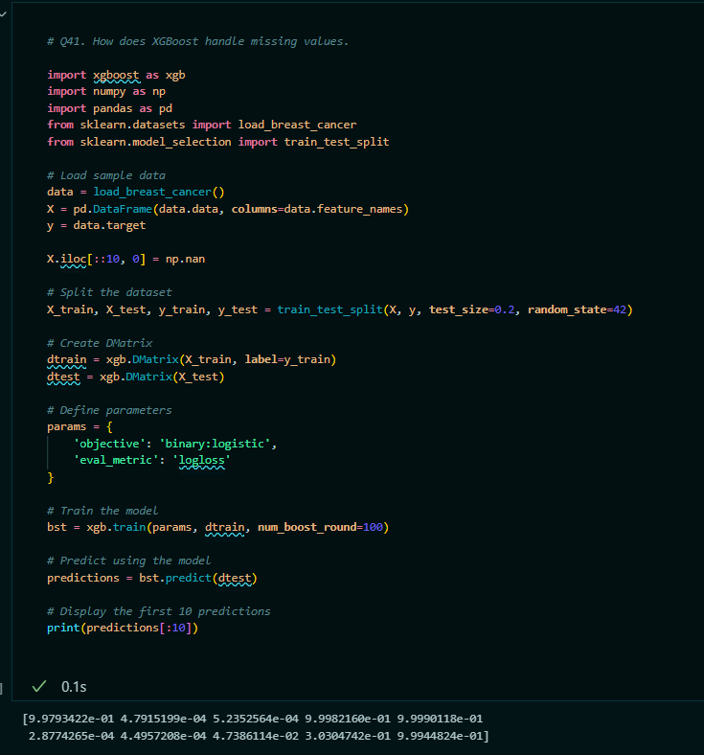

Q42. What are the key hyperparameters in XGBoost and how do they affect model performance.

Solution:

* Hyperparameters:
* **1. n_estimators (or num_boost_round):**

Number of boosting rounds (trees).

**Effect**: Increasing the number of boosting rounds can improve model performance up to a point, but too many rounds can lead to overfitting.

* **2. learning_rate (or eta):**

Step size shrinkage used to prevent overfitting.

**Effect**: Smaller values of learning_rate require more boosting rounds but can improve the model's robustness and accuracy. Typical values range from 0.01 to 0.3.

* **3. max_depth:**

Maximum depth of a tree.

**Effect**: Controls the complexity of the model. Deeper trees can model more complex relationships but are more prone to overfitting. Typical values range from 3 to 10.

* **4. min_child_weight:**

Minimum sum of instance weight (hessian) needed in a child.

**Effect**: Higher values prevent overfitting by making the algorithm more conservative. Useful when dealing with imbalanced classes.

* **5. Subsample:**

Fraction of training data used for growing each tree.

**Effect:** Prevents overfitting by introducing randomness. Values range from 0.5 to 1.0.

* **6. colsample_bytree:**

Fraction of features used for each tree.

**Effect:** Similar to subsample, this parameter introduces randomness and helps prevent overfitting. Values typically range from 0.5 to 1.0.

* **7.gamma (or min_split_loss):**

Minimum loss reduction required to make a further partition on a leaf node.

**Effect:** Higher values make the algorithm more conservative and prevent overfitting. Typical values range from 0 to 5.

* **8.lambda (or reg_lambda):**

L2 regularization term on weights.

**Effect:** Reduces overfitting by penalizing large weights. Typical values are 0 (no regularization) to 10.

* **9. alpha (or reg_alpha):**

L1 regularization term on weights.

**Effect:** Can lead to sparsity in the weights, helping in feature selection. Typical values range from 0 to 1.

* **10.** **scale_pos_weight:**

Description: Balancing of positive and negative weights.

**Effect:** Useful for imbalanced classes, where positive and negative classes are not equally represented.

* Effects on Model Performance:
* **1. Preventing Overfitting:**

Hyperparameters like max_depth, min_child_weight, gamma, subsample, and colsample_bytree help control model complexity and prevent overfitting.

* **2. Improving Accuracy:**

n_estimators and learning_rate are crucial for improving model accuracy. A balance between these two parameters is essential to avoid overfitting and underfitting.

* **3. Handling Imbalanced Data:**

Parameters like scale_pos_weight, min_child_weight, and subsample can be tuned to handle imbalanced datasets effectively.

* E.g.

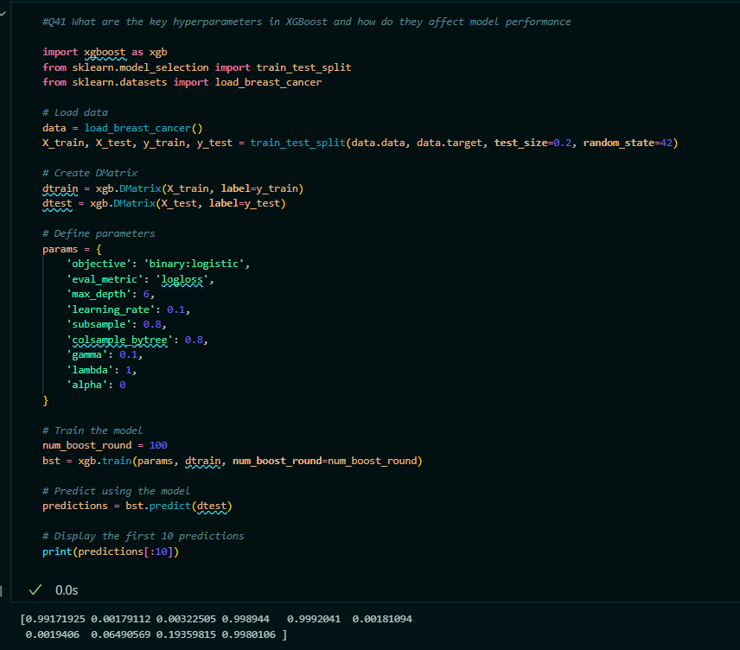

Q43. Describe the process of gradient boosting in XGBoost.

Solution:

* Gradient Boosting in XGBoost is an iterative process that builds a strong predictive model by combining multiple weak learners (typically decision trees).
* Here’s a detailed description of how gradient boosting works in XGBoost:
* **Gradient Boosting Process in XGBoost:**
* **1. Initialization:**
* **Initial Prediction:**

The process starts with an initial prediction, which is usually the mean of the target values for regression tasks or a uniform probability for classification tasks.

* **2. Iteration (Boosting Rounds):**
* **Calculate Residuals:**

For each iteration (or boosting round), calculate the residuals (errors) of the current model’s predictions. The residuals are the differences between the true target values and the predicted values.

Residual=True Value−Predicted Value.

* **Fit a New Model:**

Train a new weak learner (usually a decision tree) to predict these residuals. The goal is for this new model to capture the errors made by the previous models.

* **Compute the Gradient:**

In gradient boosting, the new model is trained to approximate the gradient of the loss function with respect to the predictions. This gradient indicates the direction to adjust the model’s predictions to minimize the loss function.

* **Update Model:**

Update the model’s predictions by adding a fraction of the new model’s predictions (scaled by a learning rate) to the current predictions.

Updated Prediction=Current Prediction+Learning Rate×New Model’s Prediction

* **Repeat:**

Repeat the process for a predefined number of boosting rounds or until the model performance stops improving.

* **3. Final Model:**

The final model is the combination of all the weak learners, where each learner contributes to the final prediction based on its weight and the learning rate.

* **Key Components in Gradient Boosting:**
* **1. Loss Function:**

The loss function measures the difference between the predicted values and the actual target values. Common loss functions include Mean Squared Error (MSE) for regression and Log Loss for classification.

* **2. Learning Rate (Shrinkage):**

The learning rate controls the contribution of each new model to the final prediction. Smaller learning rates require more boosting rounds but often result in better performance.

* **3. Weak Learner:**

In XGBoost, decision trees are commonly used as weak learners. The trees are typically shallow to ensure they capture only simple patterns and improve gradually.

* **4. Regularization:**

XGBoost includes regularization terms (L1 and L2) to prevent overfitting by penalizing complex models. Regularization helps to improve model generalization.

* **Workflow:**
* **1.Initialize:**

Start with an initial prediction (e.g., mean of the target values).

* **2. Iteration 1:**

Calculate residuals.

Train a decision tree to predict residuals.

Update predictions by adding scaled predictions of the new tree.

* **3. Iteration 2 and Beyond:**

Recalculate residuals based on updated predictions.

Train another decision tree on the new residuals.

Update predictions with the new tree’s predictions.

* **4. Final Model:**

Combine predictions from all trees, each weighted by the learning rate.

Q.44. What are the advantages and disadvantages of using XGBoost?

Solution:

* **Advantages of Using XGBoost:**
* **1. High Performance:**
* **Speed**: XGBoost is known for its speed and efficiency due to optimized implementation and parallel processing capabilities.
* **Accuracy**: Often provides high accuracy due to advanced boosting techniques and effective regularization
* **2. Handling Missing Values:**

XGBoost can automatically handle missing values, making it robust when dealing with incomplete datasets.

* **3.** **Flexibility**:

**Custom Loss Functions:** Supports custom loss functions and evaluation metrics, allowing for flexible modeling.

Variety of Model Types: Can be used for regression, classification, and ranking tasks.

* **4. Feature Importance:**

Provides feature importance scores, which are useful for feature selection and understanding the impact of different features.

* **5. Regularization:**

Includes L1 (Lasso) and L2 (Ridge) regularization to prevent overfitting and improve model generalization.

* **6. Robust to Overfitting:**

Techniques such as pruning, subsampling, and column sampling help in reducing overfitting.

* **7. Scalability:**

Can handle large datasets and is suitable for distributed computing, making it scalable for big data tasks.

* **8. Hyperparameter Tuning:**

Offers a range of hyperparameters to fine-tune and optimize model performance.

* **Disadvantages of Using XGBoost:**
* **1. Complexity:**
* **Parameter Tuning:** Requires careful tuning of multiple hyperparameters, which can be complex and time-consuming.
* **Interpretability:** Models can become complex and less interpretable compared to simpler models.
* **2. Resource Intensive:**
* **Memory Usage:** Can consume significant memory, especially with large datasets and many boosting rounds.
* **Computational Cost:** Training can be computationally expensive, particularly for very large datasets or with a large number of boosting rounds.
* **3. Overfitting Risk:**

While XGBoost includes regularization techniques to combat overfitting, it is still possible to overfit if not tuned properly.

* **4. Not Ideal for Every Problem:**
* **Small Datasets:** For very small datasets, simpler models might be more effective.
* **Real-Time Predictions**: For applications requiring real-time predictions, XGBoost’s training time may be a drawback compared to faster algorithms.
* **5. Steep Learning Curve:**

Requires a good understanding of boosting principles and hyperparameter tuning, which can be challenging for beginners.

**Machine learning Practical question:**

**Q. 1.Take any project from PW Experience Portal form machine learning domain.And make an end to end project with all the necessary documents.**

**Solution:**

Project Link : SagarAmbhore3407/Mushroom_Classification_using_ML (github.com)

Certificate Link :



**Q.2. Do the EDA on the given dataset: Lung cancer, and extract some useful information from this. Dataset Description: Lung cancer is one of the most prevalent and deadly forms of cancer worldwide, presenting significant challenges in early detection and effective treatment. To aid in the global effort to understand and combat this disease, we are excited to introduce our comprehensive Lung Cancer Dataset**

Solution:

* **Note:**
* **Note:** ***The practical implementation of this EDA project is done you can check it out from in ‘EDA’ folder navigate to “Lung_Cancer_EDA”***

**Q3. Do the Eda on this Dataset :Presidential Election Polls 2024 Dataset and extract useful information from this:**

**Dataset Description: This dataset comprises the results of a nationwide presidential election poll conducted on March 4, 2024. The data offers various insights but does not align with the official election results. You are encouraged to create your notebooks and delve into the data for further exploration**

Solution:

* **Note:**
* **Note:** ***The practical implementation of this EDA project is done you can check it out from in ‘EDA’ folder navigate to “Election_polls_EDA”***